Review of Water Thresholds - Gnangara

*Christopher Kavazos, Grant Buller, Pierre Horwitz, Ray Froend*

*01 November, 2019*

1

**Executive Summary**

[SUMMARY TABLE OF OUTCOMES]

2

**Contents**

**Executive Summary** **2**

**Introduction** **4**

Scope of study . . . . . . . . . . . . . . . . . . . . . . . . . . . . . . . . . . . . . . . . . . . . . . . 4

Structure of report . . . . . . . . . . . . . . . . . . . . . . . . . . . . . . . . . . . . . . . . . . . . . 5

**Methods** **9**

Vegetation monitoring . . . . . . . . . . . . . . . . . . . . . . . . . . . . . . . . . . . . . . . . . . . 9

Aquatic invertebrate monitoring . . . . . . . . . . . . . . . . . . . . . . . . . . . . . . . . . . . . . 9

Statistical analyses . . . . . . . . . . . . . . . . . . . . . . . . . . . . . . . . . . . . . . . . . . . . . 11

Managerial obligation assessment . . . . . . . . . . . . . . . . . . . . . . . . . . . . . . . . . . . . . 11

**General observations** **12**

Wetland vegetation . . . . . . . . . . . . . . . . . . . . . . . . . . . . . . . . . . . . . . . . . . . . . 12

Aquatic invertebrate communities . . . . . . . . . . . . . . . . . . . . . . . . . . . . . . . . . . . . . 12

**Individual wetland descriptions** **16**

Lake Goollelal . . . . . . . . . . . . . . . . . . . . . . . . . . . . . . . . . . . . . . . . . . . . . . . . 16

Hydrology and water quality . . . . . . . . . . . . . . . . . . . . . . . . . . . . . . . . . . . . 16

Vegetation dynamics . . . . . . . . . . . . . . . . . . . . . . . . . . . . . . . . . . . . . . . . . 16

Aquatic invertebrates . . . . . . . . . . . . . . . . . . . . . . . . . . . . . . . . . . . . . . . . . 17

Revised water level threshold eﬀects . . . . . . . . . . . . . . . . . . . . . . . . . . . . . . . . 17

Loch McNess . . . . . . . . . . . . . . . . . . . . . . . . . . . . . . . . . . . . . . . . . . . . . . . . 26

Hydrology and water quality . . . . . . . . . . . . . . . . . . . . . . . . . . . . . . . . . . . . 26

Vegetation dynamics . . . . . . . . . . . . . . . . . . . . . . . . . . . . . . . . . . . . . . . . . 26

Aquatic macroinvertebrates . . . . . . . . . . . . . . . . . . . . . . . . . . . . . . . . . . . . . 27

Revised water level threshold eﬀects . . . . . . . . . . . . . . . . . . . . . . . . . . . . . . . . 27

Lake Yonderup . . . . . . . . . . . . . . . . . . . . . . . . . . . . . . . . . . . . . . . . . . . . . . . 36

Hydrology and water quality . . . . . . . . . . . . . . . . . . . . . . . . . . . . . . . . . . . . 36

Vegetation dynamics . . . . . . . . . . . . . . . . . . . . . . . . . . . . . . . . . . . . . . . . . 36

Aquatic macroinvertebrate community . . . . . . . . . . . . . . . . . . . . . . . . . . . . . . . 36

Revised water level threshold eﬀects . . . . . . . . . . . . . . . . . . . . . . . . . . . . . . . . 37

Lake Joondalup . . . . . . . . . . . . . . . . . . . . . . . . . . . . . . . . . . . . . . . . . . . . . . . 43

Hydrology and water quality . . . . . . . . . . . . . . . . . . . . . . . . . . . . . . . . . . . . 43

Vegetation Dynamics . . . . . . . . . . . . . . . . . . . . . . . . . . . . . . . . . . . . . . . . . 46

Aquatic Invertebrates . . . . . . . . . . . . . . . . . . . . . . . . . . . . . . . . . . . . . . . . 46

Revised water level threshold eﬀects . . . . . . . . . . . . . . . . . . . . . . . . . . . . . . . . 46

3

Lake Mariginiup . . . . . . . . . . . . . . . . . . . . . . . . . . . . . . . . . . . . . . . . . . . . . . 57

Hydrology and water quality . . . . . . . . . . . . . . . . . . . . . . . . . . . . . . . . . . . . 57

Vegetation dynamics . . . . . . . . . . . . . . . . . . . . . . . . . . . . . . . . . . . . . . . . . 57

Aquatic invertebrates . . . . . . . . . . . . . . . . . . . . . . . . . . . . . . . . . . . . . . . . . 57

Revised thresholds . . . . . . . . . . . . . . . . . . . . . . . . . . . . . . . . . . . . . . . . . . 58

Lake Jandabup . . . . . . . . . . . . . . . . . . . . . . . . . . . . . . . . . . . . . . . . . . . . . . . 67

Hydrology and water quality . . . . . . . . . . . . . . . . . . . . . . . . . . . . . . . . . . . . 67

Vegetation dynamics . . . . . . . . . . . . . . . . . . . . . . . . . . . . . . . . . . . . . . . . . 67

Aquatic invertebrates . . . . . . . . . . . . . . . . . . . . . . . . . . . . . . . . . . . . . . . . . 67

Revised water level threshold eﬀects . . . . . . . . . . . . . . . . . . . . . . . . . . . . . . . . 68

Lake Nowergup . . . . . . . . . . . . . . . . . . . . . . . . . . . . . . . . . . . . . . . . . . . . . . . 77

Hydrology and water quality . . . . . . . . . . . . . . . . . . . . . . . . . . . . . . . . . . . . 77

Vegetation Dynamics . . . . . . . . . . . . . . . . . . . . . . . . . . . . . . . . . . . . . . . . . 77

Macroinvertebrates Dynamic . . . . . . . . . . . . . . . . . . . . . . . . . . . . . . . . . . . . 77

Revised water level threshold eﬀects . . . . . . . . . . . . . . . . . . . . . . . . . . . . . . . . 78

Lake Wilgarup . . . . . . . . . . . . . . . . . . . . . . . . . . . . . . . . . . . . . . . . . . . . . . . 88

Hydrology . . . . . . . . . . . . . . . . . . . . . . . . . . . . . . . . . . . . . . . . . . . . . . . 88

Vegetation dynamics . . . . . . . . . . . . . . . . . . . . . . . . . . . . . . . . . . . . . . . . . 88

Revised water level threshold eﬀects . . . . . . . . . . . . . . . . . . . . . . . . . . . . . . . . 88

Pipidinny Swamp . . . . . . . . . . . . . . . . . . . . . . . . . . . . . . . . . . . . . . . . . . . . . . 94

Hydrology . . . . . . . . . . . . . . . . . . . . . . . . . . . . . . . . . . . . . . . . . . . . . . . 94

Vegetation character . . . . . . . . . . . . . . . . . . . . . . . . . . . . . . . . . . . . . . . . . 94

Revised water level threshold eﬀects . . . . . . . . . . . . . . . . . . . . . . . . . . . . . . . . 94

Lexia 186 . . . . . . . . . . . . . . . . . . . . . . . . . . . . . . . . . . . . . . . . . . . . . . . . . . 97

Hydrology . . . . . . . . . . . . . . . . . . . . . . . . . . . . . . . . . . . . . . . . . . . . . . . 97

Vegetation dynamics . . . . . . . . . . . . . . . . . . . . . . . . . . . . . . . . . . . . . . . . . 97

Revised water level threshold eﬀects . . . . . . . . . . . . . . . . . . . . . . . . . . . . . . . . 97

Melaleuca Park 173 . . . . . . . . . . . . . . . . . . . . . . . . . . . . . . . . . . . . . . . . . . . . . 102

Hydrology and water quality . . . . . . . . . . . . . . . . . . . . . . . . . . . . . . . . . . . . 102

Vegetation dynamics . . . . . . . . . . . . . . . . . . . . . . . . . . . . . . . . . . . . . . . . . 102

Aquatic Invertebrates . . . . . . . . . . . . . . . . . . . . . . . . . . . . . . . . . . . . . . . . 102

Revised water level threshold eﬀects . . . . . . . . . . . . . . . . . . . . . . . . . . . . . . . . 103

Melaleuca Park 78 . . . . . . . . . . . . . . . . . . . . . . . . . . . . . . . . . . . . . . . . . . . . . 112

Hydrology . . . . . . . . . . . . . . . . . . . . . . . . . . . . . . . . . . . . . . . . . . . . . . . 112

Vegetation dynamics . . . . . . . . . . . . . . . . . . . . . . . . . . . . . . . . . . . . . . . . . 112

Revised water level threshold eﬀects . . . . . . . . . . . . . . . . . . . . . . . . . . . . . . . . 112

4

MM59B - Whiteman Park East . . . . . . . . . . . . . . . . . . . . . . . . . . . . . . . . . . . . . . 119

Hydrology . . . . . . . . . . . . . . . . . . . . . . . . . . . . . . . . . . . . . . . . . . . . . . . 119

Vegetation . . . . . . . . . . . . . . . . . . . . . . . . . . . . . . . . . . . . . . . . . . . . . . . 119

PM9 - Pinjar North . . . . . . . . . . . . . . . . . . . . . . . . . . . . . . . . . . . . . . . . . . . . 121

Hydrology . . . . . . . . . . . . . . . . . . . . . . . . . . . . . . . . . . . . . . . . . . . . . . . 121

WM1 - Pinjar . . . . . . . . . . . . . . . . . . . . . . . . . . . . . . . . . . . . . . . . . . . . . . . . 123

Hydrology . . . . . . . . . . . . . . . . . . . . . . . . . . . . . . . . . . . . . . . . . . . . . . . 123

Vegetation character . . . . . . . . . . . . . . . . . . . . . . . . . . . . . . . . . . . . . . . . . 123

WM2 - Melaleuca Park North . . . . . . . . . . . . . . . . . . . . . . . . . . . . . . . . . . . . . . . 125

Hydrology . . . . . . . . . . . . . . . . . . . . . . . . . . . . . . . . . . . . . . . . . . . . . . . 125

Vegetation character . . . . . . . . . . . . . . . . . . . . . . . . . . . . . . . . . . . . . . . . . 125

WM8 - Melaleuca Park . . . . . . . . . . . . . . . . . . . . . . . . . . . . . . . . . . . . . . . . . . 127

Hydrology . . . . . . . . . . . . . . . . . . . . . . . . . . . . . . . . . . . . . . . . . . . . . . . 127

Vegetation character . . . . . . . . . . . . . . . . . . . . . . . . . . . . . . . . . . . . . . . . . 127

Lake Gwelup . . . . . . . . . . . . . . . . . . . . . . . . . . . . . . . . . . . . . . . . . . . . . . . . 129

Hydrology . . . . . . . . . . . . . . . . . . . . . . . . . . . . . . . . . . . . . . . . . . . . . . . 129

Vegetation dynamics . . . . . . . . . . . . . . . . . . . . . . . . . . . . . . . . . . . . . . . . . 129

Revised water level threshold eﬀects . . . . . . . . . . . . . . . . . . . . . . . . . . . . . . . . 129

Quin Brook . . . . . . . . . . . . . . . . . . . . . . . . . . . . . . . . . . . . . . . . . . . . . . . . . 135

Hydrology . . . . . . . . . . . . . . . . . . . . . . . . . . . . . . . . . . . . . . . . . . . . . . . 135

Vegetation dynamics . . . . . . . . . . . . . . . . . . . . . . . . . . . . . . . . . . . . . . . . . 135

Gingin Brook . . . . . . . . . . . . . . . . . . . . . . . . . . . . . . . . . . . . . . . . . . . . . . . . 138

Hydrology . . . . . . . . . . . . . . . . . . . . . . . . . . . . . . . . . . . . . . . . . . . . . . . 138

**Summary** **142**

Overview . . . . . . . . . . . . . . . . . . . . . . . . . . . . . . . . . . . . . . . . . . . . . . . . . . 142

Vegetation . . . . . . . . . . . . . . . . . . . . . . . . . . . . . . . . . . . . . . . . . . . . . . . . . . 142

Aquatic Invertebrates . . . . . . . . . . . . . . . . . . . . . . . . . . . . . . . . . . . . . . . . . . . 142

Management objectives . . . . . . . . . . . . . . . . . . . . . . . . . . . . . . . . . . . . . . . . . . 142

Conclusions . . . . . . . . . . . . . . . . . . . . . . . . . . . . . . . . . . . . . . . . . . . . . . . . . 142

**References** **142**

5

**Introduction**

The Gnangara Groundwater System is located on the Swan Coastal Plain in south-western Australia. The system covers an area of 220 000 ha, extending from the Swan River in the south to the Moore River and Gingin Brook in the north and from the Darling Scarp in the east to the Indian Ocean in the west (Figure 1). The system consists of three major aquifers: the Superficial aquifer, Leederville aquifer and the Yarragadee aquifer. The Gnangara Mound is an expression of the Superficial aquifer, an unconfined aquifer composed of Quaternary-Tertiary sediments of the Swan Coastal Plan that is in direct connection with the lower Leederville aquifer at locations where the Osborne Formation has eroded (Salama et al., 1991). The underlying confined Leederville aquifer supplies Perth with up to 60 % of its drinking water supply. The Superficial aquifer consists mainly of sand, silt and clay sediments up to 100 m thick with diﬀerent soils types distributed parallel to the coastline. These soils consist of Guildford Clay in the east, the Bassendean Dune System and Spearwood Dune Systems in the middle and the Quindalup Dune System along the west coast (McArthur and Bettenay, 1960), with the distribution of vegetation and aquatic invertebrates largely determined by the underlying soil type, land form and depth to groundwater (Heddle et al., 1980).

Recharge of the Gnangara Mound has been declining due to disruptions of water balances. Major users of groundwater in the Gnangara Mound include native vegetation, pine forest plantations, market gardens and wetlands (Salama et al., 1991). Clearing of native vegetation for pine plantations potentially reduces the recharge of groundwater as pines transpire more than the native plants they replace as well as they directly access deeper levels of the water table. Agriculture abstraction of groundwater is also causing declines in water levels. Groundwater recharge has also been hampered by declining rainfall for the south west region of Australia. It is estimated rainfall has been declining by approximately 12 mm/year since the 1970’s (England et al., 2006). Since the mid 1990’s rainfall has generally been below the long term average (Figure 2 Left). The combined eﬀects of groundwater abstraction, changes in vegetation and declining annual rainfall have contributed to long term declines in groundwater of the Gnangara Mound (Yesertener, 2007).

The region experiences a Mediterranean-type climate with hot dry summers and cooler wet winters. June to August represent the wettest months of the year and December to March usually have little rainfall (Figure 2 Right). Although declining rainfall has contributed to decreasing groundwater levels in the Gnangara Mound, abstraction of groundwater from private wells, market gardens, pine plantations and drinking water have cumulatively driven the decline. Nonetheless, up to 20 % less rainfall and 64 % less runoﬀ occurred in the region between 1997 and 2003 compared to 1911 and 1974 (Yesertener, 2007). Drawdown of groundwater eﬀects the mortality and health of plant communities that depend on groundwater access (Groom et al., 2000; Muler et al., 2018; Zencich et al., 2002) and the composition of aquatic invertebrate communities that inhabit the surface waters of wetlands that frequent the Gnangara Mound (Horwitz et al., 2008, 2009).

**Scope of study**

The Department of Water and Environmental Regulation (DWER) has environmental conditions set on its management of Gnangara groundwater resources, specified in Ministerial Statement 819 (published on 4 December 2009) (ATTACH AS Appendix 1). Schedule 1 of Ministerial Statement 819 specifies minimum water level criteria or thresholds that the department must meet at staﬀ gauges and/or monitoring bores at 14 wetlands and 16 bushland sites in the area covered by the Gnangara groundwater allocation plan, north of Perth (Figure 1). Due to groundwater declines caused by groundwater abstraction and declining rainfall, DWER has been unable to meet the criteria levels at approximately half of the sites in recent years. DWER is currently in the process of preparing a draft Gnangara groundwater allocation plan for public comment, anticipated for released in mid-2019. Implementation of the plan will reduce public and private groundwater abstraction in the plan area by a total of up to 44 GL/yr in 2028. Even with these reductions in abstraction, modelling predicts the department will still not be able to achieve the current ‘absolute minimum’ levels at around half of the criteria sites and compliance rates will remain very similar to current rates because the expectations are for a continued drying climate regime into the future.

DWER are therefore proposing to alter the water level criteria at sites where the modelling projects absolute minimum levels will not be met in the future. The department has developed a new set of water level criteria

6

(or minimum ‘thresholds’, in line with the Environmental Protection Authority’s recommended terminology (GET REFERENCE EPA 2018a)). The proposed minimum thresholds have been based on what groundwater modelling has indicated can likely be met at the respective criteria sites following reductions in groundwater abstraction, and (in some areas) planned land use changes. Reductions to groundwater abstraction will come into eﬀect in 2028, while land use changes have started to occur in some areas already and will happen progressively over the plan period.

The primary objective of this study is to assess the proposed 2030 water level thresholds against the original listed site management objectives and values to determine:

* what of the original stated objectives can/can’t be achieved and
* what values can/can’t be protected

The thresholds will not apply until 2030 because this is the end of the planning period for the new Gnangara plan, and after the 2028 reductions to abstraction have begun to have an eﬀect on water levels.

A secondary objective is to review, and if necessary, suggest revisions to the new (proposed) management objectives to reflect what is achievable under the proposed changes to the minimum thresholds.

For some of the wetlands in the East Wanneroo area, planned urban development will increase recharge in the catchment zone, and reduced abstraction due to land use changes will also lessen drawdown impacts as current licences for irrigated agriculture are retired. Modelling projects that water levels in some of these wetlands (such as Lakes Mariginiup, Jandabup, Joondalup and Goollelal) could increase substantially. For example, water levels are projected to increase around 2 meters at Lake Joondalup, and between three and four meters in the vicinity of Lakes Jandabup and Mariginiup. These high water levels could also aﬀect some of the existing values of the wetlands. Each of the wetlands listed have maximum water level criteria as stated in WAWA (1995), though due to the dry climate and ongoing declines in water levels, maximum levels have not been a focus to date, and are not part of the current implementation conditions in Statement

1. However, in light of the proposed land use changes and model projections, it is timely to review the validity of the original maximum water level criteria at these wetlands to support future decisions around groundwater management at and around these sites.

Therefore, a third objective is to consider the model projections for the four East Wanneroo wetlands identified and assess whether the WAWA (1995) maximum water level criteria are still valid (meet the proposed management objectives or whether a) an alternative value should be set, or b) further review is required to set a more appropriate maximum threshold.

Finally, a fourth objective of this study is to establish a minimum (and, if necessary a maximum) water level threshold at the staﬀ gauge and bore for Lake Gwelup, based on maintaining the lake’s ecological and social values. Modelling projects that water levels will rise in the Lake Gwelup area by around 0.6 m.

**Structure of report**

A detailed desktop review of all data collected during the *Gnangara Mound Environmental Monitoring* *Programme* and *Surveys of Gnangara Mound Wetland Vegetation Monitoring* will be presented in this report.An initial analysis of vegetation and aquatic assemblages is provided to understand the general trends of change for the Gnangara Mound system as a whole in terms of changes in diversity, loss/gain of taxa, homogenisation of communities and the impact of invasive species. This general assessment provides each wetland with a context of how historical shifts in diversity have shaped each wetland relative to other wetlands and the general changes being experienced by the Gnangara Mound as a whole.

To understand the shifts that have occurred in aquatic and vegetation communities and the role groundwater levels have had in driving ecological changes at each of the monitored sites, a detailed examination of each wetland is provided. For each wetland, a summary of historical groundwater/surface water levels and current water quality information is provided. Each wetland vegetation community has been modeled to understand the role of groundwater level on the abundance of plant species and a discussion is provided on the causes of

7

historical and contemporary shifts in vegetation composition and the likely trajectory of change should the proposed threshold levels be adopted. A similar interpretation is provided for the aquatic macroinvertebrate communities. Considering the role of groundwater on vegetation structure and the historical shifts in aquatic assemblages, an assessment of the ecological consequences of the revised 2030 thresholds on the stated site values and site management objectives is provided for each wetland.

[INSERT PART ABOUT REVISED MANAGEMENT OBJECTIVES]

8

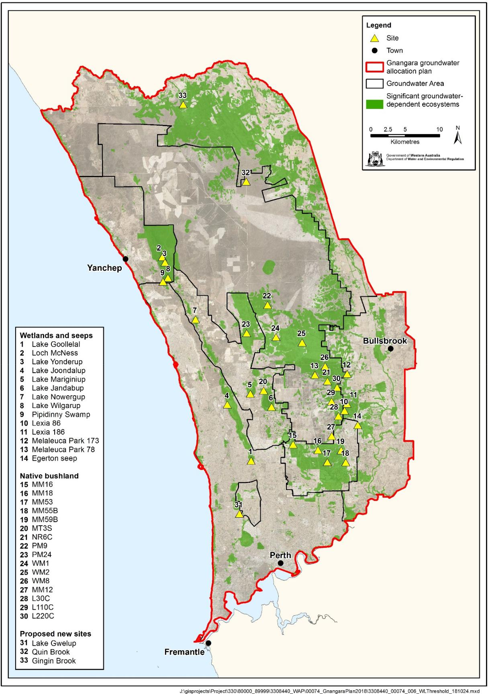

Figure 1: Gnangara groundwater allocation plan area and location of wetland and terrestrial sites investigated in this report. 9

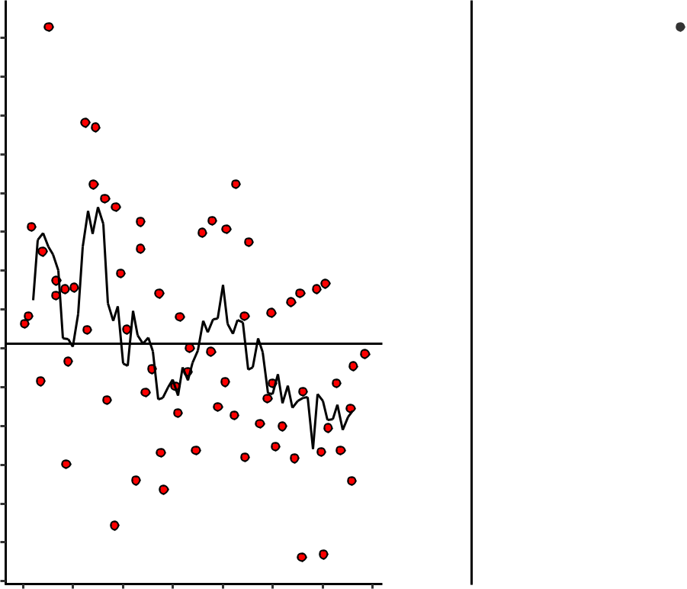

|  |  |  |  |  |
| --- | --- | --- | --- | --- |
|  | 1150 |  |  |  |
|  | 1100 |  | 400 |  |
|  |  |  |  |
|  | 1050 |  |  |  |
|  | 1000 |  |  |  |
| (mm) | 950 | (mm) | 300 |  |
|  |  |
| 900 |  |  |
| Rainfall | 850 | Rainfall |  |  |
| 800 | 200 |  |
| Annual |  | Monthly |  |
| 750 |  |  |
| 700 |  |  |
|  |  |  |
|  | 650 |  | 100 |  |
|  |  |  |  |
|  | 600 |  |  |  |
|  | 550 |  |  |  |
|  | 500 |  | 0 |  |
|  |  |  |  |
|  | 450 |  |  |  |
|  | 1950 1960 1970 1980 1990 2000 2010 2020 |  | JanFebMarAprMayJun Jul AugSepOctNovDec |  |
|  | Year |  | Month |  |

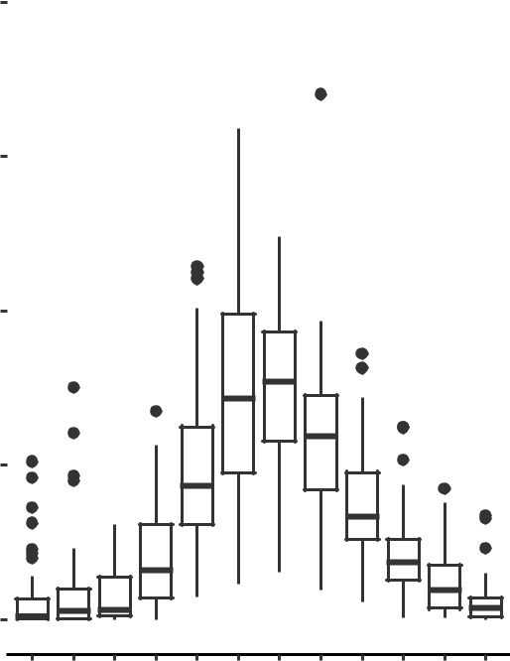

Figure 2: Left: Annual rainfall data reported for Perth Airport (BOM Site 9021) for 1950 - 2018. Dotted line represent average annual rainfall for the entire period. Solid line represents a 5-year moving average of annual rainfall data. Right: }Monthly rainfall data reported for Perth Airport (BOM Site 9021) for 1950 - 2018.

10

**Methods**

[TABLE OF WETLANDS <- THE DUNE COMPLEX THEY BELONG TO, WHETHER VEG/INVERT MONITORING, COORDINATES ]

**Vegetation monitoring**

The overall objectives of the wetland vegetation monitoring on the Gnangara Mound are:

* to determine the impact of altered groundwater regimes on the ecological condition of wetland vegetation
* to monitor the condition and composition of fringing vegetation at selected Gnangara wetland sites, and to determine if observed changes to vegetation are associated with changes in groundwater and wetland water levels
* to identify vegetation monitoring parameters relevant to monitoring objectives.

Vegetation is monitored every spring at selected wetland sites. Spring provides the best opportunity to capture the greatest plant diversity as well as enhancing identification as most Swan Coastal Plain flora are in flower. Annual surveys permit direct comparisons of vegetation changes to be made, especially in response to rapidly declining groundwaters.

Extensive methodological details can be found in the annual Wetland Vegetation Monitoring reports (see Buller et al. (2019)). The data analysed here primarily deals with the longitudinal cover abundance data set that has been compiled between 1996 and 2018. This data set has been collected by surveying the species present at established transects at each wetland. The standard design of these transects is a series of 3 to 4 10x10 m plots extending from the wetland end (Plot A) to the terrestrial end (generally Plot D). In some instances, when surface water declines are significant, the transect has been extended to include new plots at the current water edge. It is important to note that not every wetland is sampled every year, and some wetlands have gone a number of years since last survey (Figure 3). The vegetation at sites Pipidinny Swamp, WM1, WM2, WM8 and Whiteman Park East were surveyed for the first time this spring (2019). Only a brief description of those sites is given in this report and a more detailed analysis will be given in the 2020 Wetland Vegetation Report.

**Aquatic invertebrate monitoring**

Data of aquatic macroinvertebrate communities have been compiled during the Gnangara Mound Environ-mental Monitoring Programme - Macroinvertebrate and Water Quality Wetland Monitoring since 1996 (see Judd and Horwitz (2019) for latest report and comprehensive methodology). The wetlands included in this report where macroinvertebrate data has been collected include Lake Jandabup, Lake Mariginiup, Loch McNess, Lake Nowergup, Lake Yonderup, Lake Goollelal, Lake Joondalup and Melaleuca Park 173. All of these wetlands are either permanently or ephemerally inundated.

For each wetland, a series of habitat types are sampled using 250 *µ*m mesh nets and identified under a microscope to family levels. An abundance score for each taxon is recorded (rare = 1-2 specimens, scarce = 3-10 specimens, common = 11-100 specimens, abundant = 100-1000 specimens and extremely abundant =

* 1000 specimens). Sampled habitats are subject to availability, therefore not all habitats can be sampled each year for each wetland. Sampling occurs when spring high water levels are reached for each wetland each year to ensure maximum availability of habitats and potential diversity of macroinvertebrates. For the purposes of this report, sampled habitats for each wetland have been pooled for each year. Nonetheless, the disappearance of habitats when surface water levels are not high enough to make them available, or if habitats disappear due to loss of fringing vegetation, needs to be considered when considering the role of groundwater level on the aquatic ecology of these wetlands.

11

|  |
| --- |
| Wetland |

Goollelal



Loch_McNess



Yonderup



Joondalup_Nth



Joondalup_Sth



Mariginiup



Jandabup



Nowergup_Nth



Nowergup_Sth



Wilgarup



Lexia_186



EMP_173



EMP_78



Gwelup



Quin_Brook



1995 2000 2005 2010 2015

Year

Figure 3: Period of survey for each wetland.

12

**Statistical analyses**

Generalised additive models (GAMs) were used to model non-linear trends in water level time series data (Wood, 2011). Historical water level data for each of the wetlands in this report was accessed from the DWER website [(http://www.water.wa.gov.au/maps-and-data/monitoring/water-information-reporting)](http://www.water.wa.gov.au/maps-and-data/monitoring/water-information-reporting). To simplify modelling, mean monthly water levels were calculated and used for modelling. A cyclic cubic spline with 12 dimensions was used as a smooth term to ensure there was no discontinuity between Janurary and December water levels. To account for correlated errors, an ARMA process, nested within each year, was fitted to the rediduals using the R package *nlme* v 3.1-141 (Pinheiro et al., 2019). All GAMs were fitted using the R package *mgcv* v 1.8-30 (Wood, 2019).

A multivariate analysis was used to explore the eﬀects of ground/surface water level on vegetation communities. This fits a multivariate generalised linear model to the data so that the eﬀects of species covariates (including groundwater level) on each species can be modeled (Hui, 2016). Species abundances (vegetation and macroinvertebrates) were fitted to negative binomial distributions and the models fitted with two latent variables. The models were fitted and unconstrained model-based ordinations was carried out on the macroinvertebrate and vegetation data using the *boral* package v 1.7 (Hui, 2018). The resulting ordinations enable graphical representations of communities for each wetland to be made, with points closer to each other more similar in terms of taxonomic composition than those more distant. Wetland specific boral models were run using the mean fitted water level for each survey year as a covariate in order to understand species specific interactions with water levels. All analyses were conducted using R (version 3.6.1)

**Managerial obligation assessment**

[DO WE TO HAVE A FORMAL WAY OF DOING THIS?]

13



|  |  |  |
| --- | --- | --- |
| *Acacia saligna* |  | *Banksia attenuata* |
|  |  |  |

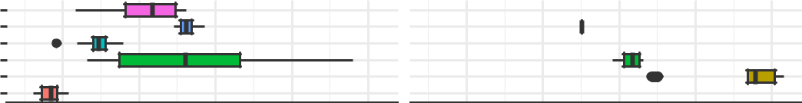

Loch McNess

Lake Yonderup

Lake Mariginiup

Lake Joondalup

Lake Jandabup

Lake Goollelal



|  |  |  |
| --- | --- | --- |
| *Banksia menziesii* |  | *Baumea articulata* |
|  |  |  |



Loch McNess

Lake Yonderup

Lake Mariginiup

Lake Joondalup

Lake Jandabup

Lake Goollelal



|  |  |  |
| --- | --- | --- |
| *Baumea juncea* |  | *Eucalyptus rudis* |
|  |  |  |

Loch McNess



Lake Yonderup

Lake Mariginiup

Lake Joondalup

Lake Jandabup

Lake Goollelal



|  |  |  |
| --- | --- | --- |
| *Lepidosperma longitudinale* |  | *Melaleuca rhaphiophylla* |
|  |  |  |

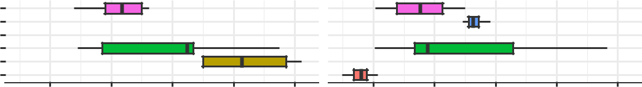

Loch McNess

Lake Yonderup

Lake Mariginiup

Lake Joondalup

Lake Jandabup

Lake Goollelal

0 1 2 3 4 0 1 2 3 4

Height above surface water (m)

Figure 4: Range of depth to water level experienced by some plant species at a few sites with reliable water monitoring during the survey period.

**General observations**

**Wetland vegetation**

Add some description of the results presented in Figure 4 and Figure 5.

**Aquatic invertebrate communities**

The aquatic invertebrate assemblages form three distinct groups based on the dunal system of the wetland (Figure 6). The Spearwood Dunes (Lake Goollelal, Lake Joondalup, Loch McNess, Lake Nowergup and Lake Yonderup) form the most diverse group, while the Bassendean Dunes Wetlands (Melaleuca Park 173) and East Wanneroo Interdunal Wetlands (Lake Jandabup and Lake Mariginiup) have diﬀerent assemblages to each other. Generally, the Bassendean Dunes and East Wanneroo Interdunal Dunes wetlands are becoming more similar with each other, although such conclusions are based on a very limited set of wetlands. The Spearwood Dunes contain wetlands with two distinct trajectories, those migrating towards initial Lake Joondalup compositions (Loch McNess, Lake Goollelal and Lake Nowergup), and those migrating towards initial Loch McNess compositions (Lake Joondalup and Lake Yonderup). Nonetheless, each wetland has a distinct assemblage of macroinvertebrates but, aquatic macroinvertebrate communities have shifted during the monitoring period. Recent monitoring suggests that Loch McNess and Melaleuca Park 173 are becoming more similar to others wetlands. For instance, Loch McNess has shifted dramatically towards early Lake

14

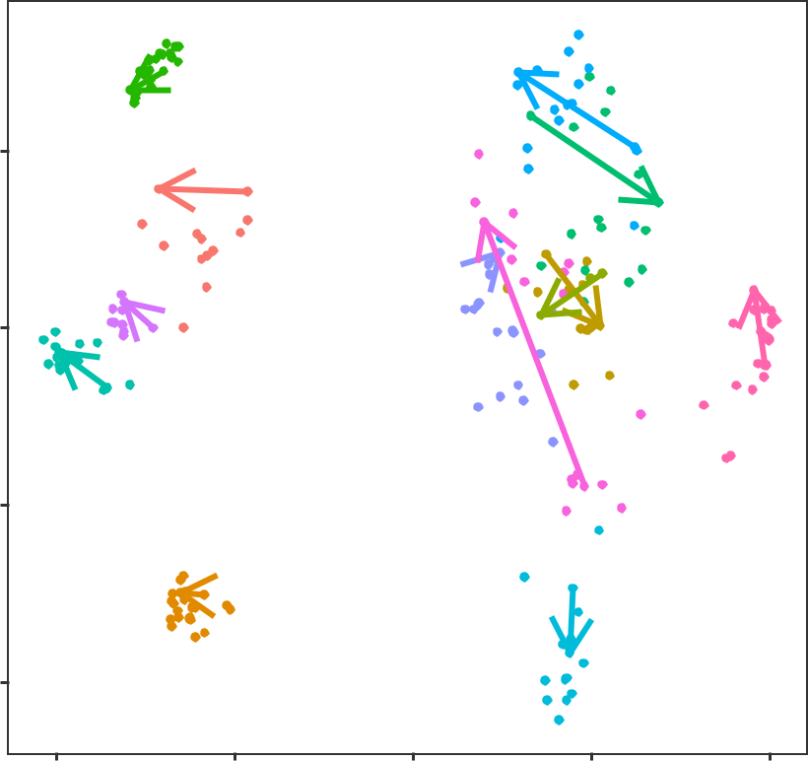

1

0

|  |
| --- |
| LV2 |

−1

−2

−2 −1 0 1 2

LV1

Wetland

Melaleuca Park 78



Melaleuca Park 173



Lake Goollelal



Lake Gwelup



Lake Jandabup



Lake Joondalup



Lexia 186



Loch McNess



Lake Mariginiup



Lake Nowergup



Quin Brook



Lake Wilgarup



Lake Yonderup



Figure 5: Unconstrained ordination plot of all vegetation surveys at each wetland site during the survey period (1996-2018). Arrows represnt change from first survey to last survey.

15

|  |
| --- |
| LV2 |

1.0

0.5

0.0

−0.5

−1.0

Wetland

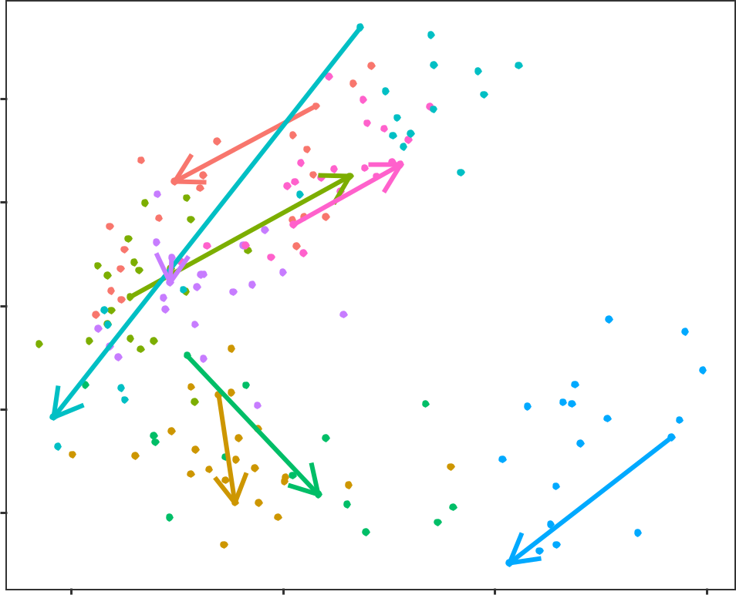

GOO



JAN



JOO



MAR



MCS



MEL



NOW



YON



−1 0 1 2

LV1

Figure 6: Unconstrained ordination plot of all samples collect at each wetland during the survey period (1996-2018). Arrows represnt change from first survey to last survey. Wetlands include Lake Goollelal (GOO), Lake Jandabup (JAN), Lake Joondalup (JOO), Lake Mariginiup (MAR), Loch McNess (MCS), Melaleuca Park 173 (MEL), Lake Nowergup (NOW) and Lake Yonderup (YON).

Joondalup composition. Lake Goollelal has displayed a similar, although not as dramatic, shift in composition. During the monitoring period, Melaleuca Park 173 is becoming increasingly similar to the assemblages at Lake Jandabup and Lake Mariginiup, which are also shifting towards Melaleuca Park 173. The communities at Lake Joondalup and Lake Yonderup have been shifting towards the early communities of Loch McNess. Lake Nowergup has shown some variation in community composition, but the current trajectory shows little change to the 1996 assemblage.

Most wetlands have lost families since the period 1996-2000, with the exception of Lake Goollelal and Loch McNess (Figure 7 and Judd and Horwitz (2019)). The richness of the Lake Joondalup assemblage has not dramatically declined either. There are 11 families of aquatic macroinvertebrates that have not been recorded from the monitored wetlands in the past 5 years and seven families currently present that were not recorded in the initial 1996-2000 (excluding singletons; Table 1). The richness of Acari (mites and ticks) has declined by 4 families while the Coleopteran Haliplidae and the Hemipteran Mesoveliidae are no absent from Lake Joondalup and Lake Yonderup. The Mollusc Sphaeriidae, probably a regionally endemic species (Sommer et al., 2008), has been absent from Lake Nowergup since 1998, while Ancylidae has become abundant (possibly due to augmentation - see Sommer et al. (2008)). The insects, Corduliidae (Odonata), Ecnomidae (Trichoptera), Haliplidae (Coleoptera) and Mesoveliidae (Hemiptera) are all species with widespread distributions in the Swan Coastal Plain (Sommer et al., 2008), but are now not found in the monitored wetlands reported here.

16

|  |
| --- |
| 2014−2018 Family Richness |

|  |  |  |  |  |  |  |  |  |  |
| --- | --- | --- | --- | --- | --- | --- | --- | --- | --- |
| 32 |  |  |  | MCS |  |  |  |  |  |
|  |  |  |  |  |  |  |  |  |
| 31 |  |  |  |  |  |  |  |  |  |
| 30 |  |  |  |  |  |  | JOO |  |  |
|  |  |  |  |  |  |  |  |  |
| 29 |  |  |  |  |  |  |  |  |  |
| 28 | GOO |  |  |  |  |  |  |  |  |
|  |  |  |  |  |  |  |  |  |
| 27 |  |  |  |  |  |  |  |  |  |
| 26 |  |  |  |  |  |  |  |  |  |
| 25 |  |  |  |  |  | YON | JAN |  |  |
|  |  |  |  |  |  |  |  |
| 24 |  |  |  |  |  |  |  |  |  |
| 23 |  |  |  |  |  |  |  |  |  |
| 22 |  |  |  |  |  |  |  | NOW |  |
|  |  |  |  |  |  |  |  |  |
| 24 | 25 | 26 | 27 | 28 | 29 | 30 | 31 | 32 |  |

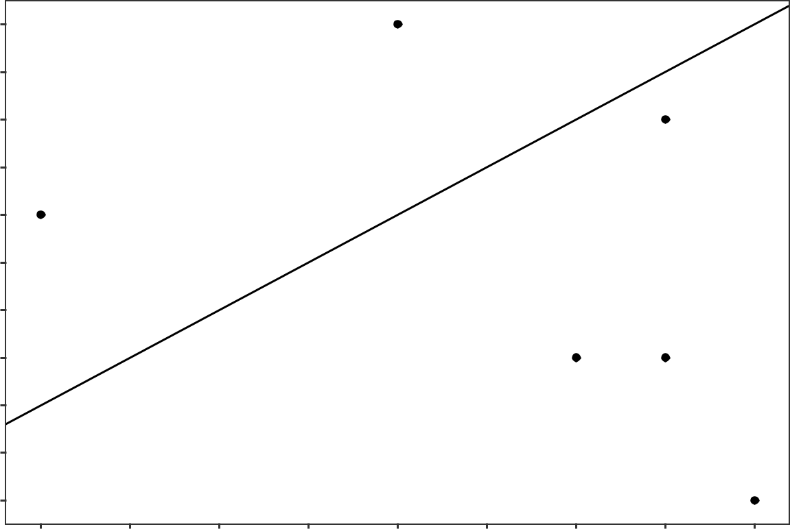

1996−2000 Family Richness

Figure 7: Comparison of aquatic macroinvertebrate family richness of six wetlands between 5 year periods 1996-2000 and 2014-2018. Wetlands include Lake Goollelal (GOO), Lake Jandabup (JAN), Lake Joondalup (JOO), Loch McNess (MCS), Melaleuca Park 173 (MEL), Lake Nowergup (NOW) and Lake Yonderup (YON). Dashed line equals null model where family richness has not changed. Wetlands above dashed line have increased family richness since the 1996-2000 period. Wetlands below dashed line have lower richness compared to 1996-2000.

17

Table 1: Families of aquatic macroinvertebrates that have been lost in the last 5 years (2018-2014) compared to the first five year period (1996-2000). Singletons have been excluded.

Taxa Gained Lost

**Mollusca** Ancylidae Sphaeriidae

**Acarina** Limnesiidae

Oribatida

Oxidae

Unioncolidae

**Insecta** Veliidae Corduliidae

Scirtidae Ecnomidae

Haliplidae

Mesoveliidae

**Ostracoda** Notodromadidae

**Cladocera** Moinidae Macrothricidae

**Individual wetland descriptions**

**Lake Goollelal**

Lake Goollelal, located within the Yellagonga Regional Park, is recognised as an important waterbird habitat and drought refuge (R Froend, R. C. Loomes, et al., 2004) as well as habitat for the Swan River Goby (*Pseudogobius olorum*) and the Western Pygmy Perch (*Edelia vittata* ; Water Authority of Western Australia (1995)). The permanent deep waters found in the lake not only provides significant habitat for fauna and fringing vegetation, but also hold significant value as a place of public enjoyment. [COMMENT ON SURROUNDING URBANISATION?]

**Hydrology and water quality**

Surface water levels recorded at Lake Goollelal reveal peak levels generally occur between September and November and lowest water levels between March and May (Table 2). There has been a consistent range of about 0.7 m in annual water level during this period. There has been a general trend of decreasing surface water levels since 1995, although recent increases since 2016 show surface waters at a similar depth to 1990 levels (Figure 8). Surface water levels show similar trends to groundwater levels at a nearby bore (61611870) as the lake is largely fed by groundwater. Although the preferred minimum threshold of 26.0 mAHD has not been breached, it is likely the threshold is set too low as acidification of waters in the lake is a concern (Quintero Vasquez and Lund, 2018). Proposed changes to the Ministerial Criteria include adopting a higher threshold level of 26.4 mAHD. The proposed threshold can be met at 2030 based on modelling.

Lake Goollelal has stable water quality (Judd and Horwitz, 2019). Water pH, normally around 7.5, has only been recorded below 7 in 2007 while the risk of acidification remains low due to declining chloride:sulphate. Currently, the lake is experiencing increasing levels of nitrogen, although levels are still below long-term averages, and low phosphorous.

**Vegetation dynamics**

The composition of vegetation at Lake Goollelal has been assessed 14 times between 1997 and 2014 at four plots along an established transect [I NEED TO READ THE 2014 VEG REPORT]. Plot A represents fringing *Melaleuca rhaphiophylla*/*Eucalyptus rudis* vegetation and a stable community of the native sedges, *Baumea*

18

Table 2: Five year summaries of surface water level data at Lake Goollelal recorded at staﬀ 6162517

|  |  |  |  |  |  |  |  |
| --- | --- | --- | --- | --- | --- | --- | --- |
| Period | Mean max seasonal | Mean min seasonal | Mean seasonal change | Month of | Month of | Mean max to |  |
| level (mAHD) | level (mAHD) | (m) | maximum | minimum | min (days) |  |
|  |  |
|  |  |  |  |  |  |  |  |
| 08/1994 - 07/1999 | 27.5 | 26.8 | 0.78 | October | May | 207 |  |
| 08/1999 - 07/2004 | 27.5 | 26.7 | 0.80 | September | March | 206 |  |
| 08/2004 - 07/2009 | 27.4 | 26.6 | 0.75 | September | April | 137 |  |
| 08/2009 - 07/2014 | 27.2 | 26.5 | 0.73 | October | April | 190 |  |
| 08/2014 - 07/2019 | 27.4 | 26.7 | 0.68 | November | April | 139 |  |
|  |  |  |  |  |  |  |  |

*articulata* and *Lepidosperma gladiatum*. The *M. rhaphiophylla* /*E. rudis* complex continues throughout thetransect, which has also remained relatively stable in terms of cover abundance since 2002. There is a high richness of exotic vegetation species present at the lake. Generally, these exotic species have increased in abundance during the survey period (Figure 9).

Ordination reveals that Plot A has a distinct assemblage to the other plots but has displayed similar shifts in vegetation composition during the monitoring period (Figure 10). All plots show an initial shift in community cover abundance from the 1997 survey and a return to 1997-like composition in the recent survey years. Plot D displays a diﬀerent pattern, probably due to the record of *B. articulata* in 1997 [SHOULD CONFIRM THIS WITH GRANT] and the high cover abundance of exotic species. Bayesian regression analysis predicts many species to increase in cover abundance with declining surface water levels, while *B. articulata* is predicted to decrease significantly in cover abundance (Figure 11). Native species thought to increase in cover abundance with declining surface water levels include *Pennisetum clandestinum*, and *Microtis media*, while cover abundance of *M. rhaphiophylla* and *E. rudis* will likely remain stable or only increase slightly. Many exotic species are likely to increases in cover abundance under a scenario of declining surface waters, including *Briza maxima*, *Fumaria capreolata*, *Setaria palmifolia* and *Sparaxis bulbifera*.

**Aquatic invertebrates**

The mean family richness of aquatic invertebrates is 22 for Lake Goollelal (Figure 13). Since 2008, family richness has mostly been stable and above the long term average. There are stable populations of Amphisopidae, Calanoida, Ceinidae, Chironominae, Corixidae, Cyprididae and Amphisopidae at the lake (Figure 12). Other taxa are not currently recorded in the lake include Ceratopogonidae, Chydoridae, Oligochaeta and Pionidae. The absence of the Chydoridae (Cladocera) is notable given the abundance in early monitoring years. There was a major shift in the assemblage composition in 2006-2007, with ordination revealing two main groups of annual data; those collected pre 2007, and those collected post 2007 (Figure 14). However, recent high water levels and low nutrients appear to shifting the assemblages back towards pre-2007 compositions (see Judd and Horwitz (2019)).

**Implications of Revised Thresholds**

Revised thresholds will likely maintain ecological conditions similar to present (Table 3).

19

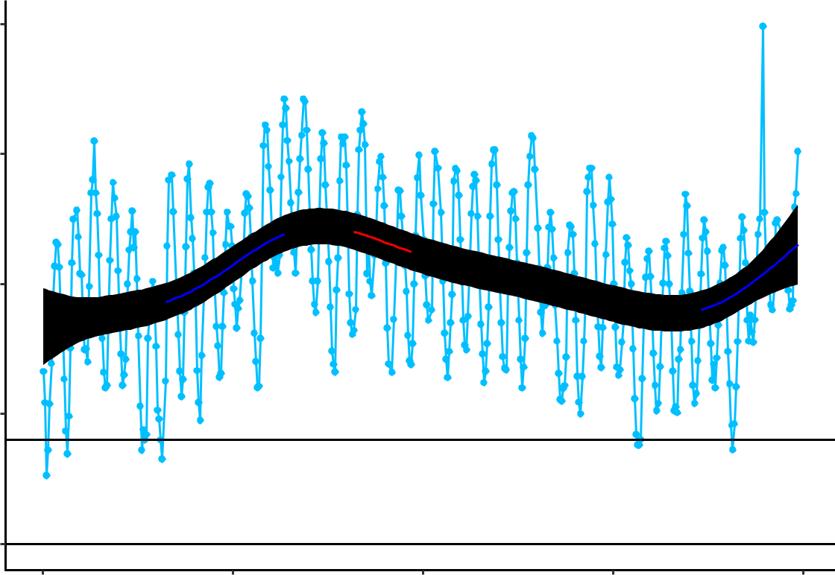

|  |  |  |  |  |  |  |
| --- | --- | --- | --- | --- | --- | --- |
|  | 28.0 |  |  |  |  |  |
|  | 27.5 |  |  |  |  |  |
| ( )mAHD |  |  |  |  |  |  |
| Water Level | 27.0 |  |  |  |  |  |
|  |  |  |  |  |  |
|  | 26.5 |  |  |  | Proposed |  |
|  |  |  |  |  | Current |  |
|  | 26.0 |  |  |  |  |  |
|  | 1980 | 1990 | 2000 | 2010 | 2020 |  |
|  |  |  | Year |  |  |  |

Figure 8: Surface water levels recorded at staﬀ 6162517 for Lake Goollelal. Red segments on fitted line represent statistically significant periods of declining water levels and blue segments represent statistically significant periods of increasing water levels. Dotted line is the current ministerial absolute minimum water levels. Dashed line is the proposed 2030 minimum threshold level.

20

|  |
| --- |
| 21 |

|  |  |  |  |  |  |  |  |  |  |  |  |  |  |  |  |  |  |  |  |  |  |  |  |  |  |  |  |  |  |  |  |
| --- | --- | --- | --- | --- | --- | --- | --- | --- | --- | --- | --- | --- | --- | --- | --- | --- | --- | --- | --- | --- | --- | --- | --- | --- | --- | --- | --- | --- | --- | --- | --- |
|  | X Briza maxima | X Bromus diandrus | X Conyza albida | X Cynodon dactylon | X Cyperus tenuiflorus | X Ehrharta calycina | X Fumaria capreolata | X Hypochaeris glabra | X Isolepis prolifera | X Moraea flaccida | X Paspalum distichum | X Pelargonium capitatum | X Phyla nodiflora | X Rumex crispus | X Schinus molle | X Sonchus oleraceus | X Stachys arvensis | Symphyotrichum squamatum | X Typha orientalis | X Vicia sativa | Acacia saligna | Agrostis avenacea | Baumea articulata | Centella asiatica | Eucalyptus rudis | Juncus pallidus | Lepidosperma gladiatum | Melaleuca rhaphiophylla | Microtis media | Pennisetum clandestinum |  |
|  | 2000 |  |  |  |  |  |  |  |  |  |  |  |  |  |  |  |  |  |  |  |  |  |  |  |  |  |  |  |  |  |  |
|  | 2005 |  |  |  |  |  |  |  |  |  |  |  |  |  |  |  |  |  |  |  |  |  |  |  |  |  |  |  |  | A |  |
|  | 2010 |  |  |  |  |  |  |  |  |  |  |  |  |  |  |  |  |  |  |  |  |  |  |  |  |  |  |  |  |  |  |
|  | 2000 |  |  |  |  |  |  |  |  |  |  |  |  |  |  |  |  |  |  |  |  |  |  |  |  |  |  |  |  |  |  |
|  | 2005 |  |  |  |  |  |  |  |  |  |  |  |  |  |  |  |  |  |  |  |  |  |  |  |  |  |  |  |  | B |  |
| Year | 2010 |  |  |  |  |  |  |  |  |  |  |  |  |  |  |  |  |  |  |  |  |  |  |  |  |  |  |  |  |  |  |
| 2000 |  |  |  |  |  |  |  |  |  |  |  |  |  |  |  |  |  |  |  |  |  |  |  |  |  |  |  |  |  |  |
|  |  |  |  |  |  |  |  |  |  |  |  |  |  |  |  |  |  |  |  |  |  |  |  |  |  |  |  |  |  |  |
|  | 2005 |  |  |  |  |  |  |  |  |  |  |  |  |  |  |  |  |  |  |  |  |  |  |  |  |  |  |  |  | C |  |
|  | 2010 |  |  |  |  |  |  |  |  |  |  |  |  |  |  |  |  |  |  |  |  |  |  |  |  |  |  |  |  |  |  |

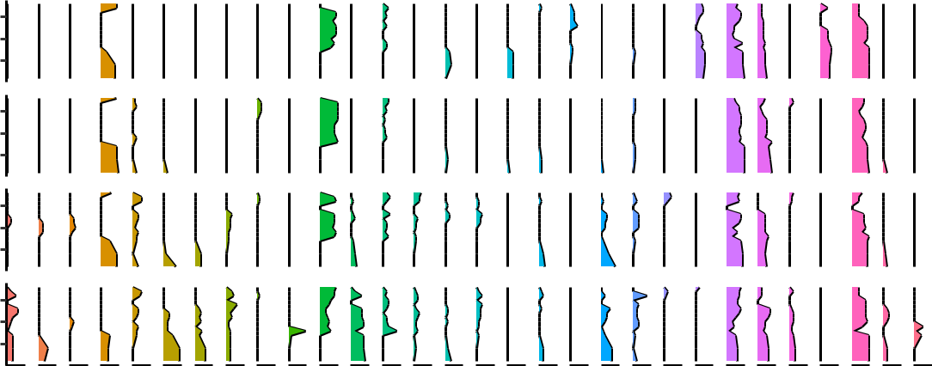

2000

2005 D

2010

Cover Abundance

Figure 9: Cover abundances for each species across the four plots (A, B, C, D) at the Lake Goollelal transect. Invasive species are denoted by ‘X’. Only the most common species are included.

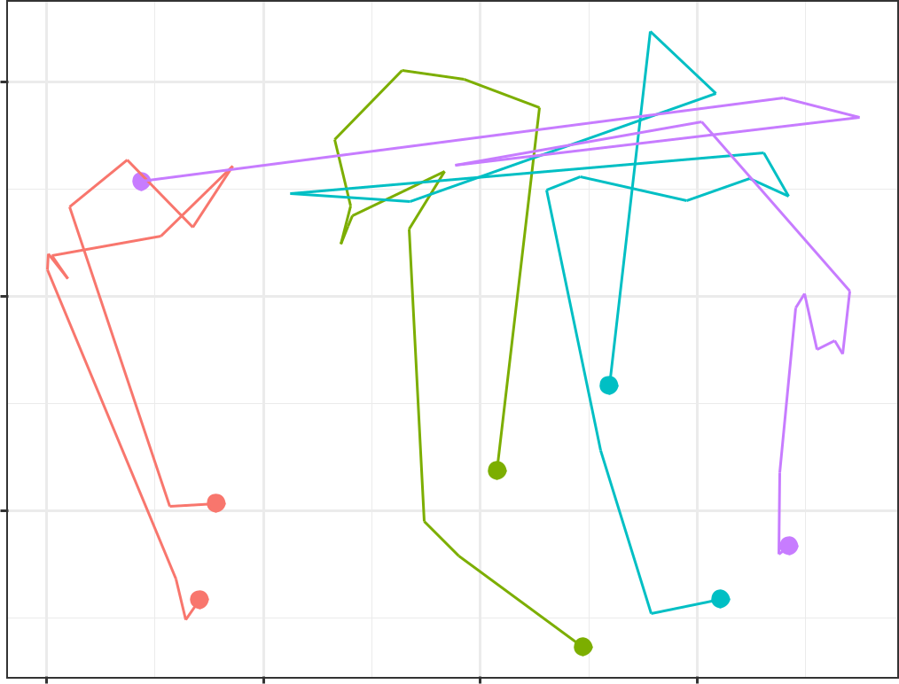

|  |  |  |  |  |  |  |
| --- | --- | --- | --- | --- | --- | --- |
| 1 |  |  |  |  |  |  |
|  | 1997 |  |  |  |  |  |
|  |  |  |  | Plot |  |  |
| 0 |  |  |  | a | A |  |
| LV2 |  |  |  | a | B |  |
|  |  |  |  |  |
|  |  |  | 1997 | a | C |  |
|  |  |  | a | D |  |
|  |  |  |  |  |
|  |  |  | 1997 |  |  |  |
| −1 | 1997 |  |  |  |  |  |
|  |  |  |  |  |  |
|  | 2014 |  |  | 2014 |  |  |
|  |  |  | 2014 |  |  |
|  |  |  | 2014 |  |  |  |
| −2 | −1 | 0 |  | 1 |  |  |
|  |  | LV1 |  |  |  |  |



Figure 10: Unconstrained ordination based on vegetation data for each surveyed year for Lake Goollelal. Plots are represented as diﬀerent colours and consecutive years are joined by a line with first and last survey years labeled.

22

|  |
| --- |
| Species |

X_Vicia_sativa

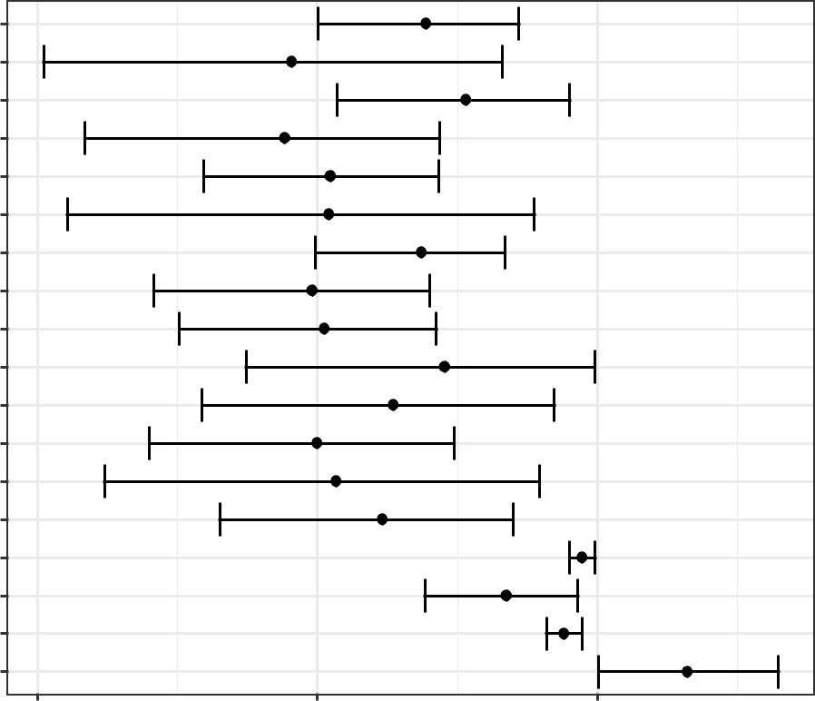

X_Sparaxis_bulbifera

X_Sonchus_oleraceus

X_Setaria_palmifolia

X_Pelargonium_capitatum

X_Moraea_flaccida

X_Hypochaeris_glabra

X_Fumaria_capreolata

X_Ehrharta_calycina

X_Conyza_albida

X_Bromus_diandrus

X_Briza_maxima

Pennisetum_clandestinum

Microtis_media

Melaleuca_rhaphiophylla

Juncus_pallidus

Eucalyptus_rudis

Baumea_articulata

−40 −20 0

Posterior Mean

Figure 11: Estimated mean regression coeﬃcients (dots) and 95% credible intervals (bars) for eﬀect of groundwater levels at Melaleuca Park 78 on vegetation species cover abundances based on Bayesian Regression Analysis (HUI REF 2015). Species with a negative mean posterior value are likely to increase in cover abundance as water levels decline while species with positive posterior values are likely to increase in cover abundance with increasing water levels. Only those species with coeﬃcients significanlty diﬀerent to zero are shown.

23

|  |
| --- |
| 24 |

|  |  |  |  |  |  |  |  |  |  |  |  |  |  |  |  |  |  |  |  |  |  |  |  |  |  |  |  |  |  |  |
| --- | --- | --- | --- | --- | --- | --- | --- | --- | --- | --- | --- | --- | --- | --- | --- | --- | --- | --- | --- | --- | --- | --- | --- | --- | --- | --- | --- | --- | --- | --- |
| Turbellaria | Hirudinea | Oligochaeta | Physidae | Planorbidae | Oxidae | Pionidae | Ceinidae | Amphisopidae | Palaemonidae | Caenidae | Baetidae | Aeshnidae | Coenagrionidae | Cordulidae | Lestidae | Hydroptilidae | Leptoceridae | Corixidae | Notonectidae | Ceratopogonidae | Chironominae | Orthocladiinae | Tanypodinae | Dytiscidae | Hydrophilidae | Calanoida | Cyclopoida | Cyprididae | Chydoridae | Daphniidae |

1995

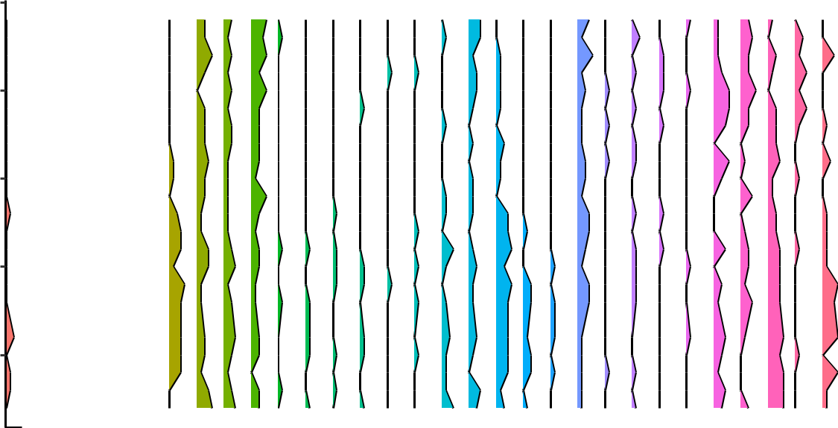

2000

2005

|  |
| --- |
| Year |

2010

2015

Abundance

Figure 12: Cover abundances for each aquatic macroinvertebrate familiy at Lake Goollelal.

Table 3: Ecological consequences of revised thresholds in terms of compliance of stated site values and site management objectives at Lake Goollelal.

|  |  |  |
| --- | --- | --- |
|  | Likely eﬀect of 2030 revised |  |
|  | thresholds | Future Compliance |
|  |  |  |
|  | **Site values** |  |
| * Waterbird habitat and drought refuge | | Yes |
| * Supports good populations of native | | Yes |
|  | fish species, Swan River goby |  |
| (*Pseudogobius olorum*) and the western | |  |
|  | pygmy perch (*Edelia vittata*) |  |
|  | **Site management objectives** |  |
| * Conservation and public enjoyment of | | Yes |
|  | natural and modified landscapes |  |
| * Protect and if possible enhance, | | Yes |
|  | fringing wetland vegetation including |  |
| woodland and sedge vegetation | |  |
| * Maintain permanent, deep water for | | Yes |
| waterbird habitat and as a drought | |  |
|  | refuge |  |
| * Maintain permanent water for fish | | Yes |
|  | and other dependent species |  |
| * Maintain the landscape amenity | | Yes |
|  | values of the wetland |  |
|  |  |  |

25

|  |  |  |  |  |  |  |  |  |  |  |  |
| --- | --- | --- | --- | --- | --- | --- | --- | --- | --- | --- | --- |
| 30 |  |  |  |  |  |  |  |  |  |  |  |
| 25 |  |  |  |  |  |  |  |  |  |  |  |
| Family richness |  |  |  |  |  |  |  |  |  |  |  |
| 20 |  |  |  |  |  |  |  |  |  |  |  |
| 15 |  |  |  |  |  |  |  |  |  |  |  |
| 1996 | 1998 | 2000 | 2002 | 2004 | 2006 | 2008 | 2010 | 2012 | 2014 | 2016 | 2018 |
|  |  |  |  |  | Year | |  |  |  |  |  |

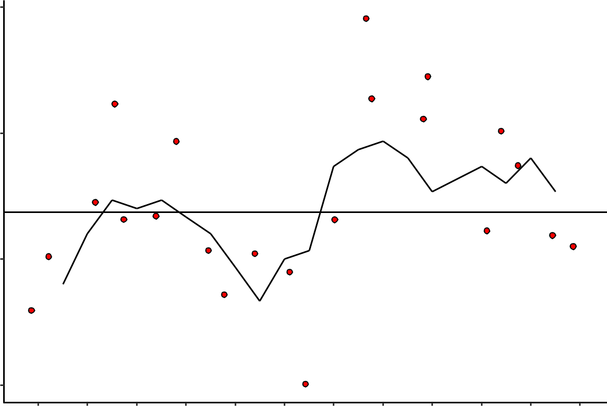

Figure 13: Richness of aquatic invertebrate families for each year at Lake Goollelal. Line is a moving 3-year averavge.

26

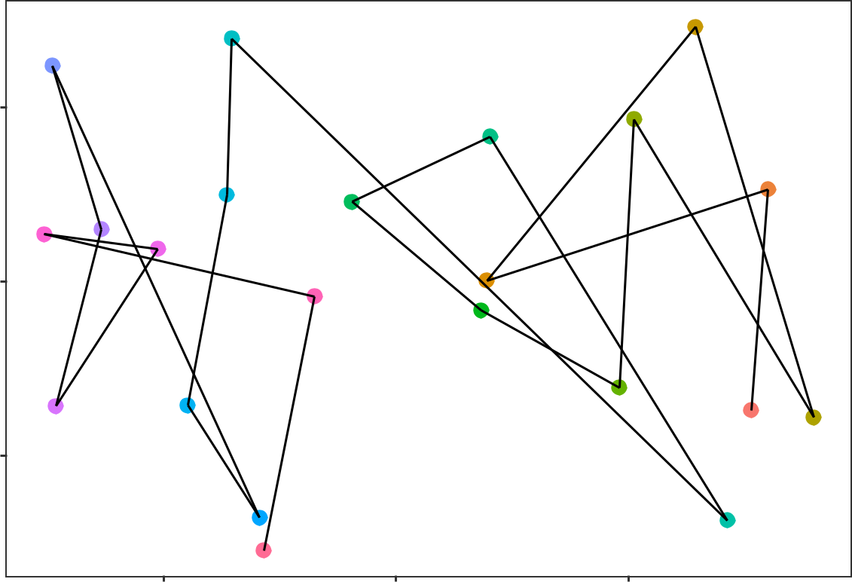

|  |  |  |  |  |
| --- | --- | --- | --- | --- |
|  | 0.1 |  |  |  |
| LV2 | 0.0 |  |  |  |
|  |  |  |  |
|  |  |  | 1996 |  |
|  | −0.1 |  |  |  |
|  |  | 2018 |  |  |
|  | −0.5 | 0.0 | 0.5 |  |
|  |  |  | LV1 |  |

Figure 14: Unconstrained ordination based on invertebrate data for each surveyed year for Lake Goollelal.

Consecutive years are joined by a line with first and last survey years labeled.

27

**Loch McNess**

Loch McNess, located in Yanchep National Park, is a relatively undisturbed wetland with large areas of intact Herdsman Complex vegetation. The lake has had relatively good water quality and provides an important habitat for water birds and other aquatic fauna (R Froend, R. C. Loomes, et al., 2004). Permanent water is required to support a local Rakali (*Hydromys chrysogaster*) population and resident as well as visiting populations of water birds and waders. The southern lake at Loch McNess is one of the few wetlands known to contain the nightfish *Bostokia porosa* and has one of the most rich aquatic macroinvertebrate communities of the Swan Coastal Plain. Loch McNess is a wetland of high conservation value because of its intact vegetation, largely unaltered aquatic processes and important populations of fauna (R Froend, R. C. Loomes, et al., 2004).

**Hydrology and water quality**

Since early 2011, readings for the staﬀ gauge at Loch McNess have frequently been below the gauge’s limit. It is therefore likely the decline in surface water levels have continued pasted the levels shown in Figure 15. Nonetheless, surface water, which were remarkably stable before 2003 at 7 mAHD, have declined at least 1.5 m to present levels. These declines have been mirrored in surrounding bores (Figure 15). Mean maximum and minimum seasonal water levels have decline by 0.9 m since 1994-2004 levels (Table 4). Changes in seasonal patterns are diﬃcult to interpret due to staﬀ gauge 6162564 being mostly dry since 2014, but during the period 2009-2014, minimum water levels were not being reached until May, compared to March in the decade 1994-2004. A recent increase in water level, as seen in surrounding wetlands during the last few seasons, has not been observed at Loch McNess. The dramatic decline in water levels is causing the terrestrialisation of the lake as much of the lake bed is now undergoing recruitment by fringing vegetation.

The lake has been non-compliant with ministerial water levels since 2003 and water levels are now approximately 1.0 m below this threshold. Modelling of groundwater levels under proposed abstraction reductions will not provide suﬃcient increases in groundwater to make this wetland compliant with existing thresholds. Under the new plan, a proposed threshold of 8.0 mAHD at bore 61612104 will satisfy the proposed threshold of surface waters in the lake at 6.2 mAHD (0.75 m below existing threshold).

Water quality at Loch McNess appears to have stabilised in the past couple of years. Normal pH is thought to be over 8.0 but has been below 8.0 since 2010. Current monitoring suggests a pH of 7.8, the highest since 2010 (Judd and Horwitz, 2019). Chloride:sulphate and alkalinity observations suggest that acidification is not a concern at the wetland. There has been a trend of increasing nitrogen levels in the wetland since 2010, but this trend has not continued for 2017-2018 despite current levels being double 1997-2007 levels. Current phosphate levels are an order of magnitude greater than 1999-2004 levels and require close monitoring.

**Vegetation dynamics**

A vegetation monitoring transect was established in 2004 with three plots (A, B, and C) plus an additional up-slope plot in 2009 (Plot D) and a plot down-slope of Plot A in 2010 (Plot E; Figure 16). The fringing vegetation is largely comprised of a *Melaleuca rhaphiophylla*/*Eucalyptus rudis* complex. Most trees are in average to good health (Buller et al., 2019). *Baumea juncea* is found in Plots A -D at relatively constant cover abundance. *Baumea articulata*, however, disappeared from Plot A in 2005 and was present in the new down-slope plot (Plot E) until 2014. (REASON FOR DISAPEARANCE?)

Plots A and B have shifted in community composition dramatically during the monitoring period as the vegetation responds to lower surface water levels in the lake and the impact of fire in 2004 and 2009 (Buller et al. (2019); Figure 17). Regressional analysis reveals that the exotic *Avena barbata* and the native *Tricoryne* *elatior* will increase the most in cover abundance as water levels in the lake remain low or decline further(Figure **??**). The natives, *Carex fascicularis*, *Triglochin centrocarpa* and *M. rhaphiophylla* are most likely to decline dramatically at the wetland under a scenario of continued low water levels.

28

Table 4: Five year summaries of surface water level data at Loch McNess

|  |  |  |  |  |  |  |  |
| --- | --- | --- | --- | --- | --- | --- | --- |
| Period | Mean max seasonal | Mean min seasonal | Mean seasonal change | Month of | Month of | Mean max to |  |
| level (mAHD) | level (mAHD) | (m) | maximum | minimum | min (days) |  |
|  |  |
|  |  |  |  |  |  |  |  |
| 08/1994 - 07/1999 | 7.1 | 7.0 | 0.11 | September | March | 123 |  |
| 08/1999 - 07/2004 | 7.1 | 6.9 | 0.12 | July | March | 91 |  |
| 08/2004 - 07/2009 | 7.0 | 6.8 | 0.21 | June | February | 131 |  |
| 08/2009 - 07/2014 | 6.5 | 6.2 | 0.31 | October | May | 229 |  |
| 08/2014 - 07/2019 | 6.2 | 6.1 | 0.11 | December | July | 25 |  |
|  |  |  |  |  |  |  |  |

**Aquatic macroinvertebrates**

Loch McNess is the most taxonomically rich of the Spearwood Dune wetlands, with about 27 macroinvertebrate families regularly found there (Figure 19). However, the composition of the community is shifting (Figure 20). The communities were relatively stable in terms of composition until 2008 when water levels began to decline significantly (Figure 15). The current trajectory suggests the dissimilarity between pre-2008 and contemporary communities will continue. The site is now dominated by common taxa of the Swan Coastal Plain such as Amphisopidae, Chironomidae larvae, Corixidae, Culicidae larvae, Cyclopoida (*Daphnia*), Dytiscidae, Notonectidae and Pionidae (Figure 18). Some of these, namely Chironomidae and Culicidae larvae, are considered nuisance species. The Amphipod, Ceinidae, has not been collected in the lake since 2014 and the shrimp *Palamonetes australis* not recorded since 2010. This shift in macroinvertebrate assemblage indicates serious changes in ecological processes as the wetland transitions towards a nutrient enriched shallow lake.

**Revised water level threshold eﬀects**

Managing the lake at the proposed thresholds will continue the deterioration of site values at Loch McNess (Table 5).

29

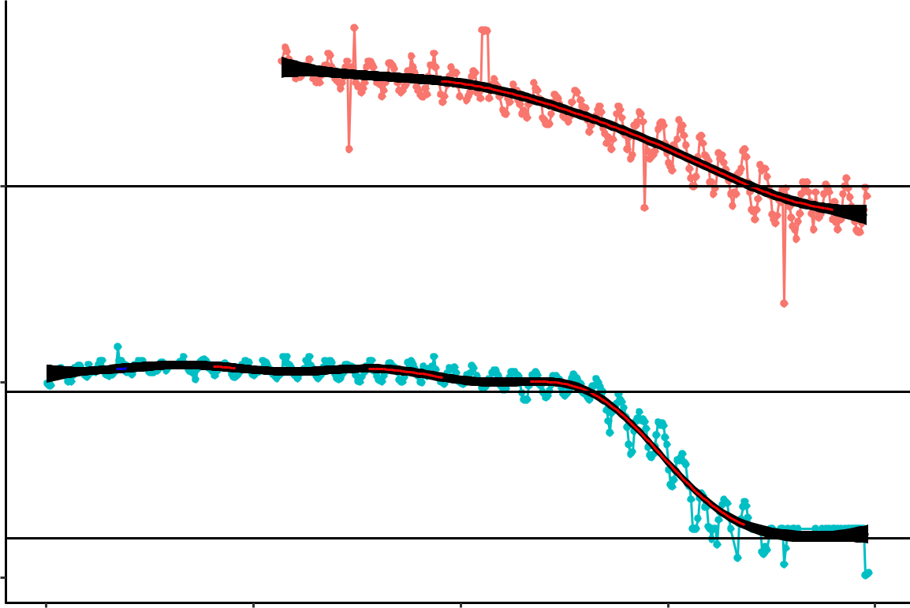

|  |  |  |  |  |  |  |
| --- | --- | --- | --- | --- | --- | --- |
|  |  | Proposed |  |  |  |  |
| ( )mAHD | 8 |  |  |  |  |  |
|  |  |  |  |  |  |
| Level |  |  |  |  |  |  |
| Water | 7 |  |  |  |  |  |
|  | Current |  |  |  |  |
|  |  |  |  |  |  |
|  |  | Proposed |  |  |  |  |
|  | 6 |  |  |  |  |  |
|  | 1980 | 1990 | 2000 | 2010 | 2020 |  |
|  |  |  | Year |  |  |  |

Figure 15: Ground and surface water levels recorded at bores 61612104 (red) and staﬀ gauge 6162564 (blue) that represent changes in water levels at Loch McNess. Segments in red represent periods of significant decline in water level. Dotted line is the current ministerial threshold water level for surface waters at the staﬀ gauge. Dashed lines are proposed ministerial thresholds for the staﬀ gauge and bore.

30

|  |
| --- |
| 31 |

2004



2008

2012 A

2016

2004



2008

2012 B

2016

|  |  |  |  |
| --- | --- | --- | --- |
| Year | 2004 |  |  |
| 2008 | C |  |
|  | 2012 |  |
|  | 2016 |  |  |



2004



2008



2012 D

2016

2004



2008



2012 E

2016

Cover Abundance

Figure 16: Cover abundances for each species across the five plots (A, B, C, D and E) at the Loch McNess transect. Plot D was established up-slope from Plot C in 2009. Plot E was established down-slope of Plot A in 2010. Invasive species are denoted by ‘X’. Only the most common species are included.

|  |
| --- |
| Species |

X_Sonchus_oleraceus

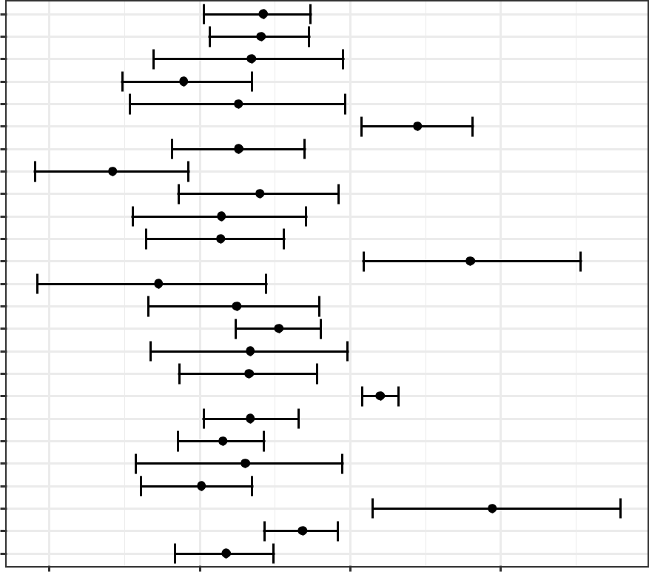

X_Pelargonium_capitatum

X_Galium_murale

X_Ehrharta_longiflora

X_Dischisma_arenarium

X_Cirsium_vulgare

X_Carpobrotus_edulis

X_Avena_barbata

X_Arctotheca_calendula

Viminaria_juncea

Unknown_climber

Triglochin_centrocarpa

Tricoryne_elatior

Trachymene_pilosa

Spyridium_globulosum

Scaevola_crassifolia

Myoporum_caprarioides

Melaleuca_rhaphiophylla

Lepidosperma_longitudinale

Hardenbergia_comptoniana

Dischisma_arenarium

Cassytha_racemosa

Carex_fascicularis

Baumea_juncea

Acacia_saligna

−6 −3 0 3

Posterior Mean

32

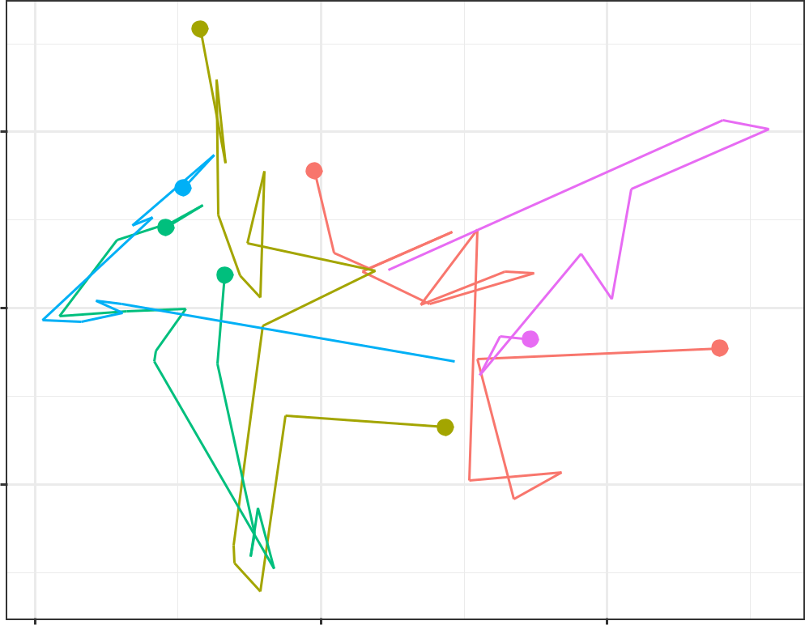

|  |  |  |  |  |  |  |
| --- | --- | --- | --- | --- | --- | --- |
|  |  | 2018 |  |  |  |  |
|  | 0.5 | 2018 |  |  |  |  |
|  |  |  |  |  |  |
|  |  | 2018 |  |  |  |  |
|  |  | 2018 |  | Plot |  |  |
|  |  | 2004 |  | a | A |  |
| LV2 | 0.0 |  |  | a | B |  |
| 2018 | 2004 | a | C |  |
|  |  |
|  |  |  |
|  |  |  |  | a | D |  |
|  |  | 2004 |  | a | Z |  |
|  |  |  |  |  |  |
|  | −0.5 |  |  |  |  |  |
|  | −1 | 0 | 1 |  |  |  |
|  |  | LV1 |  |  |  |  |



Figure 17: Unconstrained ordination based on the latent variable model for each surveyed year for Loch McNess. Plots are represented as diﬀerent colours and consecutive years are joined by a line with first and last survey years labeled.

33

|  |
| --- |
| 34 |

1995



2000

2005

|  |
| --- |
| Year |

2010

2015

Abundance

Figure 18: Cover abundances for each aquatic macroinvertebrate familiy at Loch McNess.

Table 5: Ecological consequences of revised thresholds in terms of compliance of stated site values and site management objectives at Loch McNess.

|  |  |  |  |  |
| --- | --- | --- | --- | --- |
|  |  | Likely eﬀect of 2030 revised |  |  |
|  |  | thresholds | Future Compliance |  |
|  | |  |  |  |
|  | **Site values** |  |  |  |
| * Undisturbed wetland | | Sustained low water levels will | No |  |
|  |  | continue to cause a shift in |  |  |
| * Unusual hydrologic regime | | vegetation composition |  |  |
|  |  |  |
| * Rich aquatic fauna | |  | No |  |
| * Vegetation largely intact, provides a | |  | No |  |
| range of habitat types | |  |  |  |
| * Supports good populations of water | |  |  |  |
| birds and acts as a drought refuge | |  |  |  |
| * Excellent water quality | |  | No |  |

**Site management objectives**

* Maintain the environmental quality of the lake

* Maintain North Loch NcNess’ No

pristine state

* Continue to use south Loch McNess for low key recreation
* Maintain east Loch McNess in a natural state, to restore, where possible, natural flow

|  |  |  |  |
| --- | --- | --- | --- |
| * Maintain the existing hydrological | | The loss of stable water levels (once | No |
| regime | | a characteristic of the lake) have |  |
|  |  | deteriorated to the point where |  |
|  |  | water levels have declined by 1.5 m |  |
|  |  | and are susceptible to further |  |
|  |  | declines under a drying climate. |  |
|  |  |  |  |

35

|  |  |  |  |  |  |  |  |  |  |  |  |  |  |
| --- | --- | --- | --- | --- | --- | --- | --- | --- | --- | --- | --- | --- | --- |
|  | 40 |  |  |  |  |  |  |  |  |  |  |  |  |
|  | 35 |  |  |  |  |  |  |  |  |  |  |  |  |
| richness | 30 |  |  |  |  |  |  |  |  |  |  |  |  |
|  |  |  |  |  |  |  |  |  |  |  |  |  |
| Family | 25 |  |  |  |  |  |  |  |  |  |  |  |  |
|  |  |  |  |  |  |  |  |  |  |  |  |  |
|  | 20 |  |  |  |  |  |  |  |  |  |  |  |  |
|  | 15 |  |  |  |  |  |  |  |  |  |  |  |  |
|  | 1996 | 1998 | 2000 | 2002 | 2004 | 2006 | 2008 | 2010 | 2012 | 2014 | 2016 | 2018 |  |
|  |  |  |  |  |  | Year | |  |  |  |  |  |  |

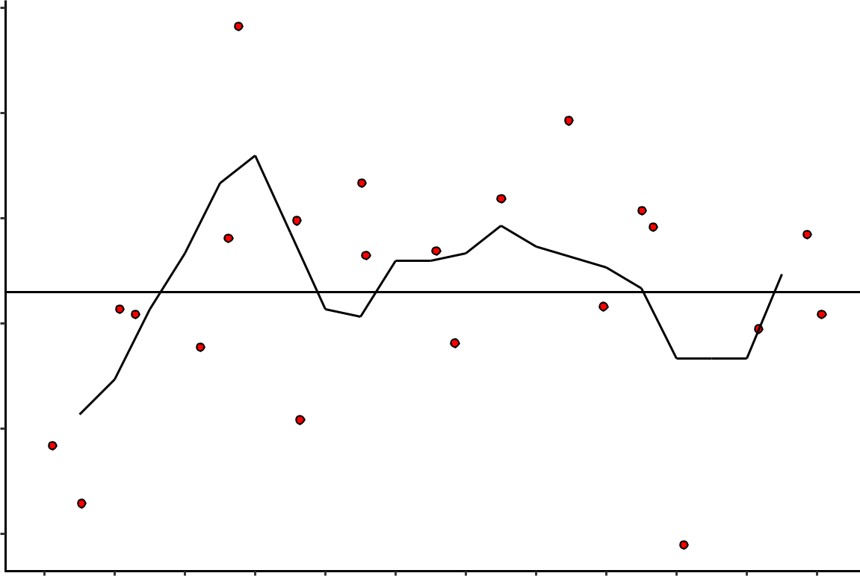

Figure 19: Richness of aquatic invertebrate families for each year. Line is a moving 3-year averavge at Loch McNess.

36

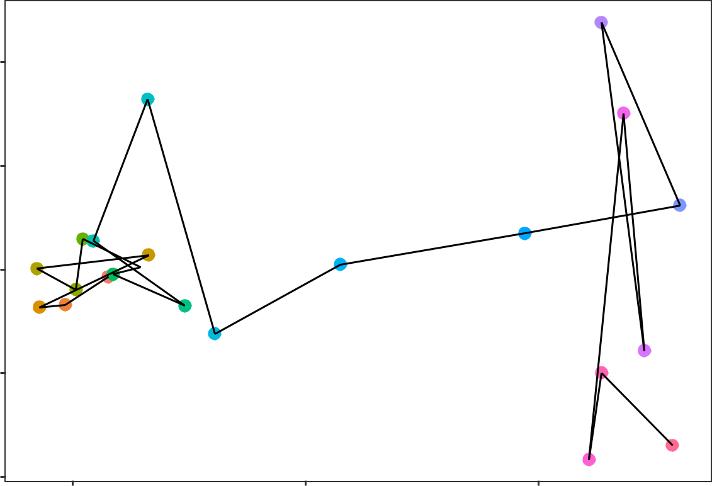

|  |  |  |  |
| --- | --- | --- | --- |
| 0.2 |  |  |  |
| 0.1 |  |  |  |
| LV2 | 1996 |  |  |
| 0.0 |  |  |
| −0.1 |  |  |  |
|  |  | 2018 |  |
| −0.2 |  |  |  |
| −1 | 0 | 1 |  |
|  |  | LV1 |  |

Figure 20: Unconstrained ordination based on invertebrate data for each surveyed year for Loch McNess.

Consecutive years are joined by a line with first and last survey years labeled.

37

**Lake Yonderup**

Located to the south of Loch McNess and north of Lake Wilgarup in Yanchep National Park, Lake Yonderup has a high conservation value as it represents a largely undisturbed wetland with high macroinvertebrate richness and excellent water quality. The permanently filled lake is dependent on groundwater to maintain habitats and biophysical processes (R Froend, R Loomes, et al., 2004). Like other lakes in the region, Lake Yonderup has experienced a consistent decline in surface water levels that has aﬀected the condition and health of fringing vegetation and aquatic processes. A fire eﬀected the fringing vegetation in 2004/2005 (Rogan et al., 2006).

**Hydrology and water quality**

There has been a continual decline in surface water levels at staﬀ gauge 6162565 since 1994. Prior to 1994, water levels were relatively stable at 6 mAHD but have since declined to approximately 5.3 mAHD (Figure 21). There has been no increase in surface water levels with recent high rainfall seasons. Mean maximum and minimum seasonal water levels have only declined 0.2 and 0.3 m, respectively from 1994-1999 levels (Table 6). There has been nearly a four fold increase in seasonal water level variation and waters are generally now in decline for more than 200 days a year. The bore 61611840 is located near the vegetation transects and represents the groundwater levels in the superficial aquifer that the vegetation at the transect is utilising. There has been a similar decline in groundwater levels at this bore until 2017, although observations have only been recorded since 2008. Therefore surface water levels are used to assess changes in vegetation as surface water is likely an expression of the superficial aquifer and show similar trends (R Froend, R. C. Loomes, et al., 2004).

Lake Yonderup has the lowest nutrient levels of all the monitored wetlands on the Gnangara Mound (Judd and Horwitz, 2019), however, the most recent observations for 2018 indicate that total nitrogen levels may be increasing. Otherwise, the water chemistry of the lake has remained relatively stable. Stable alkalinity and a pH that consistently remains above 7.0 suggests there is little risk of acidification.

**Vegetation dynamics**

The vegetation transect, established in 1997, is located 750 m south of the basin and is therefore not representative of vegetation at the wetland itself. The lake provides habitat for *Baumea articulata* although there is recent evidence of *Typha orientalis* invading the wetland (Judd and Horwitz, 2019). At the vegetation monitoring transects, the site was reported to have a rich exotic community before monitoring began in 1997 and this characteristic of the site has persisted. Currently, exotics account for 60% of the cover abundance and native richness has been declining (Buller et al. (2019); Figure 22). The shifts in vegetation composition at each plot changed dramatically since 1997 but largely stabilised in the late 2000’s (Figure 23). There was a dramatic shift in vegetation composition after the 2004/2005 fire. All the native species, including *Banksia* *attenuatta* and *Melaleuca preissiana*, are likely to decline in cover abundance under a scenario of sustain lowwater levels or further declining groundwaters (Figure 24).

**Aquatic macroinvertebrate community**

Taxonomic richness of the macroinvertebrate assemblage in Lake Yonderup has been declining since 2012 (Figure 26). Richness is now lower than previous records and the trend may suggests some shifts in ecological processes due to declining water levels. The composition of the Lake Yonderup macroinvertebrate community is variable (Figure 27). Many taxa are not recorded every year, or are absent for periods, such as Ceinidae, Oligochaeta and Orthocladiinae. Other taxa have declined, or perhaps become locally extinct, including Dytiscidae and Hydrophilidae. Chironominae, Cyclopoida, Cyprididae and Leptoceridae have been recorded in nearly every sampling event at Lake Yonderup.

38

Table 6: Five year summaries of surface water level data at Yonderup

|  |  |  |  |  |  |  |  |
| --- | --- | --- | --- | --- | --- | --- | --- |
| Period | Mean max seasonal | Mean min seasonal | Mean seasonal change | Month of | Month of | Mean max to |  |
| level (mAHD) | level (mAHD) | (m) | maximum | minimum | min (days) |  |
|  |  |
|  |  |  |  |  |  |  |  |
| 08/1994 - 07/1999 | 6.0 | 5.9 | 0.07 | August | September | 82 |  |
| 08/1999 - 07/2004 | 6.0 | 5.9 | 0.06 | September | February | 144 |  |
| 08/2004 - 07/2009 | 5.9 | 5.9 | 0.06 | April | April | 130 |  |
| 08/2009 - 07/2014 | 5.9 | 5.7 | 0.19 | September | April | 212 |  |
| 08/2014 - 07/2019 | 5.8 | 5.6 | 0.25 | September | March | 218 |  |
|  |  |  |  |  |  |  |  |

**Revised water level threshold eﬀects**

Managing the lake at the proposed thresholds will continue the deterioration of site values at Lake Yonderup (Table 7).

39

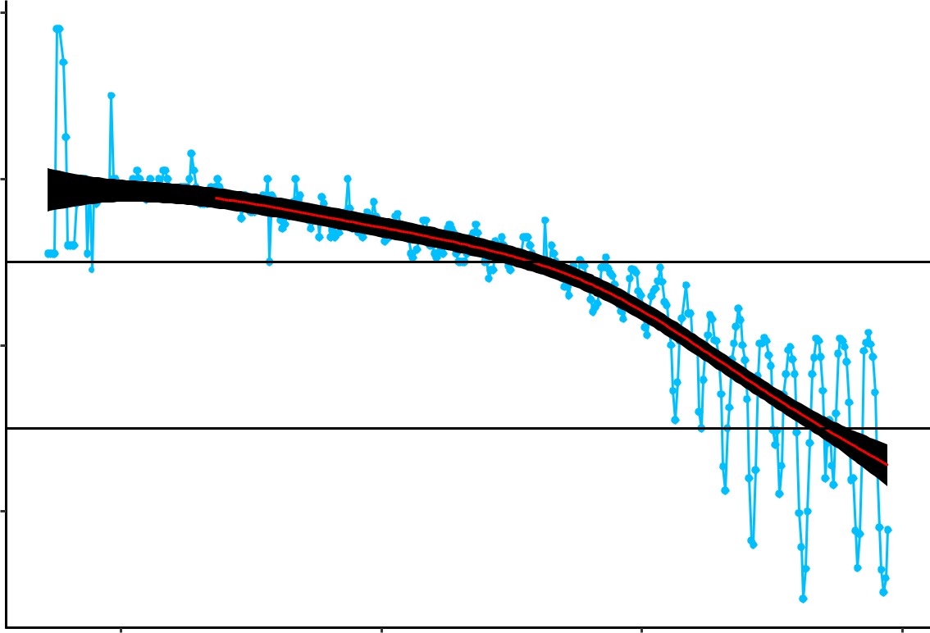

|  |  |  |  |  |
| --- | --- | --- | --- | --- |
|  | 6.2 |  |  |  |
|  | 6.0 |  |  |  |
| ( )mAHD | Current |  |  |  |
| Level | 5.8 |  |  |  |
| Water |  |  |  |  |
|  | Proposed |  |  |  |
|  | 5.6 |  |  |  |
|  | 1990 | 2000 | 2010 | 2020 |
|  |  |  | Year |  |

Figure 21: Surface water levels recorded at staﬀ gauge 6162565 for Lake Yonderup. Red segments along trendline indicate preiods of significant decline in groundwater levels and blue segments represent significant increases in groundwater level.

40

|  |
| --- |
| 41 |

2000



2005 A

2010

2015



|  |  |  |  |
| --- | --- | --- | --- |
|  | 2000 |  |  |
|  | 2005 | B |  |
|  | 2010 |  |
|  |  |  |
| Year | 2015 |  |  |
| 2000 |  |  |
|  |  |  |
|  | 2005 | C |  |
|  | 2010 |  |
|  |  |  |
|  | 2015 |  |  |

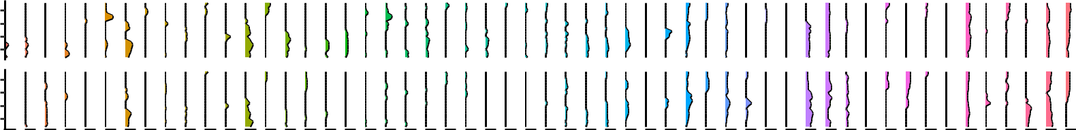

2000

2005 D

2010

2015

Cover Abundance

Figure 22: Cover abundances for each species across the four plots (A, B, C, D) at the Lake Yonderup transect. Invasive species are denoted by ‘X’.

Only the most common species are included.

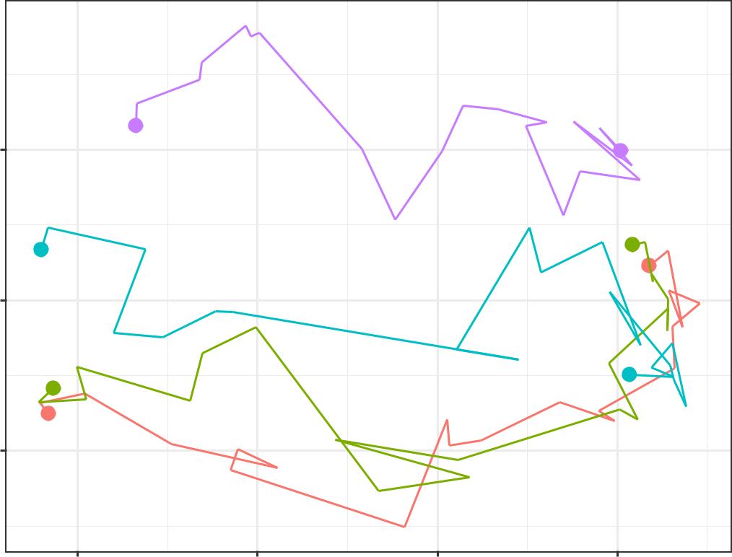

|  |  |  |  |  |  |  |  |  |
| --- | --- | --- | --- | --- | --- | --- | --- | --- |
|  | 1 | 1997 |  |  |  |  |  |  |
|  |  |  |  | 2018 |  |  |  |
|  |  |  |  |  |  |  |  |
|  |  |  |  |  |  | Plot |  |  |
|  |  |  |  |  | 2018 | a | A |  |
|  |  | 1997 |  |  |  |  |
| LV2 |  |  |  | 2018 | a | B |  |
| 0 |  |  |  |  |
|  |  |  |  |  | a | C |  |
|  |  |  |  |  |  |  |
|  |  |  |  |  | 2018 | a | D |  |
|  |  | 1997 |  |  |  |  |  |
|  |  |  |  |  |  |  |  |
|  |  | 1997 |  |  |  |  |  |  |
|  | −1 |  |  |  |  |  |  |  |
|  |  | −2 | −1 | 0 | 1 |  |  |  |
|  |  |  |  | LV1 |  |  |  |  |



Figure 23: Unconstrained ordination based on the latent variable model for each surveyed year for Lake Yonderup. Plots are represented as diﬀerent colours and consecutive years are joined by a line with first and last survey years labeled.

42

|  |
| --- |
| Species |

Xanthorrhoea_preissii

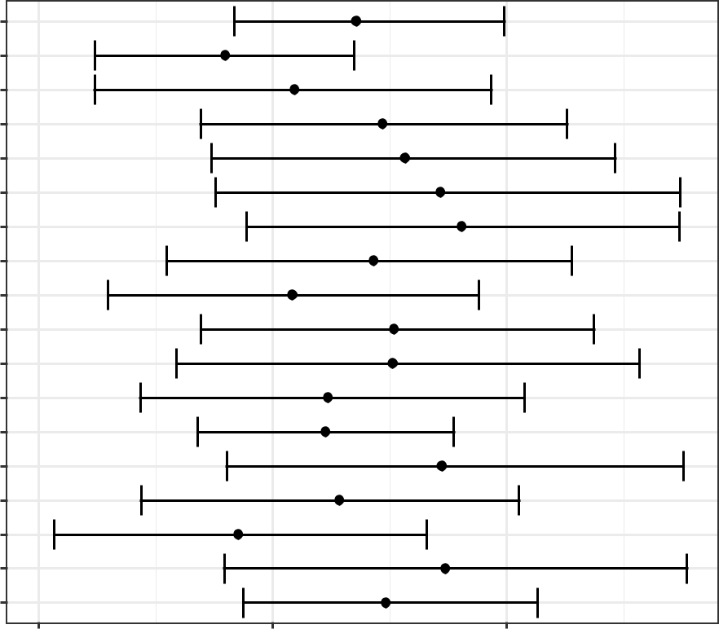

Spyridium_globulosum

Rhagodia_baccata

Opercularia_hispida

Myoporum_caprarioides

Melaleuca_preissiana

Macrozamia_sp_

Lobelia_alata

Lepidosperma_gladiatum

Lachnagrostis_filiformis

Juncus_pallidus

Hardenbergia_comptoniana

Gahnia_trifida

Epilobium_billardierianum

Cassytha_racemosa

Banksia_littoralis

Banksia_attenuata

Acacia_saligna

0 2 4

Posterior Mean

Figure 24: Estimated mean regression coeﬃcients (dots) and 95% credible intervals (bars) for eﬀect of groundwater levels at Lake Yonderup on vegetation species cover abundances based on Bayesian Regression Analysis (HUI REF 2015). Species with a negative mean posterior value are likely to increase in cover abundance as water levels decline. Only those species with coeﬃcients significanlty diﬀerent to zero are shown.

43

|  |
| --- |
| 44 |

1995



2000

2005

|  |
| --- |
| Year |

2010

2015

Abundance

Figure 25: Cover abundances for each aquatic macroinvertebrate familiy at Lake Yonderup.

Table 7: Ecological consequences of revised thresholds in terms of compliance of stated site values and site management objectives at Lake Yonderup.

|  |  |  |  |
| --- | --- | --- | --- |
|  |  | Likely eﬀect of 2030 revised |  |
|  |  | thresholds | Future Compliance |
|  | |  |  |
|  | **Site values** |  |  |
| * High ecological values due to | |  |  |
| undisturbed nature | |  |  |
| * Rich invertebrate fauna | |  | No |
| * Excellent water quality | |  | At risk |
| * Undisturbed hydrologic regime and | | Seasonal variation has increased | No |
| lack of seasonal variation | | with declining water levels |  |
| * *Banksia* woodland <8m depth to | |  |  |
| groundwater | |  |  |

**Site management objectives**

* Maintain the environmental quality of the lake
* Maintain the existing hydrological regime

**Lake Joondalup**

At 611.5 ha, Lake Joondalup is the largest monitored wetland and is managed by the Department of Biodiversity, Conservation and Attractions. The lake is an important habitat and drought refuge for water birds, and in conjunction with Lake Goollelal, is managed to support the full range of avian habitats (Water Authority of Western Australia, 1995). Other management objectives include the conservation of diverse wetland vegetation communities, including sedge beds, fringing woodlands and aquatic macrophytes, and the maintenance or enhancement of aquatic fauna in the lake. Lake Joondalup supports an important population of Pygmy Perch (*Edelia vittata*) and Swan River Goby (*Pseudogobius olorum*) and the fringing woodlands and bushland support a variety of significant mammal species.

**Hydrology and water quality**

Lake Joondalup has remained permanently inundated at the staﬀ gauge since 1986 (Horwitz et al., 2009). However, vast regions of the basin dry most summers and provide habitat for visiting water birds. Recent monitoring of surface water levels at the staﬀ gauge 6162572 remained relatively stable from 2002 but have been increasing from 16.4 mAHD to approximately 17.2 mAHD in 2019 (Figure 28). Five-year summaries of hydrological regimes at Lake Joondalup also reveal the higher mean minimum and maximum surface water levels in the latest period compared to earlier periods, as well as an increase in the number of days to reach seasonal minimum water levels (Table 8). Historically, groundwater levels at monitoring bore 61610661 declined significantly by 1.2 m from 1970 to 2002. Currently, groundwater levels at this bore, as well as bore 61611423 (likely to better reflect lake surface water variation), have been increasing since 2015 to levels similar to the early 1990s.

Recent monitoring suggests pH has been increasing from 6.8 in 2016 up to 8.4 in 2018, probably attributable the higher water levels (Judd and Horwitz, 2019). The lake often has the lowest levels of acidity and highest alkalinity of all the monitored wetlands. Total nitrogen and phosphorus levels have been high in Lake Joondalup, which is now typical of Spearwood dune lakes in modified urban landscapes.

45

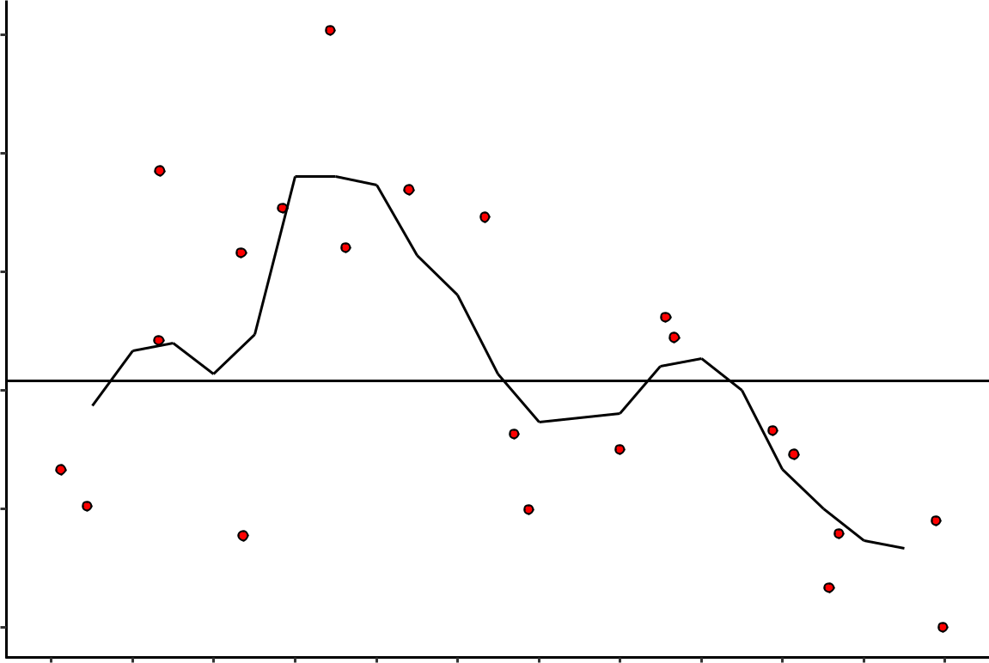

|  |  |  |  |  |  |  |  |  |  |  |  |  |  |
| --- | --- | --- | --- | --- | --- | --- | --- | --- | --- | --- | --- | --- | --- |
|  | 40 |  |  |  |  |  |  |  |  |  |  |  |  |
|  | 35 |  |  |  |  |  |  |  |  |  |  |  |  |
| richness | 30 |  |  |  |  |  |  |  |  |  |  |  |  |
|  |  |  |  |  |  |  |  |  |  |  |  |  |
| Family | 25 |  |  |  |  |  |  |  |  |  |  |  |  |
|  |  |  |  |  |  |  |  |  |  |  |  |  |
|  | 20 |  |  |  |  |  |  |  |  |  |  |  |  |
|  | 15 |  |  |  |  |  |  |  |  |  |  |  |  |
|  | 1996 | 1998 | 2000 | 2002 | 2004 | 2006 | 2008 | 2010 | 2012 | 2014 | 2016 | 2018 |  |
|  |  |  |  |  |  | Year | |  |  |  |  |  |  |

Figure 26: Richness of aquatic invertebrate families for each year at Lake Yonderup. Line is a moving 3-year averavge.

46

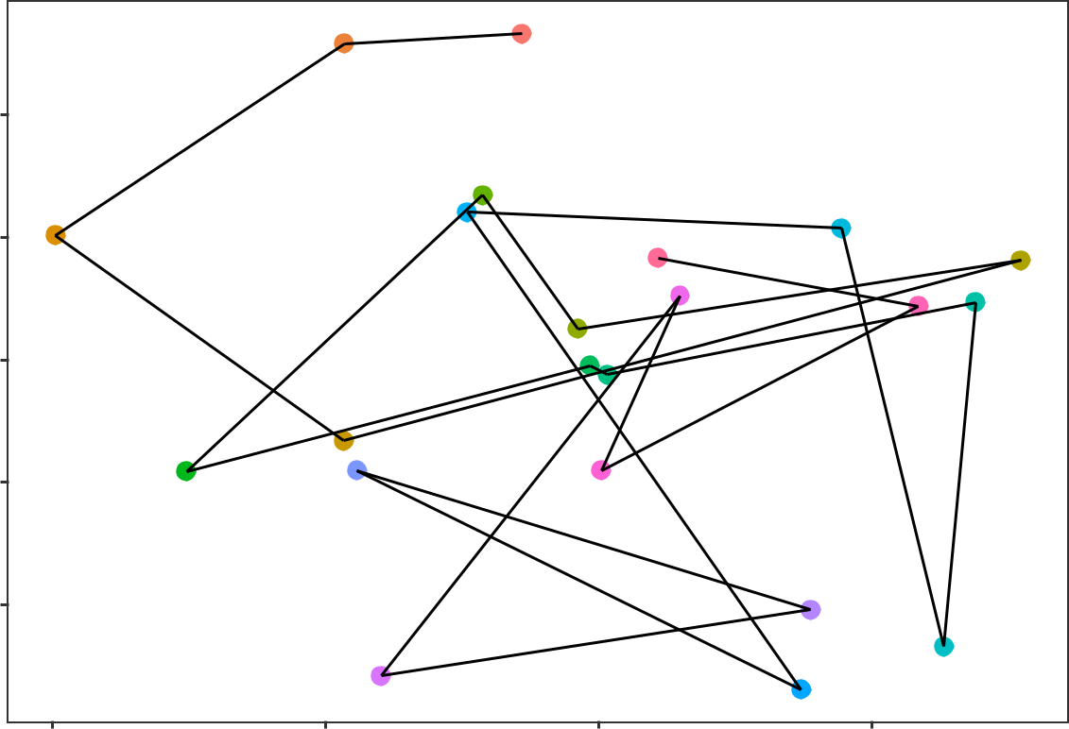

|  |  |  |  |  |  |
| --- | --- | --- | --- | --- | --- |
|  |  |  | 1996 |  |  |
|  | 0.2 |  |  |  |  |
|  | 0.1 |  |  |  |  |
|  |  |  | 2018 |  |  |
| LV2 | 0.0 |  |  |  |  |
|  |  |  |  |  |
|  | −0.1 |  |  |  |  |
|  | −0.2 |  |  |  |  |
|  | −0.4 | −0.2 | 0.0 | 0.2 |  |
|  |  |  | LV1 |  |  |

Figure 27: Unconstrained ordination based on invertebrate data for each surveyed year for Lake Yonderup.

Consecutive years are joined by a line with first and last survey years labeled.

47

**Vegetation Dynamics**

Vegetation surveys have been conducted along a northern (Figure 29) and southern (Figure 30) transect at Lake Joondalup since 1996 and were last surveyed in 2015. *Melaleuca raphiophylla* dominates the overstorey of plots in the northern transect while exotic species are abundant in the understory vegetation. There has been an increasing trend in cover abundance of the exotics *Bromus diandrus*, *Ehrharta longiflora*, *Euphorbia* *terracina*, *Fumaria muralis* and *Peargonium capitatum* in recent years. Fires in 2003 reduced the canopycondition and abundance of *M. raphiophylla* in the southern transect, and despite the slightly higher cover abundance of native species, native and exotic species richness is equal along the transect. The site also contains healthy stands of *Baumea articulate* in the submerged regions of the transect.

All plots in both transects have displayed similar trends in community compositional change during the survey periods (Figure 31). In the southern transect, latent model ordination reveals separation of the plots along the first axis, with a general temporal trend along the second axis, except for a period around 2003

* 2006 where there was a hiatus. This hiatus may be associated with the 2003 bushfire and represents a recovery period where species composition changed little. The trajectory for plot A is diﬀerent, however, as the trend away from the original 1996 survey has reversed and the contemporary community is now becoming more like the 1996 communities. Similar patterns have been observed in the northern transect despite the transect not being impacted by the 2003 fire event. A number of native species are likely to increase in cover abundance at the transects if water levels remain at present levels or increase further, including *Baumea* *articulata* (Figure 32). Other natives are likely to decline in cover abundance under a similar scenario of highwater levels, including a number of *Acacia saligna*, *Banksia menziesii* and *Banksia prionotes*.

**Aquatic Invertebrates**

Aquatic invertebrates have been sampled from Lake Joondalup every year since 1996. During this period, 16-30 families of aquatic invertebrates have been recorded per sampling event, except for the latest round in 2018 where family richness was only nine (Figure 34). This exceptionally low family richness was likely due to the lack of insects and associated parasitic mites among the sampled communities. The phreatoicid isopod *Amphisopus palustris* was also absent in 2018 despite being collected every spring in Lake Joondalup (expect2004 ; Figure 33). Furthermore, this reduced richness occurred during a period of relatively high surface water levels, suggesting other anthropogenic factors may be responsible for the decline of insect fauna within the lake. Otherwise, the lake hosts abundant populations of Ceinidae (amphipods), *Palaemonetes australis* (crustacean), *Calanoid copepods* and Cyprididae (ostracods). There is high variation in the composition of annual macroinvertebrate community composition making it diﬃcult to interpret a trajectory of compositional change (Figure 35). There has been a general trend of community composition shifting away from the initial 1996 community.

**Revised water level threshold eﬀects**

The water levels in the vicinity of Lake Joondalup are expected to increase up to 2.1 m by 2030 from 2013 levels based on the revised groundwater allocations. This increase in water level will continue the increasing trend being observed in the lake’s surface water levels since 2015. Maintaining surface water levels above 16.2 mAHD at staﬀ 6162572 will ensure permanent water habitat for fauna and flora and the visual amenity of the area (Table 9). The diverse macrophytes inhabiting plot A and B of both transects are likely to persist and continue to provide a rich habitat for aquatic vertebrates. Although important native macrophytes and wetland species are likely to continue at relatively high cover abundances under the future scenario, there are some native species that are likely to decrease in cover abundance or disappear. This group mainly includes *Acacia* and *Banksia* species which provide important habitat for fauna up-slope of the lake. Further vegetation monitoring is required at these transects to determine vegetation compositional changes since 2015 to understand if the trajectory in compositional change is continuing.

48

|  |  |  |  |  |  |  |
| --- | --- | --- | --- | --- | --- | --- |
|  | 18.0 |  |  |  |  |  |
|  | 17.5 |  |  |  |  |  |
| ( )mAHD | 17.0 |  |  |  |  |  |
|  |  |  |  |  |  |
| Level |  |  |  |  |  |  |
| Water | 16.5 |  |  |  |  |  |
|  |  |  |  |  |  |
|  | Proposed |  |  |  |  |  |
|  | 16.0 |  |  |  |  |  |
|  | Current |  |  |  |  |  |
|  | 1980 | 1990 | 2000 | 2010 | 2020 |  |
|  |  |  | Year |  |  |  |

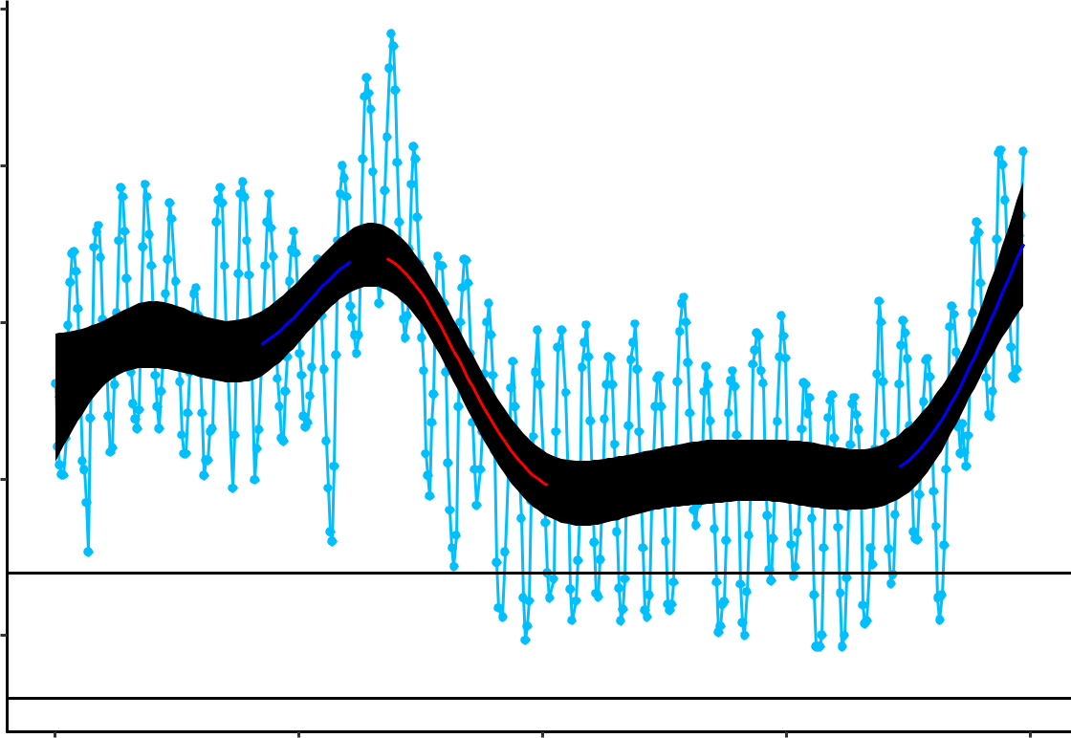

Figure 28: Surface water levels recorded at staﬀ gauge 6162572 for Lake Joondalup. Red segments along trendline indicate preiods of significant decline in groundwater levels and blue segments represent significant increases in groundwater level.

49

Table 8: Five year summaries of surface water level data at Lake Joondalup

|  |  |  |  |  |  |  |  |
| --- | --- | --- | --- | --- | --- | --- | --- |
| Period | Mean max seasonal | Mean min seasonal | Mean seasonal change | Month of | Month of | Mean max to |  |
| level (mAHD) | level (mAHD) | (m) | maximum | minimum | min (days) |  |
|  |  |
|  |  |  |  |  |  |  |  |
| 08/1994 - 07/1999 | 17.2 | 16.2 | 0.96 | September | April | 213 |  |
| 08/1999 - 07/2004 | 17.0 | 16.1 | 0.92 | October | April | 179 |  |
| 08/2004 - 07/2009 | 16.9 | 16.1 | 0.79 | October | April | 181 |  |
| 08/2009 - 07/2014 | 16.9 | 16.1 | 0.82 | October | March | 173 |  |
| 08/2014 - 07/2019 | 17.2 | 16.5 | 0.68 | October | April | 206 |  |
|  |  |  |  |  |  |  |  |

50

|  |
| --- |
| 51 |

|  |  |  |  |  |  |  |  |  |  |  |  |  |  |  |  |  |  |  |  |  |  |  |  |  |
| --- | --- | --- | --- | --- | --- | --- | --- | --- | --- | --- | --- | --- | --- | --- | --- | --- | --- | --- | --- | --- | --- | --- | --- | --- |
| X Bromus diandrus__ | X Cynodon dactylon__ | X Ehrharta calycina__ | X Ehrharta longiflora__ | X Euphorbia terracina__ | X Celery like__ | X Ficus carica__ | X Fumaria capreolata__ | X Paspalum distichum__ | X Pelargonium capitatum__ | X Phyla nodiflora__ | X Solanum sp__ | X Solanum nigrum__ | X Sonchus oleraceus__ | Acacia cyclops_ | Acacia saligna_ | Austrostipa compressa_ | Banksia prionotes_ | Baumea articulata_ | Baumea juncea_ | Dichopogon capillepes_ | Jacksonia furcellata_ | Lepidosperma longitudinale_ | Melaleuca rhaphiophylla_ | Poaceae sp_ |
| 2000 |  |  |  |  |  |  |  |  |  |  |  |  |  |  |  |  |  |  |  |  |  |  |  |  |
| 2005 |  |  |  |  |  |  |  |  |  |  |  |  |  |  |  |  |  |  |  |  |  |  |  | A |
| 2010 |  |  |  |  |  |  |  |  |  |  |  |  |  |  |  |  |  |  |  |  |  |  |  |  |
| 2015 |  |  |  |  |  |  |  |  |  |  |  |  |  |  |  |  |  |  |  |  |  |  |  |  |

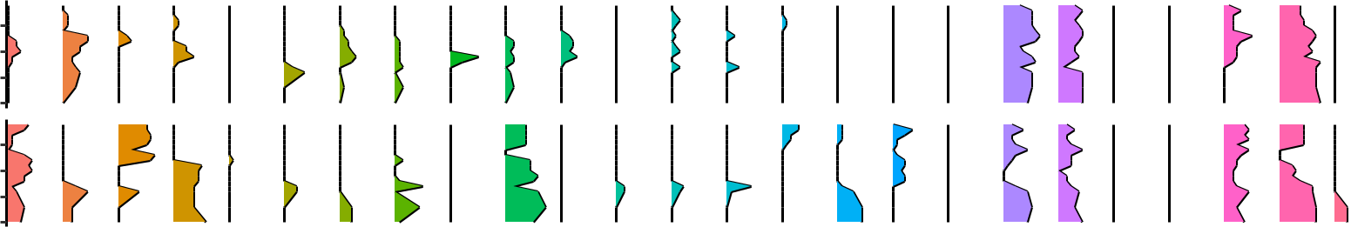

|  |  |  |  |
| --- | --- | --- | --- |
| Year | 2000 |  |  |
| 2005 | B |  |
|  |  |
|  | 2010 |  |  |
|  | 2015 |  |  |
|  | 2000 |  |  |
|  | 2005 | C |  |
|  | 2010 |  |  |
|  | 2015 |  |  |



Cover Abundance

Figure 29: Cover abundances for each species across the four plots (A, B, C, D) at the northern Lake Joondalup transect. Invasive species are denoted by ‘X’. Only the most common species are included.

|  |
| --- |
| 52 |

|  |  |  |  |  |  |  |  |  |  |  |  |  |  |  |  |  |  |  |  |  |  |  |  |  |  |  |  |  |  |  |  |  |  |  |  |  |  |  |  |  |  |  |  |  |  |
| --- | --- | --- | --- | --- | --- | --- | --- | --- | --- | --- | --- | --- | --- | --- | --- | --- | --- | --- | --- | --- | --- | --- | --- | --- | --- | --- | --- | --- | --- | --- | --- | --- | --- | --- | --- | --- | --- | --- | --- | --- | --- | --- | --- | --- | --- |
|  | X Avena barbarta | X Bromus diandrus | X Conyza bonariensis | X Conyza albida | X Cynodon dactylon | X Cyperus sp_ | X Ehrharta calycina | X Ehrharta longiflora | X Euphorbia peplus | X Ficus carica | X Fumaria capreolata | X Fumaria muralis | X Gladiolus caryophyllaceus | X Paspalum distchum | X Pelargonium capitatum | X Pentaschistis airoides | X Phyla nodiflora | X Solanum laciniatum | X Solanum nigrum | X Sonchus asper | X Sonchus oleraceus | X Symphyotrichum squamatum | Acacia saligna | Banksia attenuata | Banksia menziesii | Banksia prionotes | Baumea articulata | Centella asiatica | Centella cordifolia | Dianella divaricata | Hakea trifurcata | Isolepis sp | Jacksonia furcellata | Lachnagrostis filiformis | Lemna disperma | Lobelia alata | Macrozamia riedlei | Melaleuca rhaphiophylla | Myoporum caprarioides | Rhagodia baccata | Solanum symonii | Spyridium globulosum | Submerged macrophyte | Villarsia capitata |  |
|  | 2000 |  |  |  |  |  |  |  |  |  |  |  |  |  |  |  |  |  |  |  |  |  |  |  |  |  |  |  |  |  |  |  |  |  |  |  |  |  |  |  |  |  |  |  |  |
|  | 2005 |  |  |  |  |  |  |  |  |  |  |  |  |  |  |  |  |  |  |  |  |  |  |  |  |  |  |  |  |  |  |  |  |  |  |  |  |  |  |  |  |  |  | A |  |
|  | 2010 |  |  |  |  |  |  |  |  |  |  |  |  |  |  |  |  |  |  |  |  |  |  |  |  |  |  |  |  |  |  |  |  |  |  |  |  |  |  |  |  |  |  |  |  |
|  | 2015 |  |  |  |  |  |  |  |  |  |  |  |  |  |  |  |  |  |  |  |  |  |  |  |  |  |  |  |  |  |  |  |  |  |  |  |  |  |  |  |  |  |  |  |  |
|  | 2000 |  |  |  |  |  |  |  |  |  |  |  |  |  |  |  |  |  |  |  |  |  |  |  |  |  |  |  |  |  |  |  |  |  |  |  |  |  |  |  |  |  |  |  |  |
|  | 2005 |  |  |  |  |  |  |  |  |  |  |  |  |  |  |  |  |  |  |  |  |  |  |  |  |  |  |  |  |  |  |  |  |  |  |  |  |  |  |  |  |  |  | B |  |
| Year | 2010 |  |  |  |  |  |  |  |  |  |  |  |  |  |  |  |  |  |  |  |  |  |  |  |  |  |  |  |  |  |  |  |  |  |  |  |  |  |  |  |  |  |  |  |  |
| 2015 |  |  |  |  |  |  |  |  |  |  |  |  |  |  |  |  |  |  |  |  |  |  |  |  |  |  |  |  |  |  |  |  |  |  |  |  |  |  |  |  |  |  |  |  |
|  |  |  |  |  |  |  |  |  |  |  |  |  |  |  |  |  |  |  |  |  |  |  |  |  |  |  |  |  |  |  |  |  |  |  |  |  |  |  |  |  |  |  |  |  |
|  | 2000 |  |  |  |  |  |  |  |  |  |  |  |  |  |  |  |  |  |  |  |  |  |  |  |  |  |  |  |  |  |  |  |  |  |  |  |  |  |  |  |  |  |  |  |  |
|  | 2005 |  |  |  |  |  |  |  |  |  |  |  |  |  |  |  |  |  |  |  |  |  |  |  |  |  |  |  |  |  |  |  |  |  |  |  |  |  |  |  |  |  |  | C |  |
|  | 2010 |  |  |  |  |  |  |  |  |  |  |  |  |  |  |  |  |  |  |  |  |  |  |  |  |  |  |  |  |  |  |  |  |  |  |  |  |  |  |  |  |  |  |  |  |
|  | 2015 |  |  |  |  |  |  |  |  |  |  |  |  |  |  |  |  |  |  |  |  |  |  |  |  |  |  |  |  |  |  |  |  |  |  |  |  |  |  |  |  |  |  |  |  |
|  | 2000 |  |  |  |  |  |  |  |  |  |  |  |  |  |  |  |  |  |  |  |  |  |  |  |  |  |  |  |  |  |  |  |  |  |  |  |  |  |  |  |  |  |  |  |  |
|  | 2005 |  |  |  |  |  |  |  |  |  |  |  |  |  |  |  |  |  |  |  |  |  |  |  |  |  |  |  |  |  |  |  |  |  |  |  |  |  |  |  |  |  |  | D |  |
|  | 2010 |  |  |  |  |  |  |  |  |  |  |  |  |  |  |  |  |  |  |  |  |  |  |  |  |  |  |  |  |  |  |  |  |  |  |  |  |  |  |  |  |  |  |  |  |
|  | 2015 |  |  |  |  |  |  |  |  |  |  |  |  |  |  |  |  |  |  |  |  |  |  |  |  |  |  |  |  |  |  |  |  |  |  |  |  |  |  |  |  |  |  |  |  |

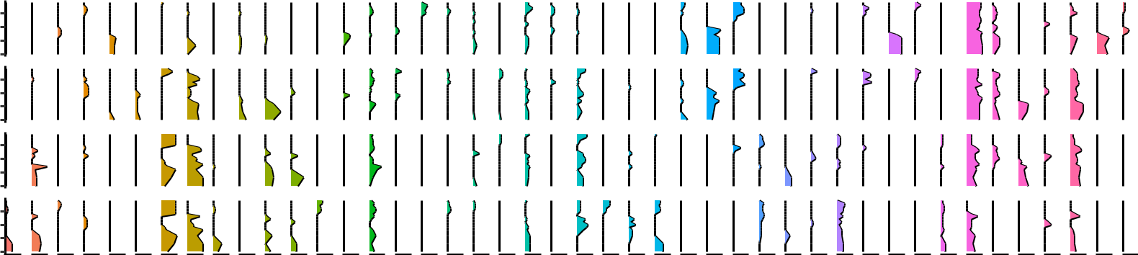

Cover Abundance

Figure 30: Cover abundances for each species across the four plots (A, B, C, D) at the southern Lake Joondalup transect. Invasive species are denoted by ‘X’. Only the most common species are included.

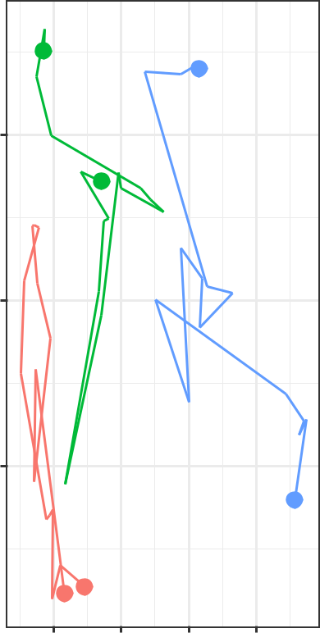

|  |  |  |  |  |  |
| --- | --- | --- | --- | --- | --- |
|  | 2015 | | 2015 | |  |
|  |  |  |  |
|  | 1 |  |  |  |  |
|  |  | 1996 |  |  |  |
| LV2 | 0 |  |  |  |  |
|  |  |  |  |  |
|  | −1 |  |  |  |  |
|  |  |  |  | 1996 |  |
|  |  | 1996 |  |  |  |
|  | 2015 | |  |  |  |
|  | −1 | 0 | 1 | 2 |  |
|  |  |  | LV1 |  |  |

|  |  |  |  |  |  |  |  |  |  |
| --- | --- | --- | --- | --- | --- | --- | --- | --- | --- |
|  |  |  |  |  | 2015 |  |  |  |  |
|  |  |  |  | 2015 |  |  |  |  |  |
|  |  | 1 |  |  |  | 2015 |  |  |  |
|  |  |  |  |  |  |  |  |  |
| Plot |  |  |  |  |  |  | Plot |  |  |
|  |  |  |  |  |  | a | A |  |
| a | A | 0 |  |  |  |  |  |
| LV2 |  |  |  |  | a | B |  |
| a | B |  |  |  |  |  |
|  |  |  |  |  |  |
|  |  |  |  |  | a | C |  |
| a | C |  |  |  |  |  |  |
|  |  | 1996 |  |  | a | D |  |
|  |  |  |  |  |  |  |
|  |  | −1 |  |  | 1996 | 2015 | |  |  |
|  |  |  |  |  |  |  |  |
|  |  |  |  |  |  | 1996 |  |  |  |
|  |  | −2 | 1996 | |  |  |  |  |  |
|  |  |  |  |  |  |  |  |  |
|  |  |  | −2 | −1 | 0 | 1 | 2 |  |  |
|  |  |  |  |  | LV1 |  |  |  |  |

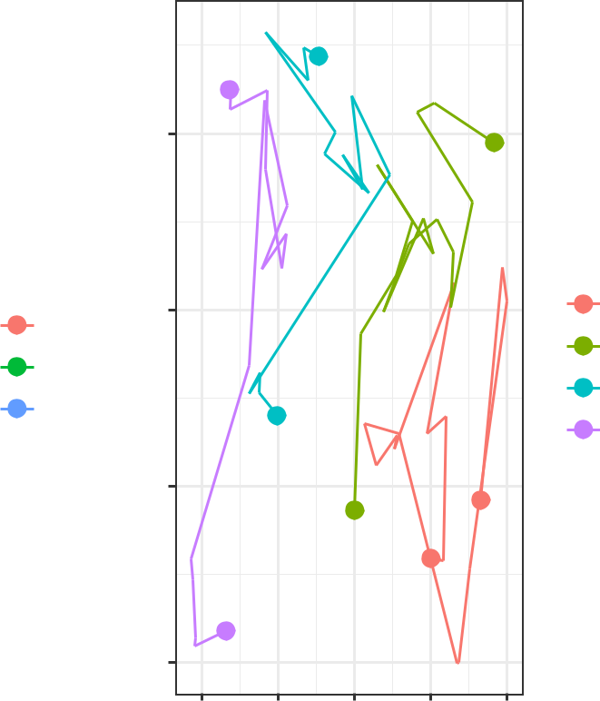

Figure 31: Unconstrained ordination based on the latent variable model for each surveyed year for the northern (left) and southern (right) Lake Joondalup transects. Plots are represented as diﬀerent colours and consecutive years are joined by a line with first and last survey years labeled.

53

|  |
| --- |
| Species |

X_Phyla_nodiflora

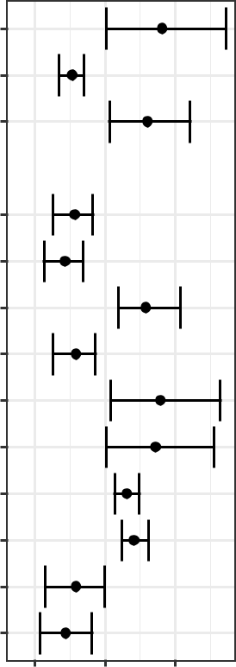

X_Pelargonium_capitatum

X_Ficus_carica

X_Euphorbia_terracina 

X_Ehrharta_longiflora

X_Ehrharta_calycina

X_Cynodon_dactylon

X_Bromus_diandrus

Triglochin_sp

Cotula_coronopifolia

Baumea_juncea

Baumea_articulata

Austrostipa_compressa

Acacia_saligna

−2 0 2

Posterior Mean

|  |
| --- |
| Species |

X_Phyla_nodiflora

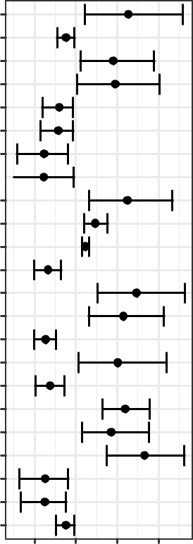

X_Pelargonium_capitatum

X_Orobanche_minor

X_Ficus_carica

X_Ehrharta_longiflora

X_Ehrharta_calycina

X_Bromus_diandrus

X_Avena_barbarta 

Villarsia_capitata

Myoporum_caprarioides

Melaleuca_rhaphiophylla

Macrozamia_riedlei

Lobelia_alata

Lachnagrostis_filiformis

Jacksonia_furcellata

Hibbertia_sp_

Dianella_divaricata

Centella_cordifolia

Centella_asiatica

Baumea_articulata

Banksia_prionotes

Banksia_menziesii

Acacia_saligna

−2.5 0.0 2.5 5.0

Posterior Mean

Figure 32: Estimated mean regression coeﬃcients (dots) and 95% credible intervals (bars) for eﬀect of groundwater levels at the northern (left) and southern (right) Lake Joondalup transects on vegetation species cover abundances based on Bayesian Regression Analysis (HUI REF 2015). Species with a negative mean posterior value are likely to increase in cover abundance as water levels decline and species with positive values are likely to increase in cover abundance when water levels increase. Only those species with coeﬃcients significanlty diﬀerent to zero are shown.

54

|  |
| --- |
| 55 |

1995



2000

2005

|  |
| --- |
| Year |

2010

2015

Abundance

Figure 33: Cover abundances for each aquatic macroinvertebrate familiy at Lake Joondalup.

Table 9: Ecological consequences of revised thresholds in terms of compliance of stated site values and site management objectives at Lake Joondalup.

|  |  |  |  |  |
| --- | --- | --- | --- | --- |
|  |  | Likely eﬀect of 2030 revised |  |  |
|  |  | thresholds | Future Compliance |  |
|  | |  |  |  |
|  | **Site values** |  |  |  |
| Water bird habitat and drought refuge | | The proposed increases in | Yes |  |
|  |  | groundwater levels around the lake |  |  |
|  |  | will ensure the site remains an |  |  |
|  |  | important water bird habitat. The |  |  |
|  |  | proposed increases will also ensure |  |  |
|  |  | the lake is permanently inundated, |  |  |
|  |  | which will ensure the lake is a |  |  |
|  |  | drought refuge for water birds. |  |  |
| Diverse range of macrophytes | | The current diversity of | Yes |  |
|  |  | macrophytes, including *B.* |  |  |
|  |  | *articulata*, *B. juncea* and *L.* |  |  |
|  |  | *longitudinale*, will continue. There |  |  |
|  |  | is the possibility of these species |  |  |
|  |  | extending into current terrestrial |  |  |
| **Site management objectives** | | regions of the lake. |  |  |
|  |  |  |
| Conservation and public enjoyment of | |  | Yes |  |
| natural and modified landscapes | |  |  |  |
| Conserve existing wetland vegetation, | | The predicted increases in | Yes |  |
| including sedge beds, fringing | | groundwater levels will ensure the |  |  |
| woodland and aquatic macrophytes | | current wetland at a state similar |  |  |
|  |  | to 2015. It is possible that |  |  |
|  |  | sustained increases in groundwater |  |  |
|  |  | levels will extend the range of these |  |  |
|  |  | species around the lake by |  |  |
| Maintain and if possible, enhance the | | ‘migrating’ up slope. |  |  |
|  |  |  |
| aquatic fauna of the lake | |  |  |  |
| In conjunction with Lake Goollelal, to | | The maintenance of permanent | Yes |  |
| support the full range of habitats for | | surface water and wetland |  |  |
| avian fauna | | vegetation will continue to provide |  |  |
|  |  | a diverse habitat for diﬀerent avian |  |  |
|  |  | species. [NEED TO COMMENT |  |  |
| Ensure the landscape and amenity | | ON AQ INVERTS AS FOOD] | Yes |  |
|  |  |
| values of the lake are maintained, | |  |  |  |
| except under very low rainfall climatic | |  |  |  |
| conditions | |  |  |  |
|  |  |  |  |  |

56

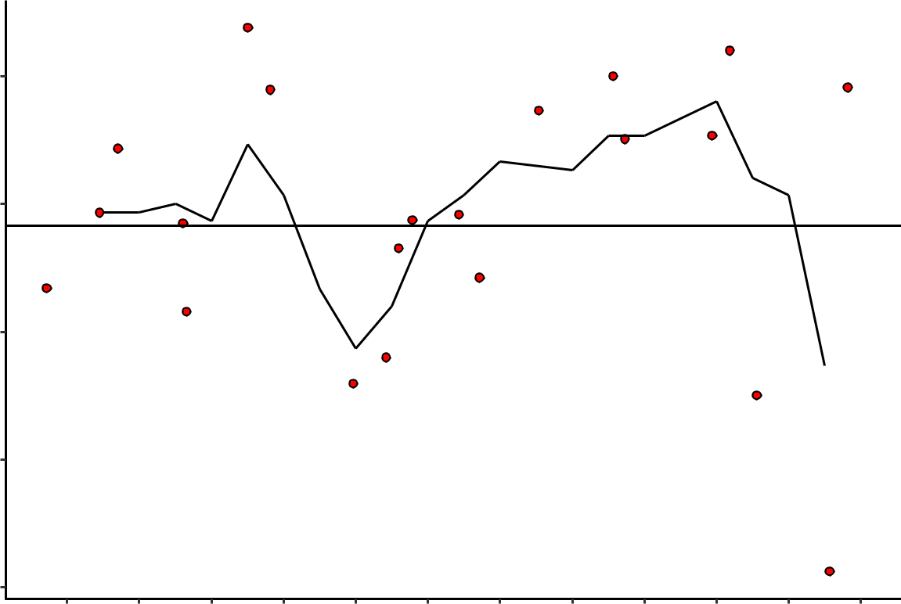

|  |  |  |  |  |  |  |  |  |  |  |  |  |  |
| --- | --- | --- | --- | --- | --- | --- | --- | --- | --- | --- | --- | --- | --- |
|  | 30 |  |  |  |  |  |  |  |  |  |  |  |  |
|  | 25 |  |  |  |  |  |  |  |  |  |  |  |  |
| richness |  |  |  |  |  |  |  |  |  |  |  |  |  |
| Family | 20 |  |  |  |  |  |  |  |  |  |  |  |  |
|  |  |  |  |  |  |  |  |  |  |  |  |  |
|  | 15 |  |  |  |  |  |  |  |  |  |  |  |  |
|  | 10 |  |  |  |  |  |  |  |  |  |  |  |  |
|  | 1996 | 1998 | 2000 | 2002 | 2004 | 2006 | 2008 | 2010 | 2012 | 2014 | 2016 | 2018 |  |
|  |  |  |  |  |  | Year |  |  |  |  |  |  |  |

Figure 34: Richness of aquatic invertebrate families for each year at Lake Joondalup. Line is a moving 3-year averavge.

57

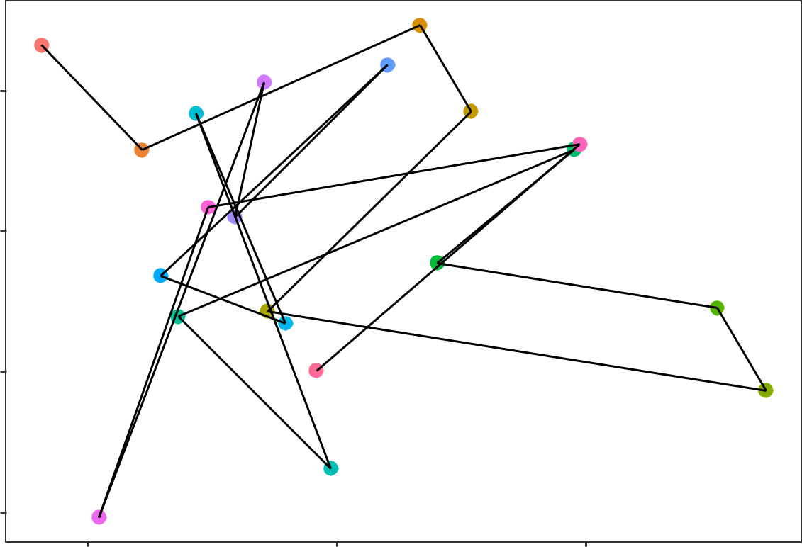

|  |  |  |  |
| --- | --- | --- | --- |
| 1996 |  |  |  |
| 0.1 |  |  |  |
| 0.0 |  |  |  |
| LV2 |  |  |  |
| −0.1 | 2018 |  |  |
|  |  |  |
| −0.2 |  |  |  |
| −0.1 | 0.0 | 0.1 |  |
|  |  | LV1 |  |

Figure 35: Unconstrained ordination based on invertebrate data for each surveyed year for Lake Joondalup.

Consecutive years are joined by a line with first and last survey years labeled.

58

**Lake Mariginiup**

Lake Mariginiup has a high conservation value as a groundwater dependent wetland (R Froend, R. C. Loomes, et al., 2004). There are a number of wader birds present at the lake that require the shallow water during the summer for feeding, however, high water levels are required in winter to prevent vegetation encroachment into these habitats. The dramatic decline in surface and groundwaters has likely diminished this important component of the system. Sediment processes have been altered as soils dry and water quality is deteriorating due to acidification (Judd and Horwitz, 2019).

**Hydrology and water quality**

Since 1997, Lake Mariginiup has frequently dried or been dry at the staﬀ gauge 6162577 during the summer. Interpretations of seasonal patterns therefore need to be made with caution and perhaps it is more reliable to use groundwater levels at the nearby bore 616100685 as a proxy (Figure 36). Nonetheless, mean season maximum water levels have declined from 42.0 m to 41.4 m since the 1994-1999 period (Table **??**). Maximum water levels usually occur in September/October. There has been a recent increase in groundwater level since 2015 which has caused maximum spring surface levels to increase. Proposed changes in 2030 abstraction are projected to increase surface water levels by 3.9 m and meet a threshold level of 42.1 mAHD. This will increase surface waters to levels higher than has been recorded during the monitoring program.

Acidification has eﬀected the water quality at Lake Mariginiup. Since 2005, the pH of the surface water has consistently been below 4.0 with only 2018 levels slightly higher (4.3; Judd and Horwitz (2019)). Alkalinity is below 1 mg/L suggesting that the lake has lost its capacity to buﬀer changes in pH. Recent changes in acidification are likely due to the rises in surface waters since 2015 that has helped reduce the sulphate concentrations. Ammonia and total nitrogen levels of Lake Mariginiup are the highest of any lake monitored on the Swan Coastal Plain. Recent total phosphorous levels have doubled and make Lake Mariginiup one of the highest phosphorous wetlands.

**Vegetation dynamics**

Vegetation composition and shifts in composition are similar along the length of the transect at Lake Mariginiup which was established in 1996 (Figure 37). *Baumea articulata* was present at high cover abundance throughout the transect until the early 2000’s, but has since disappeared as surface water levels declined. *Eucalyptus rudis* has declined in the lower parts of the plots and *Melaleuca rhaphiophyla* is no longer present at the transect. There has been a general increase in the cover abundances of exotics throughout the monitoring period. There was a shift in community composition at all three plots around 2005 which was driven by increases in

*Exocarpus sparteus* and *Jacksonia furcellata* and some exotics, such as *Ehrharta calycina*, *Ehrhatah longiflora*, *Lotus suaveolens* and *Ursinnia anthemoides*.

Regression analysis reveals a number of native species that will increase in cover abundance with increasing surface water levels (Figure 39). Species likely to increase in cover abundance include *Angianthus* sp.,

*Epilobium billardierianum*, *Isolepis cernua*, *Juncus* sp., *Lepyrodia muirii*, *Lobelia alata* and *Villarsia capitata*.Other natives, including *Acacia cyclops*, *Acacia saligna* and *E. sparteus*, are likely to decrease in cover abundance as water levels increase.

**Aquatic invertebrates**

Lake Mariginiup has been sampled every year between 1996 and 2002, 2004 and 2009, 2012 and 2018, making it diﬃcult to interpret trends in community change. Despite the acidification that has occurred in the lake, there is a remarkably high richness of invertebrates (Figure 41) and seems to be a recovery since the 2012 sampling event where family richness was 13. Nonetheless, richness has been below average for the site since 2005 when acidification processes began aﬀecting the lake. Recent increases in water levels may be promoting higher richness by increasing habitat availability and diversity. There has been a dramatic shift in

59

Table 10: Five year summaries of surface water level data at Lake Mariginiup. Minimal water levels should be treated with caution as the staﬀ gauge 6162577 has frequently been dry since 2000.

|  |  |  |  |  |  |  |  |
| --- | --- | --- | --- | --- | --- | --- | --- |
| Period | Mean max seasonal | Mean min seasonal | Mean seasonal change | Month of | Month of | Mean max to |  |
| level (mAHD) | level (mAHD) | (m) | maximum | minimum | min (days) |  |
|  |  |
|  |  |  |  |  |  |  |  |
| 08/1994 - 07/1999 | 42.0 | 41.2 | 0.81 | September | February | 176 |  |
| 08/1999 - 07/2004 | 41.8 | 41.3 | 0.51 | October | July | 136 |  |
| 08/2004 - 07/2009 | 41.5 | 41.3 | 0.21 | September | July | 112 |  |
| 08/2009 - 07/2014 | 41.3 | 41.1 | 0.19 | October | January | 21 |  |
| 08/2014 - 07/2019 | 41.4 | 41.0 | 0.40 | September | January | 134 |  |
|  |  |  |  |  |  |  |  |

macroinvertebrate community compositions between 2002 and 2004 (Figure 42). Recent data suggests the community may be returning to pre-2004 composition, which again may be attributable to increased surface waters and habitat availability. Some families have disappeared from the lake, including Amphisopidae, Ceinidae, Chydoridae and Cyprididae (Figure 40).

**Revised thresholds**

The site values of Lake Mariginiup are likely to be maintained under the proposed threshold levels (Table 11).

60

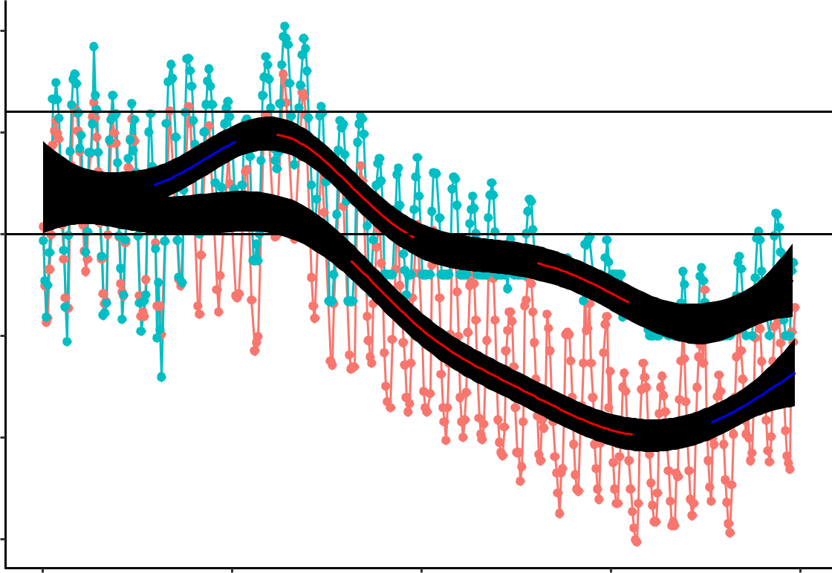

|  |  |  |  |  |  |  |
| --- | --- | --- | --- | --- | --- | --- |
|  | 42.5 |  |  |  |  |  |
|  |  |  |  |  | Proposed |  |
|  | 42.0 |  |  |  |  |  |
| ( )mAHD |  |  |  |  | Current |  |
| 41.5 |  |  |  |  |  |
|  |  |  |  |  |  |
| Level |  |  |  |  |  |  |
| Water | 41.0 |  |  |  |  |  |
|  |  |  |  |  |  |
|  | 40.5 |  |  |  |  |  |
|  | 40.0 |  |  |  |  |  |
|  | 1980 | 1990 | 2000 | 2010 | 2020 |  |
|  |  |  | Year |  |  |  |

Figure 36: Ground and surface water levels recorded at bore 61610685 (red) and staﬀ gauge 6162577 (blue) that represent changes in water levels at Lake Mariginiup.

61

|  |
| --- |
| 62 |

|  |  |  |  |  |  |  |  |  |  |  |  |  |  |  |  |  |  |  |  |  |  |  |  |  |  |  |  |  |  |  |  |  |
| --- | --- | --- | --- | --- | --- | --- | --- | --- | --- | --- | --- | --- | --- | --- | --- | --- | --- | --- | --- | --- | --- | --- | --- | --- | --- | --- | --- | --- | --- | --- | --- | --- |
|  | X Acacia longifolia | X Avena fatua | X Briza maxima | X Briza minor | X Bromus diandrus | X Carpobrotus edulis | X Conyza bonariensis | X Ehrharta calycina | X Ehrhata longiflora | X Euphorbia sp_ | X Hypochaeris glabra | X Lotus suaveolens | X Sonchus oleraceus | X Trifolium sp_ | X Ursinia anthemoides | X Vulpia myuros | X Wahlenbergia capensis | Acacia cyclops | Acacia saligna | Agrostis avenacea | Aster sp_ | Baumea articulata | Eucalyptus rudis | Exocarpus sparteus | Jacksonia furcellata | Lepyrodia muirii | Lobelia alata | Melaleuca teretifolia | Podolepis lessonii | Sonchus sp_ | Villarsia capitata |  |
|  | 1995 |  |  |  |  |  |  |  |  |  |  |  |  |  |  |  |  |  |  |  |  |  |  |  |  |  |  |  |  |  |  |  |
|  | 2000 |  |  |  |  |  |  |  |  |  |  |  |  |  |  |  |  |  |  |  |  |  |  |  |  |  |  |  |  |  |  |  |
|  | 2005 |  |  |  |  |  |  |  |  |  |  |  |  |  |  |  |  |  |  |  |  |  |  |  |  |  |  |  |  |  | A |  |
|  | 2010 |  |  |  |  |  |  |  |  |  |  |  |  |  |  |  |  |  |  |  |  |  |  |  |  |  |  |  |  |  |  |
|  |  |  |  |  |  |  |  |  |  |  |  |  |  |  |  |  |  |  |  |  |  |  |  |  |  |  |  |  |  |  |  |
|  | 2015 |  |  |  |  |  |  |  |  |  |  |  |  |  |  |  |  |  |  |  |  |  |  |  |  |  |  |  |  |  |  |  |
|  | 1995 |  |  |  |  |  |  |  |  |  |  |  |  |  |  |  |  |  |  |  |  |  |  |  |  |  |  |  |  |  |  |  |
| Year | 2000 |  |  |  |  |  |  |  |  |  |  |  |  |  |  |  |  |  |  |  |  |  |  |  |  |  |  |  |  |  |  |  |
| 2010 |  |  |  |  |  |  |  |  |  |  |  |  |  |  |  |  |  |  |  |  |  |  |  |  |  |  |  |  |  |  |  |
|  | 2005 |  |  |  |  |  |  |  |  |  |  |  |  |  |  |  |  |  |  |  |  |  |  |  |  |  |  |  |  |  | B |  |
|  |  |  |  |  |  |  |  |  |  |  |  |  |  |  |  |  |  |  |  |  |  |  |  |  |  |  |  |  |  |  |  |
|  | 2015 |  |  |  |  |  |  |  |  |  |  |  |  |  |  |  |  |  |  |  |  |  |  |  |  |  |  |  |  |  |  |  |

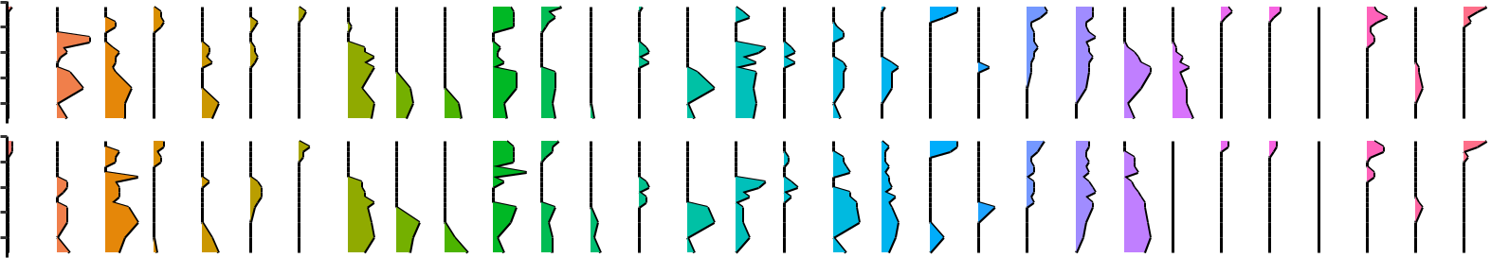

1995



2000

2005 C

2010

2015

Cover Abundance

Figure 37: Cover abundances for each species across the three plots (A, B, C) at the Lake Mariginiup transect. Invasive species are denoted by ‘X’.

Only the most common species are included.

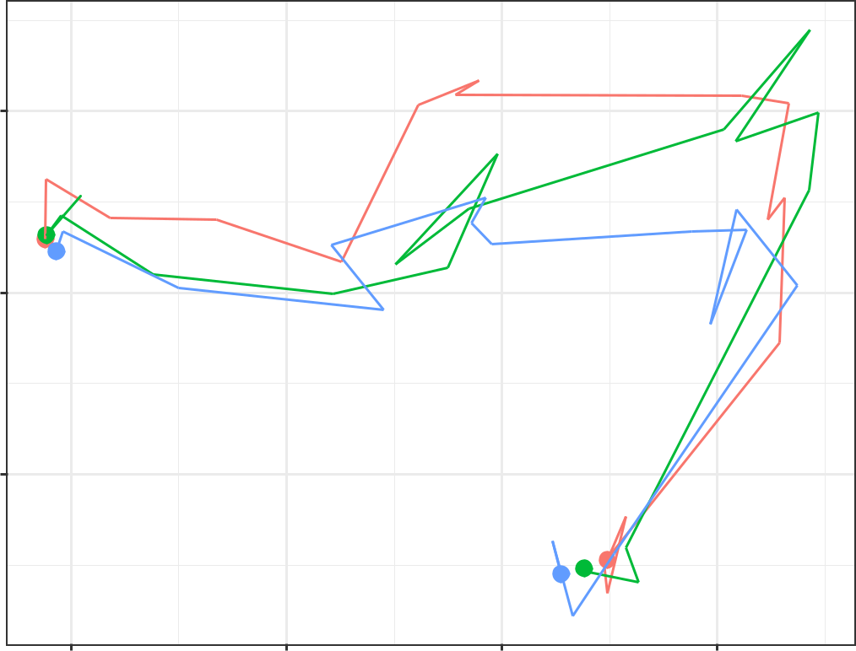

|  |  |  |  |  |  |
| --- | --- | --- | --- | --- | --- |
| 1 |  |  |  |  |  |
| 1996 |  |  |  |  |  |
| 1996 |  |  |  |  |  |
| 1996 |  |  | Plot |  |  |
|  |  |  |  |  |
| 0 |  |  | a | A |  |
| LV2 |  |  |  |
|  |  | a | B |  |
|  |  |  |  |
|  |  |  | a | C |  |
| −1 |  |  |  |  |  |
|  |  |  | 2018 |  |  |
|  |  | 2018 | 2018 |  |  |
| −2 | −1 | 0 | 1 |  |  |
|  |  | LV1 |  |  |  |



Figure 38: Unconstrained ordination based on the latent variable model for each surveyed year for Lake Mariginiup. Plots are represented as diﬀerent colours and consecutive years are joined by a line with first and last survey years labeled.

63

|  |
| --- |
| Species |

X_Pelargonium_capitatum

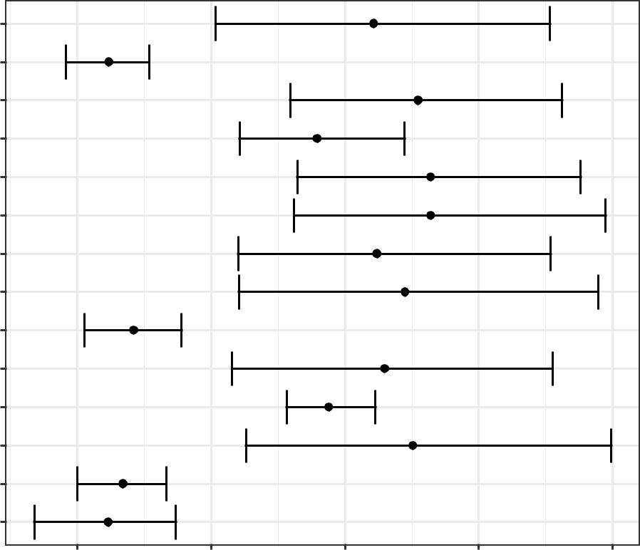

X_Briza_maxima

Villarsia_capitata

Podolepis_lessonii

Lobelia_alata

Lepyrodia_muirii

Juncus_sp_

Isolepis_cernua

Exocarpus_sparteus

Epilobium_billardierianum

Baumea_articulata

Angianthus_sp_

Acacia_saligna

Acacia_cyclops

−5 0 5 10 15

Posterior Mean

Figure 39: Estimated mean regression coeﬃcients (dots) and 95% credible intervals (bars) for eﬀect of groundwater levels at Lake Mariginiup on vegetation species cover abundances based on Bayesian Regression Analysis (HUI REF 2015). Species with a negative mean posterior value are likely to increase in cover abundance as water levels decline and species with positive values are predicted to increae in cover abundance with increasing water levels. Only those species with coeﬃcients significanlty diﬀerent to zero are shown.

64

|  |
| --- |
| 65 |

1995



2000

2005

|  |
| --- |
| Year |

2010

2015

Abundance

Figure 40: Cover abundances for each aquatic macroinvertebrate familiy at Lake Mariginiup.

Table 11: Ecological consequences of revised thresholds in terms of compliance of stated site values and site management objectives at Lake Mariginiup.

|  |  |  |  |  |
| --- | --- | --- | --- | --- |
|  |  | Likely eﬀect of 2030 revised |  |  |
|  |  | thresholds | Future Compliance |  |
|  | |  |  |  |
|  | **Site values** |  |  |  |
| * Rich aquatic fauna (Swan River | |  | Yes |  |
| Goby, *Pseudogobius olorum*) | |  |  |  |
| * Wading bird habitat | | Will increased surface waters |  |  |
|  |  | decline in summer enough to |  |  |
| * Good water quality | | provide important mud flat habitat? | Yes |  |
|  |  |
| **Site management objectives** | |  |  |  |
| * Conservation of flora and fauna | |  |  |  |
| * Maintenance of the existing areas of | | Likely to increase in cover | Yes |  |
| fringing sedge vegetation | | abundance |  |  |
| * Maintain invertebrate diversity | |  | Yes |  |
| through some lake bed drying in | |  |  |  |
| summer | |  |  |  |
| * Maintain and if possible, enhance | | *Acacia* woodland likely to decrease |  |  |
| fringing woodland vegetation | | in cover abundance in transect. |  |  |
|  |  | Can it move further upslope? |  |  |
|  |  |  |  |  |

66

|  |
| --- |
| Family richness |

30

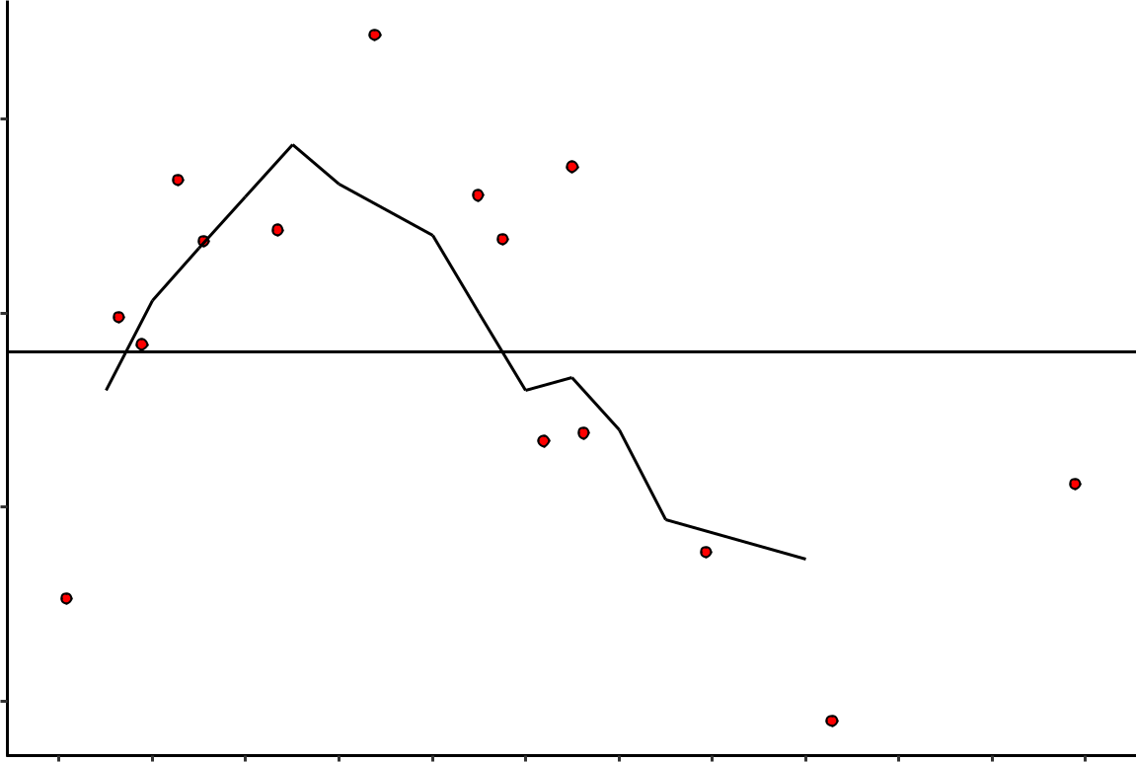

25

20

15

1996 1998 2000 2002 2004 2006 2008 2010 2012 2014 2016 2018

Year

Figure 41: Richness of aquatic invertebrate families for each year at Lake Mariginiup. Line is a moving 3-year averavge.

67

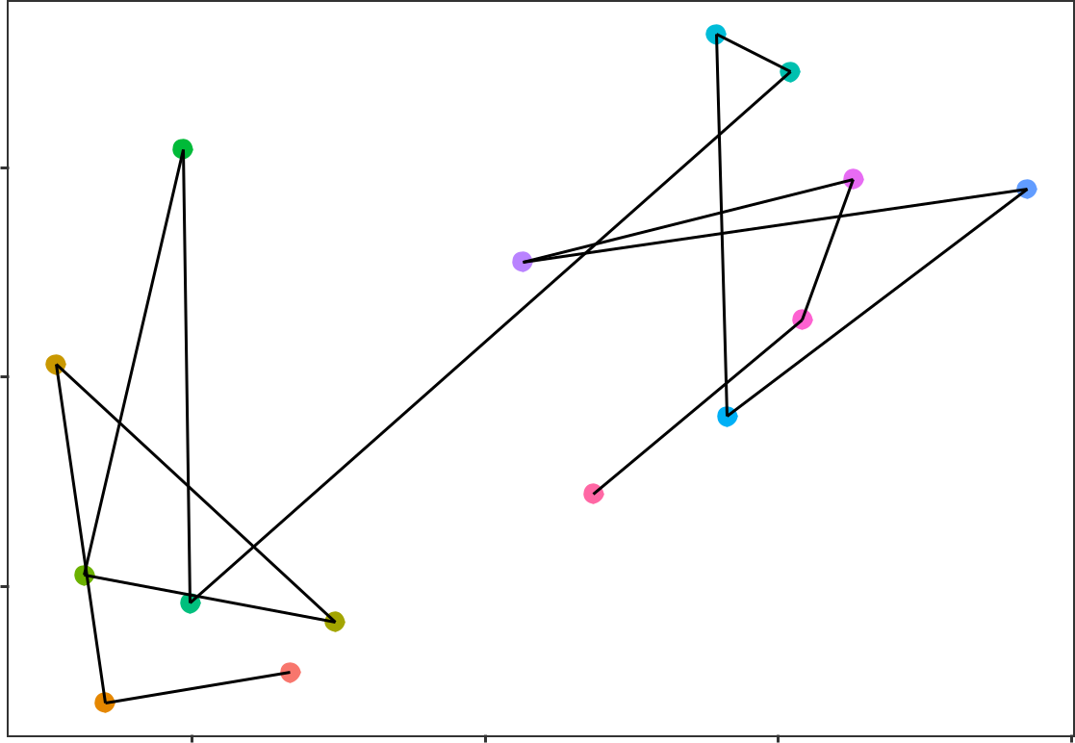

|  |  |  |  |  |
| --- | --- | --- | --- | --- |
|  | 0.05 |  |  |  |
| LV2 | 0.00 |  |  |  |
|  |  |  | 2018 |  |
|  | −0.05 |  |  |  |
|  |  | 1996 |  |  |
|  | −0.5 | 0.0 | 0.5 | 1.0 |
|  |  |  | LV1 |  |

Figure 42: Unconstrained ordination based on invertebrate data for each surveyed year for Lake Mariginiup.

Consecutive years are joined by a line with first and last survey years labeled.

68

**Lake Jandabup**

Lake Jandabup is an artificially watered wetland that supports the most diverse sedge and macrophyte vegetation communities in the Bassendean Dune wetlands (Judd and Horwitz, 2019). Lake Jandabup has a high conservation value as it is one of the few ‘eastern circular wetlands’ to not be be permanently acidic. Low rainfall and groundwater abstraction impacts are thought to have caused an acidification event in 1998 and 1999 but restoration of water levels has returned the pH to normal levels (Judd and Horwitz, 2019). The waters usually have low levels of nutrients and clear waters that supports a diverse aquatic invertebrate community. The abundance of invertebrates and fringing vegetation habitats also allow the wetland to support high numbers of resident and visiting water birds (Bamford and Bamford, 2003).

**Hydrology and water quality**

Surface water levels of Lake Jandabup have only declined slightly since 1980 (Figure 43). Mean maximum seasonal water levels are now 0.2 m lower than in 1994-1999 but mean minimum seasonal water levels are 0.1 m higher than 1994-1999 levels and since 2009, the period of annual maximum to minimum water levels has increased (Table 12). Projected surface water levels are predicted to increase by 3.4 m in 2030 due to proposed changes in abstraction. It is unlikely surface waters will need to be sustained artificially and that an increased threshold level can be proposed.

The pH of Lake Jandabup has not exceeded 7.0 since 2011 and is currently between 6.1 and 6.6. Low water levels expose sediments at Lake Jandabup, making it susceptible to acidification. Alkalinity is currently very low, suggesting that the lake may be loosing its capacity to buﬀer pH changes. Deterioration of the chloride:sulphate ratio is also concerning. Maintaining high water levels may be essential to preventing the drying of sediments around the lake margin and subsequent acidification of this wetland. Typically, Lake Jandabup is a low nutrient wetland, however current total nitrogen and phosphorus levels are currently the highest recorded for the monitoring period.

**Vegetation dynamics**

The Lake Jandabup wetland consists of a diverse community of native vegetation. In the 2017-2018 season, 43 native species were recorded with only 14% of the total cover abundance belonging to exotic species (Buller et al., 2019). There are four overstorey species present at the wetland, including *Banksia attenuata*, *Banksia* *ilicifolia*, *Banksia menziesii*, *Eucalyptus rudis* and *Maleleuca preissiana* (Figure 44), all of which have beenincreasing in health. A dense understorey of *A. scoparia*, *B. elegans* and *H. angustifolium* exists at plots A and B. There has been a continual shift in community composition of Lake Jandabup throughout the monitoring period that reflects changes in invasive species cover abundances (Figure 45). A number of species are predicted to increase in cover abundance with increasing water levels, particularly *Euchilopsis linearis* which is currently present in the lower parts of the basin (Figure 46).

**Aquatic invertebrates**

Family richness of aquatic macroinvertebrates in Lake Jandabup is distinct and higher than other monitored sites because of the relatively high degree of habitat diversity. However, the family richness of the lake has been below average for the lake since 2016 (Figure 48). There has been a recent shift in community composition away from the 1996 community, suggesting that the community may continue to shift away from what has typically been recorded in the lake in future years as water quality and hydrological changes alter ecosystem processes (Figure 49). The highly variable communities between 1996-2006 may be in response to acidification events. Ceinidae, Calanoida, Daphniidae and Notonectidae are usually present in the lake at high abundance (Figure 47).

69

Table 12: Five year summaries of surface water level data at Lake Jandabup

|  |  |  |  |  |  |  |  |
| --- | --- | --- | --- | --- | --- | --- | --- |
| Period | Mean max seasonal | Mean min seasonal | Mean seasonal change | Month of | Month of | Mean max to |  |
| level (mAHD) | level (mAHD) | (m) | maximum | minimum | min (days) |  |
|  |  |
|  |  |  |  |  |  |  |  |
| 08/1994 - 07/1999 | 44.9 | 44.1 | 0.81 | October | February | 156 |  |
| 08/1999 - 07/2004 | 44.9 | 44.2 | 0.64 | September | March | 151 |  |
| 08/2004 - 07/2009 | 44.8 | 44.2 | 0.59 | July | March | 108 |  |
| 08/2009 - 07/2014 | 44.7 | 44.2 | 0.52 | October | January | 164 |  |
| 08/2014 - 07/2019 | 44.7 | 44.2 | 0.51 | September | March | 182 |  |
|  |  |  |  |  |  |  |  |

**Revised water level threshold eﬀects**

The site values of Lake Jandabup are likely to be maintained under the proposed changes to groundwater abstraction (Table 13).

70

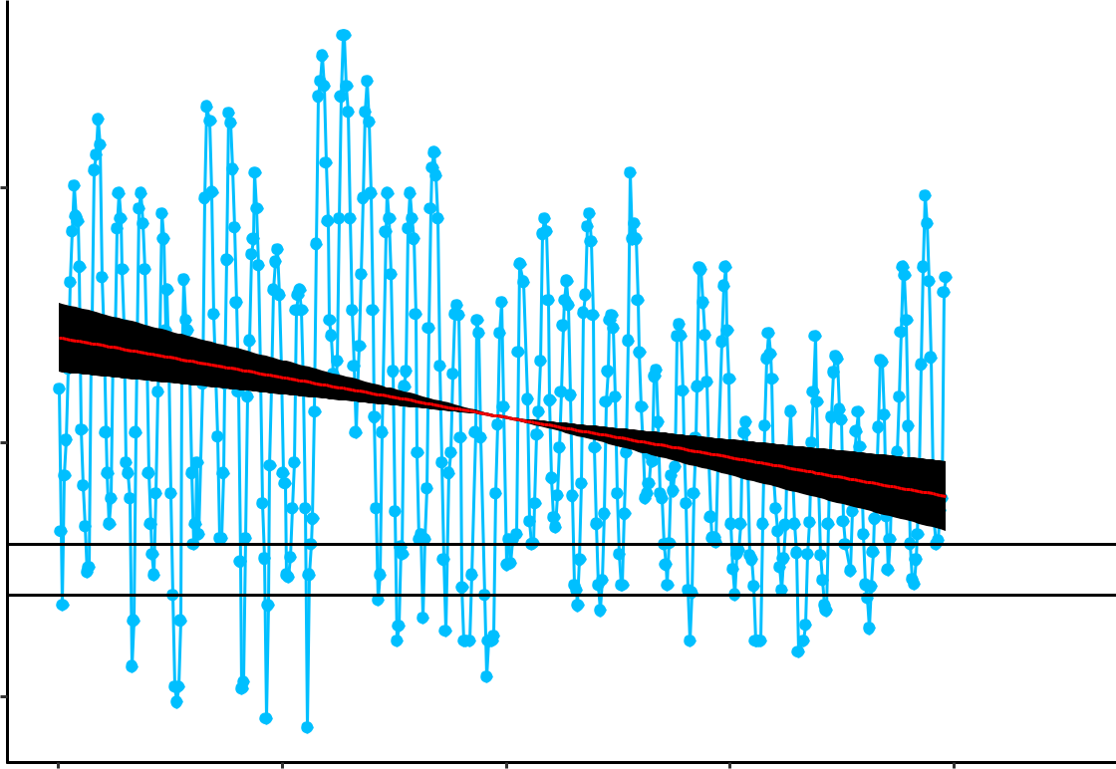

|  |  |  |  |  |  |  |
| --- | --- | --- | --- | --- | --- | --- |
|  | 45.0 |  |  |  |  |  |
| ( )mAHD |  |  |  |  |  |  |
| Level | 44.5 |  |  |  |  |  |
| Water |  |  |  |  |  |
|  |  |  |  | Proposed |  |
|  |  |  |  |  |  |
|  |  |  |  |  | Current |  |
|  | 44.0 |  |  |  |  |  |
|  | 1980 | 1990 | 2000 | 2010 | 2020 |  |
|  |  |  |  | Year |  |  |

Figure 43: Surface water levels for Lake Jandabup recorded at staﬀ 6162578. Red segments on fitted line represent statistically significant periods of declining water levels and blue segments represent periods of increasing water levels. Dotted line represent current ministerial threshold and dashed line represents the prospsed threshold for 2030.

71

|  |
| --- |
| 72 |

1995



2000

2005 A

2010

2015

|  |  |  |  |
| --- | --- | --- | --- |
|  | 1995 |  |  |
|  | 2000 |  |  |
|  | 2005 | B |  |
|  | 2010 |  |
|  |  |  |
| Year | 2015 |  |  |
| 1995 |  |  |
|  | 2000 |  |  |
|  | 2005 | C |  |
|  | 2010 |  |
|  |  |  |
|  | 2015 |  |  |



1995



2000

2005 D

2010

2015

Cover Abundance

Figure 44: Cover abundances for each species across the four plots (A, B, C, D) at the Lake Jandabup transect. Invasive species are denoted by ‘X’.

Only the most common species are included.

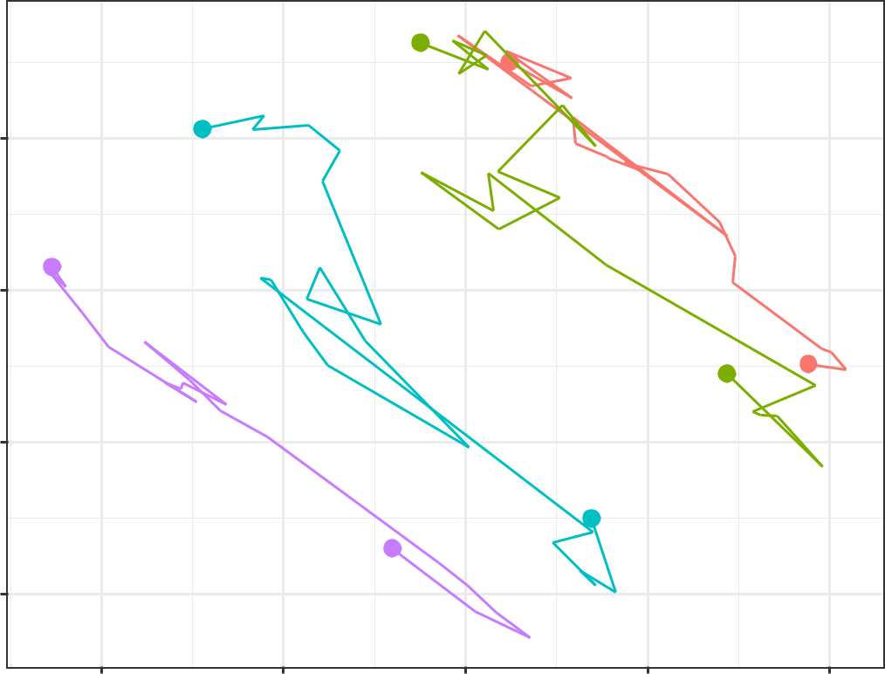

|  |  |  |  |  |  |  |  |
| --- | --- | --- | --- | --- | --- | --- | --- |
|  |  | 2018 |  |  |  |  |  |
|  |  | 2018 |  |  |  |  |  |
|  | 2018 |  |  |  |  |  |  |
| 1 |  |  |  |  |  |  |  |
| 2018 |  |  |  |  | Plot |  |  |
| 0 |  |  |  |  | a | A |  |
| LV2 |  |  | 1996 | 1996 | a | B |  |
|  |  | a | C |  |
|  |  |  |  |  |  |
|  |  |  |  |  | a | D |  |
| −1 |  |  |  |  |  |  |  |
|  |  |  | 1996 |  |  |  |  |
|  |  | 1996 |  |  |  |  |  |
| −2 |  |  |  |  |  |  |  |
| −2 | −1 | 0 | 1 | 2 |  |  |  |
|  |  | LV1 |  |  |  |  |  |



Figure 45: Unconstrained ordination based on the latent variable model for each surveyed year for Lake Jandabup. Plots are represented as diﬀerent colours and consecutive years are joined by a line with first and last survey years labeled.

73

|  |
| --- |
| Species |

X_Ehrharta_calycina

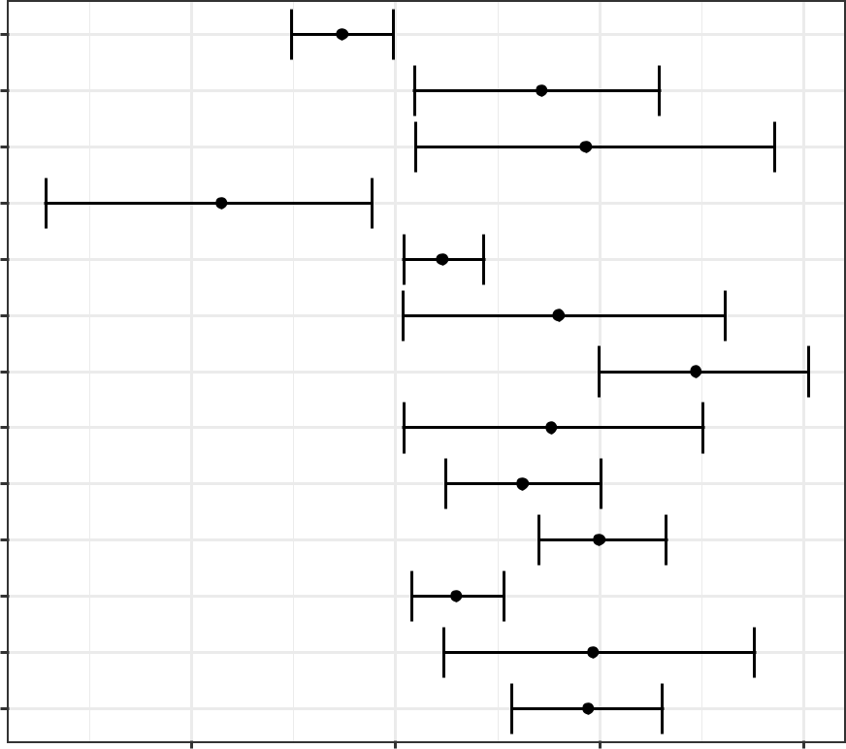

Patersonia_occidentalis

Lyginia_barbata

Jacksonia_furcellata

Hypocalymma_angustifolium

Hovea_pungens

Euchilopsis_linearis

Dianella_divaricata

Dampiera_linearis

Beaufortia_elegans

Astartea_scoparia

Allocasuarina_fraseriana

Acacia_pulchella

−0.2 0.0 0.2 0.4

Posterior Mean

Figure 46: Estimated mean regression coeﬃcients (dots) and 95% credible intervals (bars) for eﬀect of groundwater levels at Lake Jandabup on vegetation species cover abundances based on Bayesian Regression Analysis (HUI REF 2015). Species with a negative mean posterior value are likely to increase in cover abundance as water levels decline while species with positive values are likely to increase in cover abundance as water levels increase. Only those species with coeﬃcients significanlty diﬀerent to zero are shown.

74

|  |
| --- |
| 75 |

1995



2000

2005

|  |
| --- |
| Year |

2010

2015

Abundance

Figure 47: Cover abundances for each aquatic macroinvertebrate familiy at Lake Jandabup.

Table 13: Ecological consequences of revised thresholds in terms of compliance of stated site values and site management objectives at Lake Jandabup.

|  |  |  |  |
| --- | --- | --- | --- |
|  |  | Likely eﬀect of 2030 revised |  |
|  |  | thresholds | Future Compliance |
|  |  |  |  |
|  | **Site values** |  |  |
| * Most diverse sedge and macrophyte | |  |  |
| vegetation of all Bassendean dune | |  |  |
| wetlands, including unusual species | |  |  |
| * Supports wide range of waterbirds, | |  |  |
|  | especially waders |  |  |
| * Extremely good water quality with | |  |  |
|  | low nutrients |  |  |
|  | **Site management objectives** |  |  |
| * Conservation of flora and fauna | |  | Yes |
| * Maintenance of the current extent of | |  | Yes |
| wading bird habitat | |  |  |
| * No expansion in the areas of sedge | | Modeling does not suggest sedge | Yes |
| vegetation, but maintenance of existing | | vegetation is likely to increase |  |
|  | areas |  |  |
| * Removal of mosquito fish from the | |  |  |
|  | lake |  |  |
| * Maintenance of high species richness | |  |  |
|  | of aquatic macroinvertebrates, |  |  |
|  | macrophytes and sedge vegetation |  |  |
|  |  |  |  |

76

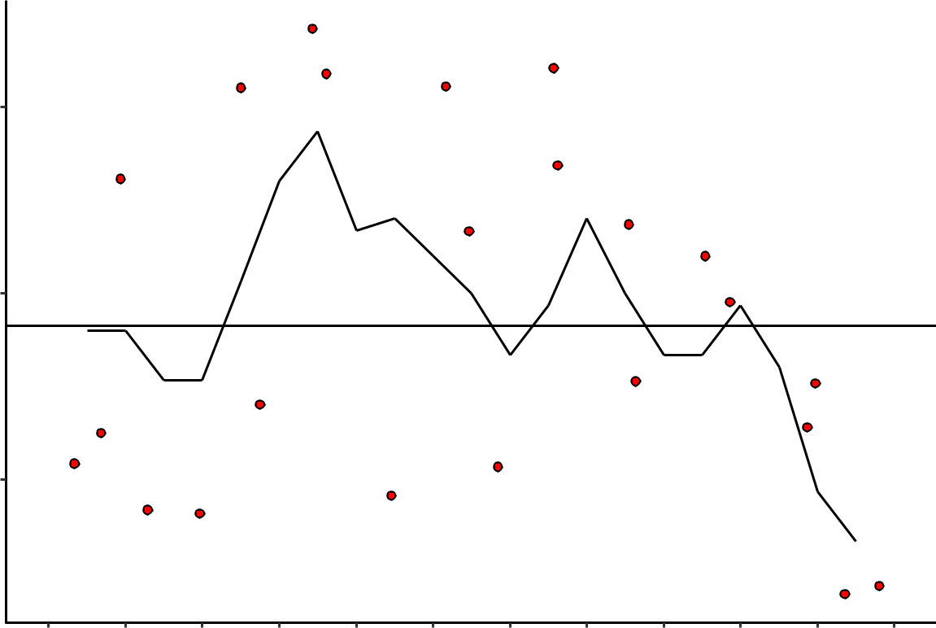

|  |  |  |  |  |  |  |  |  |  |  |  |  |  |
| --- | --- | --- | --- | --- | --- | --- | --- | --- | --- | --- | --- | --- | --- |
|  | 35 |  |  |  |  |  |  |  |  |  |  |  |  |
| Family richness | 30 |  |  |  |  |  |  |  |  |  |  |  |  |
|  |  |  |  |  |  |  |  |  |  |  |  |  |
|  | 25 |  |  |  |  |  |  |  |  |  |  |  |  |
|  | 1996 | 1998 | 2000 | 2002 | 2004 | 2006 | 2008 | 2010 | 2012 | 2014 | 2016 | 2018 |  |
|  |  |  |  |  |  | Year | |  |  |  |  |  |  |

Figure 48: Richness of aquatic invertebrate families for each year at Lake Jandabup. Line is a moving 3-year averavge.

77

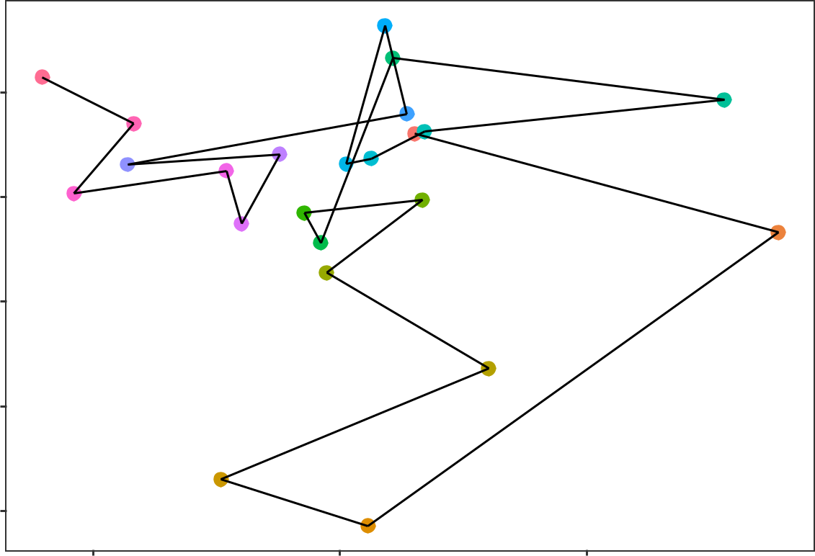

|  |  |  |
| --- | --- | --- |
| 2018 |  |  |
| 0.1 |  |  |
|  |  | 1996 |
| 0.0 |  |  |
| LV2 |  |  |
| −0.1 |  |  |
| −0.2 |  |  |
| −0.3 |  |  |
| −0.5 | 0.0 | 0.5 |
|  |  | LV1 |

Figure 49: Unconstrained ordination based on invertebrate data for each surveyed year for Lake Jandabup.

Consecutive years are joined by a line with first and last survey years labeled.

78

**Lake Nowergup**

Lake Nowergup is one of the deepest permanent lakes on the Swan Coastal Plain and provides a permanent habitat for aquatic invertebrates and fish, as well as an important drought refuge for water birds (R Froend, R. C. Loomes, et al., 2004). Despite the wetlands being artificially maintained since 1989, water levels have continued to decline. This decline has altered the fringing vegetation of the lake and reduced the area of permanent water.

**Hydrology and water quality**

Since 2010, surface water levels in the lake have decline significantly to levels that are currently below the minimum reading on the staﬀ gauge 6162567 (Figure 50). Groundwater levels at the nearby bore 61611247 have shown similar trends as surface water levels. Between 2008 and 2014, groundwater levels at the bore have declined by more than 1.0 m. A similar decline in surface waters is likely and measurements from this bore have been used in the vegetation analysis. Currently, groundwater levels have increased to above 15 mAHD due to recent rainfall. At bore 61611247, mean seasonal maximum and minimum groundwater levels have declined by 1.7 and 1.5 m, respectively from the 1994-1999 to 2014-2019 period (Table 14). Maximum and minimum water levels now tend to occur earlier in the year than previously. Proposed threshold levels will apply to bore 61610601, where under proposed reduction in abstraction a threshold at 18.0 mAHD should be achievable. This is likely to correspond to threshold level of 16.0 mAHD at the staﬀ gauge, 0.8 m lower than the current threshold.

Water quality in Lake Nowergup is remarkably stable given the declines in surface waters and associated groundwaters (Judd and Horwitz, 2019). Acidity is usually low and alkalinity high, indicating that the lake has suﬃcient capacity to buﬀer against acidification. A pH above 9 is not unusual for this system. Recent monitoring suggests the lake currently has high nutrient levels, with current total nitrogen and total phosphorus at record high concentrations for the lake, and among the highest for all Spearwood Dune wetlands. Current nitrogen levels are twice the mean levels. Stock has recently been able to access the lake bed and may be the cause of elevated nutrients.

**Vegetation Dynamics**

There are two vegetation monitoring transects at Lake Nowergup, one in the northern part of the lake and one in the southern part. Both transects were established in 1996 and the northern one was last surveyed in 2016 while the southern one was last surveyed in 2018.

(“Lake Nowergup South transect was realigned in 2001 due to a lack of wetland species in upland plots and to encompass wetland vegetation at the lake end of the transect (Bertuch et al., 2004)”) - WHAT ARE THE IMPLICATIONS? May need to re-run analyses excluding years before 2001. Don’t know plot elevations before 2001. Will write up once we have made a decision.

**Macroinvertebrates Dynamic**

Aquatic invertebrate richness has been below average for Lake Nowergup since 2010, with 19 families detected for the last three sampling occasions (Figure 56). There is currently a trend of declining richness since 2008. This decline in richness is likely due to the loss of fringing macrophytes due to declining water levels and submerged macrophytes in the center of the lake which have also disappeared (GMEMP 2018). Loss of macrophytic habitat has coincided with elevated nutrient levels which would have also altered ecological processes and invertebrate assemblages. Ordination reveals a marked change in assemblage composition from 1996 to 2018 (Figure 57). Communities appeared to shifted most dramatically from 2002 to 2006 which coincides with supplementation of surface waters by artificial watering. The current shift away from the 1996 community may be driven by the high nutrients being experienced at the lake. Changes can be associated to loss of Ceinidae, Amphisopidae, Notodromadidae and Chydoridae (Figure 55). As stated in GMEMP 2019

79

Table 14: Five year summaries of groundwater level data at Lake Nowergup based on bore 61611247

|  |  |  |  |  |  |  |  |
| --- | --- | --- | --- | --- | --- | --- | --- |
| Period | Mean max seasonal | Mean min seasonal | Mean seasonal change | Month of | Month of | Mean max to |  |
| level (mAHD) | level (mAHD) | (m) | maximum | minimum | min (days) |  |
|  |  |
|  |  |  |  |  |  |  |  |
| 08/1994 - 07/1999 | 16.6 | 15.3 | 1.30 | October | May | 144 |  |
| 08/1999 - 07/2004 | 16.5 | 14.8 | 1.69 | October | May | 53 |  |
| 08/2004 - 07/2009 | 16.6 | 15.6 | 1.02 | October | January | 14 |  |
| 08/2009 - 07/2014 | 15.6 | 13.4 | 2.11 | September | March | 222 |  |
| 08/2014 - 07/2019 | 14.9 | 13.8 | 1.07 | July | April | 19 |  |
|  |  |  |  |  |  |  |  |

REPORT [ADD REF] “*The macroinvertebrate monitoring undertaken in 2018 confirms the trends of reduced* *richness and changing assemblages. The artificial maintenance regime at this wetland was clearly inadequate to maintain ecological integrity and has failed to prevent a loss of habitats, the consequence of lowered water levels. The resulting change in invertebrate assemblages may well be irreversible and steps to restore more representative assemblages must involve more than maintenance of minimum water levels.*”

**Revised water level threshold eﬀects**

The site values of Lake Nowergup are unlikely to be maintained under the proposed changes to groundwater abstraction (Table 15).

80

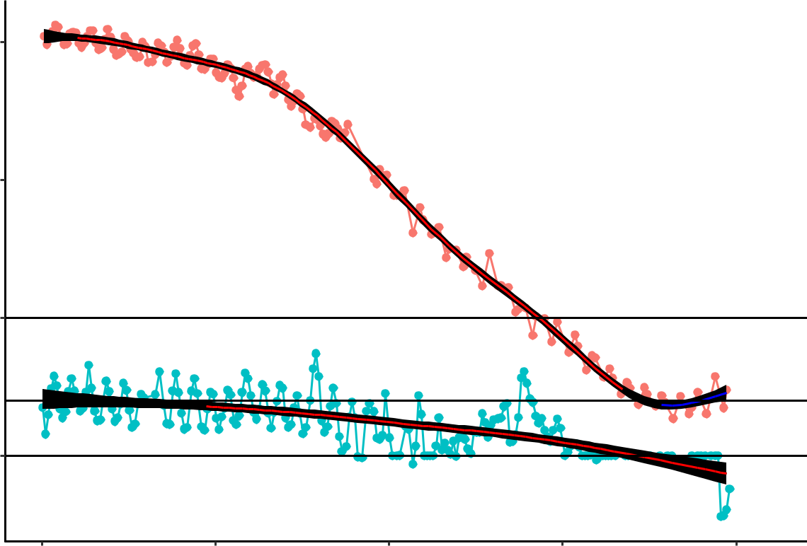

|  |  |  |  |  |  |  |
| --- | --- | --- | --- | --- | --- | --- |
|  | 22 |  |  |  |  |  |
| ( )mAHD | 20 |  |  |  |  |  |
|  |  |  |  |  |  |
| Level |  |  |  |  | Proposed |  |
| Water | 18 |  |  |  |  |  |
|  |  |  |  |  |  |
|  |  |  |  |  | Current |  |
|  | 16 |  |  |  | Proposed |  |
|  |  |  |  |  |  |
|  | 1980 | 1990 | 2000 | 2010 | 2020 |  |
|  |  |  | Year |  |  |  |

Figure 50: Ground and surface water levels for Lake Nowergup recorded at bore 61610601 (red) and staﬀ gauge 6162567 (blue). The minimum recordable water level for the staﬀ gaugue is 16.0 mAHD. Blue dots at 16.0 mAHD represent water levels below the minimum level measurable at the staﬀ gaufe. Red segments on fitted line represent statistically significant periods of declining water levels and blue segments represent periods of increasing water levels.

81

|  |
| --- |
| 82 |

|  |  |  |  |  |  |  |  |  |  |  |  |  |  |  |  |  |  |  |  |  |  |  |  |  |  |  |  |  |  |
| --- | --- | --- | --- | --- | --- | --- | --- | --- | --- | --- | --- | --- | --- | --- | --- | --- | --- | --- | --- | --- | --- | --- | --- | --- | --- | --- | --- | --- | --- |
|  | X Briza maxima | X Bromus diandrus | X Cynodon dactylon | X Ehrharta calycina | X Ehrharta longiflora | X Lactuca serriola | X Pelargonium capitatum | X Rumex crispus | X Solanum nigrum | X Sonchus asper | X Sonchus oleraceus | X Typha orientalis | Acacia saligna | Acanthocarpus preissii | Austrostipa campylachne | Austrostipa compressa | Baumea articulata | Baumea juncea | Conostylis candicans | Eucalyptus rudis | Gyrostemon ramulosus | Jacksonia sternbergiana | Lepidosperma longitudinale | Melaleuca rhaphiophylla | Microlena stipoides | Persicaria decipiens | Rhagodia baccata | Spyridium globulosum |  |
|  | 1995 |  |  |  |  |  |  |  |  |  |  |  |  |  |  |  |  |  |  |  |  |  |  |  |  |  |  |  |  |
|  | 2000 |  |  |  |  |  |  |  |  |  |  |  |  |  |  |  |  |  |  |  |  |  |  |  |  |  |  |  |  |
|  | 2005 |  |  |  |  |  |  |  |  |  |  |  |  |  |  |  |  |  |  |  |  |  |  |  |  |  |  | A |  |
|  | 2010 |  |  |  |  |  |  |  |  |  |  |  |  |  |  |  |  |  |  |  |  |  |  |  |  |  |  |  |  |
|  | 2015 |  |  |  |  |  |  |  |  |  |  |  |  |  |  |  |  |  |  |  |  |  |  |  |  |  |  |  |  |
|  | 1995 |  |  |  |  |  |  |  |  |  |  |  |  |  |  |  |  |  |  |  |  |  |  |  |  |  |  |  |  |
|  | 2000 |  |  |  |  |  |  |  |  |  |  |  |  |  |  |  |  |  |  |  |  |  |  |  |  |  |  |  |  |
|  | 2005 |  |  |  |  |  |  |  |  |  |  |  |  |  |  |  |  |  |  |  |  |  |  |  |  |  |  | B |  |
| Year | 2010 |  |  |  |  |  |  |  |  |  |  |  |  |  |  |  |  |  |  |  |  |  |  |  |  |  |  |  |  |
| 2015 |  |  |  |  |  |  |  |  |  |  |  |  |  |  |  |  |  |  |  |  |  |  |  |  |  |  |  |  |
|  | 1995 |  |  |  |  |  |  |  |  |  |  |  |  |  |  |  |  |  |  |  |  |  |  |  |  |  |  |  |  |
|  | 2000 |  |  |  |  |  |  |  |  |  |  |  |  |  |  |  |  |  |  |  |  |  |  |  |  |  |  |  |  |
|  | 2005 |  |  |  |  |  |  |  |  |  |  |  |  |  |  |  |  |  |  |  |  |  |  |  |  |  |  | C |  |
|  | 2010 |  |  |  |  |  |  |  |  |  |  |  |  |  |  |  |  |  |  |  |  |  |  |  |  |  |  |  |  |
|  | 2015 |  |  |  |  |  |  |  |  |  |  |  |  |  |  |  |  |  |  |  |  |  |  |  |  |  |  |  |  |
|  | 1995 |  |  |  |  |  |  |  |  |  |  |  |  |  |  |  |  |  |  |  |  |  |  |  |  |  |  |  |  |
|  | 2000 |  |  |  |  |  |  |  |  |  |  |  |  |  |  |  |  |  |  |  |  |  |  |  |  |  |  |  |  |
|  | 2005 |  |  |  |  |  |  |  |  |  |  |  |  |  |  |  |  |  |  |  |  |  |  |  |  |  |  | D |  |
|  | 2010 |  |  |  |  |  |  |  |  |  |  |  |  |  |  |  |  |  |  |  |  |  |  |  |  |  |  |  |  |
|  | 2015 |  |  |  |  |  |  |  |  |  |  |  |  |  |  |  |  |  |  |  |  |  |  |  |  |  |  |  |  |

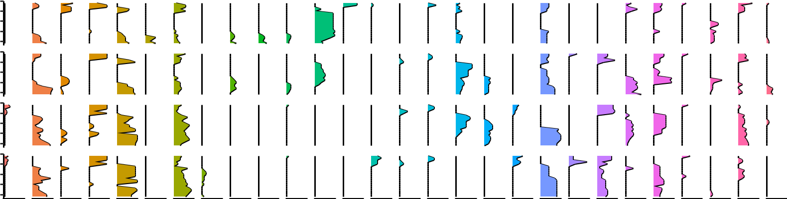

Cover Abundance

Figure 51: Cover abundances for each species across the four plots (A, B, C, D) at the northern Lake Nowergup transect. Invasive species are denoted by ‘X’. Only the most common species are included.

|  |
| --- |
| 83 |

|  |  |  |  |  |  |  |  |  |  |  |  |  |  |  |  |  |  |  |  |  |  |  |  |  |  |  |  |  |  |  |  |  |  |
| --- | --- | --- | --- | --- | --- | --- | --- | --- | --- | --- | --- | --- | --- | --- | --- | --- | --- | --- | --- | --- | --- | --- | --- | --- | --- | --- | --- | --- | --- | --- | --- | --- | --- |
|  | X Avena fatua | X Azolla filiculoides | X Bromus diandrus | X Carpobrotus edulis | X Conyza sp_ | X Cynodon dactylon | X Ehrharta calycina | X Ehrhata longiflora | X Euphorbia terracina | X Ficus carica | X Lactuca sp_ | X Lupinus cosentinii | X Pelargonium capitatum | X Phytolacca octandra | X Solanum nigrum | X Sonchus asper | X Typha orientalis | Acanthocarpus preissii | Banksia grandis | Baumea articulata | Baumea juncea | Eucalyptus gomphocephala | Eucalyptus rudis | Jacksonia furcellata | Jacksonia sternbergiana | Lepidosperma longitudinale | Macrozamia reidlei | Melaleuca rhaphiophylla | Persicaria decipiens | Rhagodia baccata | Stipa campylachne | Stipa compressa |  |
|  | 1995 |  |  |  |  |  |  |  |  |  |  |  |  |  |  |  |  |  |  |  |  |  |  |  |  |  |  |  |  |  |  |  |  |
|  | 2000 |  |  |  |  |  |  |  |  |  |  |  |  |  |  |  |  |  |  |  |  |  |  |  |  |  |  |  |  |  |  |  |  |
|  | 2005 |  |  |  |  |  |  |  |  |  |  |  |  |  |  |  |  |  |  |  |  |  |  |  |  |  |  |  |  |  |  | A |  |
|  | 2010 |  |  |  |  |  |  |  |  |  |  |  |  |  |  |  |  |  |  |  |  |  |  |  |  |  |  |  |  |  |  |  |
|  |  |  |  |  |  |  |  |  |  |  |  |  |  |  |  |  |  |  |  |  |  |  |  |  |  |  |  |  |  |  |  |  |
|  | 2015 |  |  |  |  |  |  |  |  |  |  |  |  |  |  |  |  |  |  |  |  |  |  |  |  |  |  |  |  |  |  |  |  |
|  | 1995 |  |  |  |  |  |  |  |  |  |  |  |  |  |  |  |  |  |  |  |  |  |  |  |  |  |  |  |  |  |  |  |  |
|  | 2000 |  |  |  |  |  |  |  |  |  |  |  |  |  |  |  |  |  |  |  |  |  |  |  |  |  |  |  |  |  |  |  |  |
|  | 2005 |  |  |  |  |  |  |  |  |  |  |  |  |  |  |  |  |  |  |  |  |  |  |  |  |  |  |  |  |  |  | B |  |
|  | 2010 |  |  |  |  |  |  |  |  |  |  |  |  |  |  |  |  |  |  |  |  |  |  |  |  |  |  |  |  |  |  |  |
|  |  |  |  |  |  |  |  |  |  |  |  |  |  |  |  |  |  |  |  |  |  |  |  |  |  |  |  |  |  |  |  |  |
| Year | 2015 |  |  |  |  |  |  |  |  |  |  |  |  |  |  |  |  |  |  |  |  |  |  |  |  |  |  |  |  |  |  |  |  |
| 1995 |  |  |  |  |  |  |  |  |  |  |  |  |  |  |  |  |  |  |  |  |  |  |  |  |  |  |  |  |  |  |  |  |
|  | 2000 |  |  |  |  |  |  |  |  |  |  |  |  |  |  |  |  |  |  |  |  |  |  |  |  |  |  |  |  |  |  |  |  |
|  | 2005 |  |  |  |  |  |  |  |  |  |  |  |  |  |  |  |  |  |  |  |  |  |  |  |  |  |  |  |  |  |  | C |  |
|  | 2010 |  |  |  |  |  |  |  |  |  |  |  |  |  |  |  |  |  |  |  |  |  |  |  |  |  |  |  |  |  |  |  |
|  |  |  |  |  |  |  |  |  |  |  |  |  |  |  |  |  |  |  |  |  |  |  |  |  |  |  |  |  |  |  |  |  |
|  | 2015 |  |  |  |  |  |  |  |  |  |  |  |  |  |  |  |  |  |  |  |  |  |  |  |  |  |  |  |  |  |  |  |  |

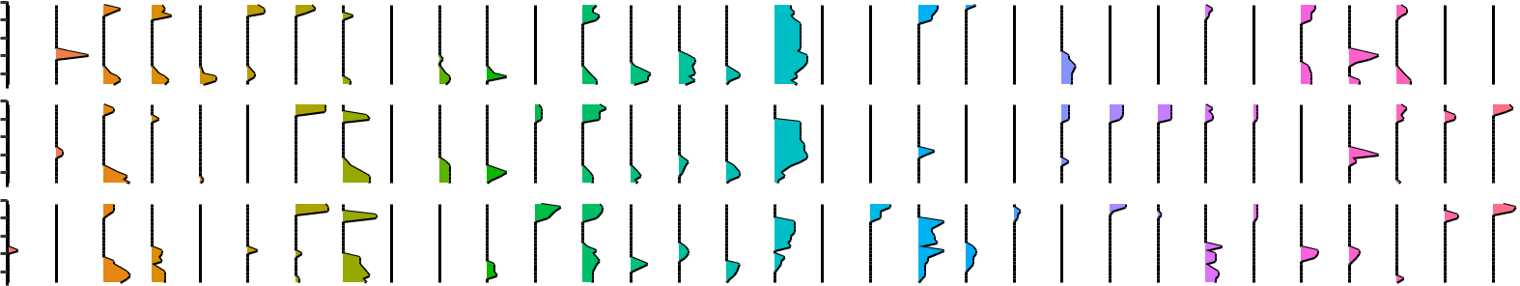

1995



2000

2005 D

2010

2015

Cover Abundance

Figure 52: Cover abundances for each species across the four plots (A, B, C, D) at the souther Lake Nowergup transect. Invasive species are denoted by ‘X’. Only the most common species are included.

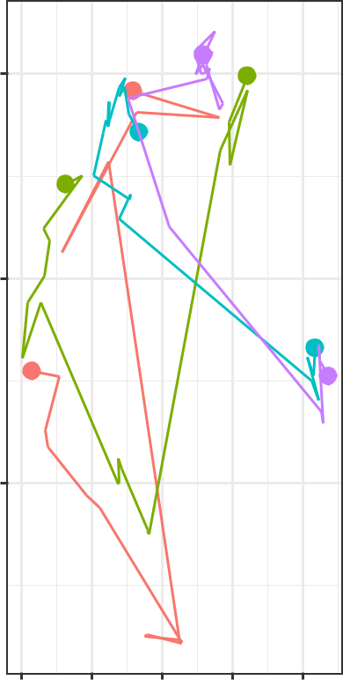

|  |  |  |  |  |  |
| --- | --- | --- | --- | --- | --- |
|  |  | 2016 |  |  |  |
| 1 |  | 1996 | 1996 | |  |
|  |  | 2016 |  |
|  |  |  |  |  |
|  | 2016 |  |  |  |  |
| 0 |  |  |  |  |  |
| LV2 |  |  |  | 1996 |  |
| 2016 |  |  |  |  |
|  |  |  | 1996 |  |
|  |  |  |  |  |
| −1 |  |  |  |  |  |
| −2 | −1 | 0 | 1 | 2 |  |
|  |  | LV1 |  |  |  |

|  |  |  |  |  |  |  |  |  |
| --- | --- | --- | --- | --- | --- | --- | --- | --- |
|  |  |  |  |  | 1996 |  |  |  |
|  |  |  |  |  | 1996 |  |  |  |
|  |  |  | 1 |  | 1996 |  |  |  |
|  |  |  |  |  |  |  |  |
| Plot |  |  |  |  |  | Plot |  |  |
| a | A | LV2 |  |  |  | a | A |  |
| a | B | 0 |  | 2018 | a | B |  |
|  |  |  |
| a | C |  |  |  | a | C |  |
|  |  |  | 2018 |  |
| a | D |  |  |  | a | D |  |
|  |  | 2018 | |  |
|  |  |  |  |  |  |  |
|  |  |  | −1 | 1996 |  |  |  |  |
|  |  |  |  |  |  |  |  |
|  |  |  |  | 2018 |  |  |  |  |
|  |  |  | −1 | 0 | 1 |  |  |  |
|  |  |  |  | LV1 |  |  |  |  |

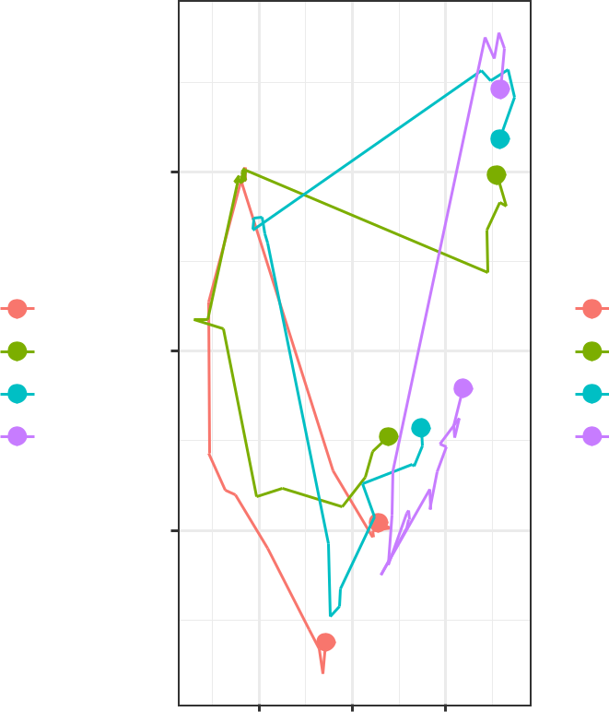

Figure 53: Unconstrained ordination based on the latent variable model for each surveyed year for the northern (left) and southern (right) Lake Nowergup transects. Plots are represented as diﬀerent colours and consecutive years are joined by a line with first and last survey years labeled.

84

|  |
| --- |
| Species |

X_Typha_orientalis

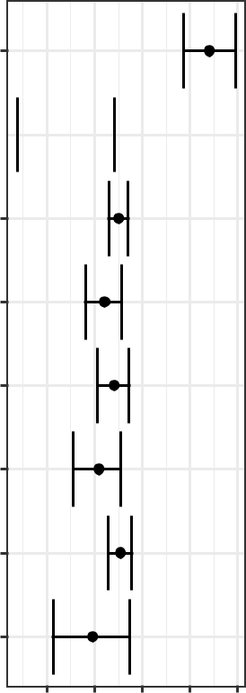

X_Rumex_crispus 

X_Pelargonium_capitatum

X_Ehrharta_longiflora

X_Bromus_diandrus

Jacksonia_sternbergiana

Eucalyptus_rudis

Baumea_juncea

−2 −1 0 1 2

Posterior Mean

|  |
| --- |
| Species |

X_Typha_orientalis

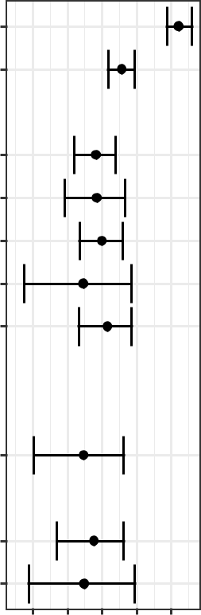

X_Pelargonium_capitatum

X_Euphorbia_terracina 

X_Ehrhata_longiflora

X_Carpobrotus_edulis

X_Bromus_diandrus

X_Avena_barbata

Rhagodia_baccata

Melaleuca_rhaphiophylla  Lepidosperma_longitudinale 

Jacksonia_furcellata

Eucalyptus_gomphocephala 

Baumea_juncea

Acanthocarpus_preissii

−3 −2 −1 0 1

Posterior Mean

Figure 54: Estimated mean regression coeﬃcients (dots) and 95% credible intervals (bars) for eﬀect of groundwater levels at the northern (left) and southern (right) Lake Nowergup transects on vegetation species cover abundances based on Bayesian Regression Analysis (HUI REF 2015). Species with a negative mean posterior value are likely to increase in cover abundance as water levels decline and species with positive values are likely to increase in cover abundance when water levels increase. Only those species with coeﬃcients significantly diﬀerent to zero are shown.

85

|  |
| --- |
| 86 |

1995



2000

2005

|  |
| --- |
| Year |

2010

2015

Abundance

Figure 55: Cover abundances for each aquatic macroinvertebrate familiy at Lake Nowergup.

Table 15: Ecological consequences of revised thresholds in terms of compliance of stated site values and site management objectives at Lake Nowergup.

|  |  |  |  |
| --- | --- | --- | --- |
|  |  | Likely eﬀect of 2030 revised |  |
|  |  | thresholds | Future Compliance |
|  |  |  |  |
|  | **Site values** |  |  |
| * As a permanent deep-water wetland | | How much lower will water levels |  |
|  | acts as a major drought refuge for | go? |  |
| waterbirds | |  |  |
| * Supports dependent invertebrates | | Dependent on extent of reduced |  |
|  | and fish species (one native, Swan | water area and depth |  |
|  | River Goby (*Pseudogobius olorum*); |  |  |
|  | and one exotic, Mosquito fish |  |  |
| (*Gambusia holbrooki*) | |  |  |
| * Large areas of sedges minimize | | Likely to be jeopardised with |  |
|  | impact of nutrient enrichment on | declining water levels |  |
|  | aquatic fauna |  |  |
|  | **Site management objectives** |  |  |
| * Wildlife and conservation, scientific | |  |  |
|  | study and preservation of features of |  |  |
|  | archaeological, historic or scientific |  |  |
|  | interest |  |  |
| * Maintain the existing areas of | | Fringing vegetation will need to | No |
|  | fringing sedge vegetation | migrate down-slope |  |
| * Maintain deep, permanent water as a | | Declining water levels will | No |
|  | bird habitat and drought refuge and to | jeopardise the lake as a drought |  |
|  | protect aquatic invertebrates and fish | refuge |  |
|  | dependent on permanent water |  |  |
| * Maintain the existing extent of | |  |  |
| *Baumea* fringe between *Typha* stands | |  |  |
|  | and the fringing woodland |  |  |
| * Provide some area of wading bird | |  |  |
|  | habitat at the end of summer, |  |  |
|  | although it is recognized that this is |  |  |
|  | limited by the shape of the wetland. |  |  |
|  |  |  |  |

87

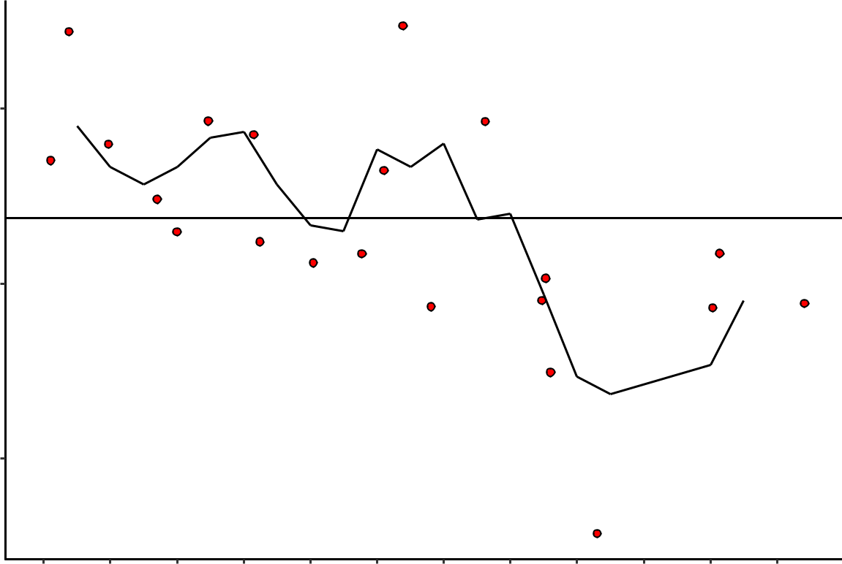

|  |  |  |  |  |  |  |  |  |  |  |  |  |  |
| --- | --- | --- | --- | --- | --- | --- | --- | --- | --- | --- | --- | --- | --- |
|  | 30 |  |  |  |  |  |  |  |  |  |  |  |  |
| richness | 20 |  |  |  |  |  |  |  |  |  |  |  |  |
| Family |  |  |  |  |  |  |  |  |  |  |  |  |
|  |  |  |  |  |  |  |  |  |  |  |  |  |
|  | 10 |  |  |  |  |  |  |  |  |  |  |  |  |
|  | 1996 | 1998 | 2000 | 2002 | 2004 | 2006 | 2008 | 2010 | 2012 | 2014 | 2016 | 2018 |  |
|  |  |  |  |  |  |  | Year |  |  |  |  |  |  |

Figure 56: Richness of aquatic invertebrate families for each year at Lake Nowergup. Line is a moving 3-year averavge.

88

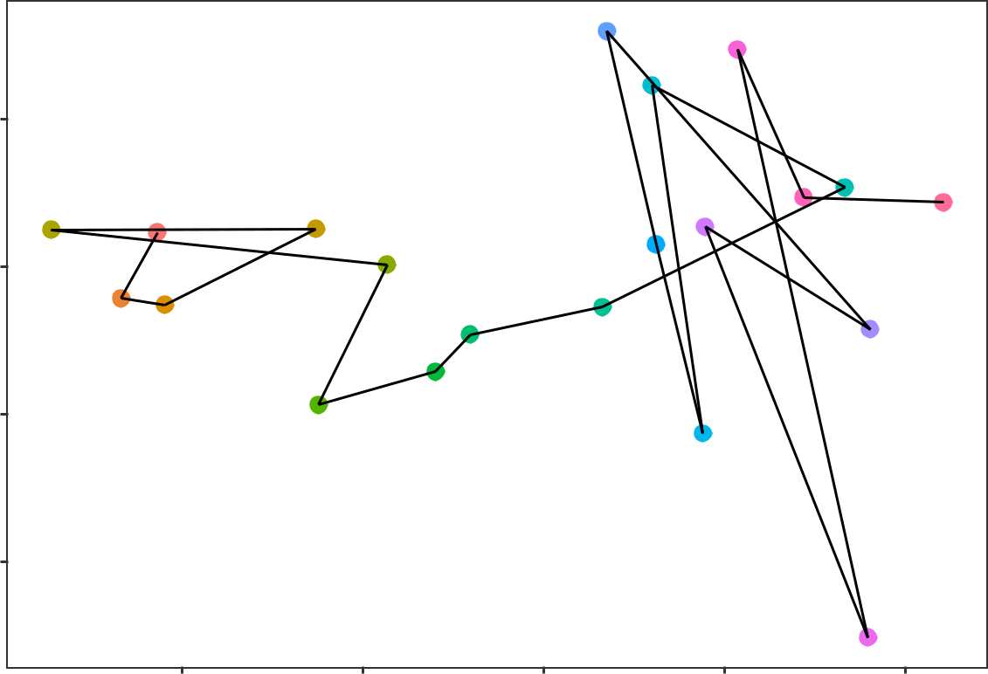

|  |  |  |  |  |
| --- | --- | --- | --- | --- |
| 0.1 |  |  |  |  |
|  |  |  |  | 2018 |
| 1996 |  |  |  |  |
| 0.0 |  |  |  |  |
| LV2 |  |  |  |  |
| −0.1 |  |  |  |  |
| −0.2 |  |  |  |  |
| −0.50 | −0.25 | 0.00 | 0.25 | 0.50 |
|  |  | LV1 |  |  |

Figure 57: Unconstrained ordination based on invertebrate data for each surveyed year for Lake Nowergup.

Consecutive years are joined by a line with first and last survey years labeled.

89

Table 16: Five year summaries of surface water level data at Lake Wilgarup

|  |  |  |  |  |  |  |  |
| --- | --- | --- | --- | --- | --- | --- | --- |
| Period | Mean max seasonal | Mean min seasonal | Mean seasonal change | Month of | Month of | Mean max to |  |
| level (mAHD) | level (mAHD) | (m) | maximum | minimum | min (days) |  |
|  |  |
|  |  |  |  |  |  |  |  |
| 08/1994 - 07/1999 | 5.2 | 4.3 | 0.91 | October | March | 184 |  |
| 08/1999 - 07/2004 | 4.7 | 4.0 | 0.73 | October | April | 193 |  |
| 08/2004 - 07/2009 | 4.3 | 3.7 | 0.62 | September | May | 150 |  |
| 08/2009 - 07/2014 | 3.8 | 3.2 | 0.59 | October | April | 190 |  |
| 08/2014 - 07/2019 | 3.6 | 3.1 | 0.55 | October | May | 212 |  |
|  |  |  |  |  |  |  |  |

**Lake Wilgarup**

Lake Wilgarup is a high conservation, seasonally inundated dampland located in the southern area of Yanchep National Park. The basin covers an area of 16 ha in a limestone depression that experiences discharge from rising groundwaters. There are extensive peat deposits in the lake bed that suggest the sediments have been saturated for a long period. Surface waters have not been recorded in the basin since 1998 and peats are now dry and vulnerable to combustion.

**Hydrology**

Groundwater levels have been recorded at the nearby bore 61618500 since 1997 (Figure 58). There has been a significant decline in groundwater levels throughout this monitoring period from 4.75 to 3.25 mAHD despite recent increased annual rainfall. Maximum and minimum seasonal groundwater levels have decreased by 1.6 and 1.2 m, respectively (Table 16). Maximum water levels have consistently occurred during September-October, but minimum water levels are now occurring later in the year with the site experiencing a longer period of drying. The wetland has been non-compliant with ministerial thresholds for most of the monitoring period. A proposed threshold at 0.5 m lower than the current threshold is likely to be achievable under proposed reductions in abstraction by 2030. These changes in abstraction may result in small increases in groundwater levels, but are likely to reduce the risk of further declines.

**Vegetation dynamics**

A vegetation monitoring transect was established at Lake Wilgarup in 1997 and was last surveyed in 2012. Two additional sites were added to the transect in 2009 down-slope of Plot A. The sedges, *Baumea articulata*, *Baumea juncea* and *Baumea vaginalis* have all disappeared from the wetland during the monitoring period(Figure 59). Tuart trees (*Eucalyptus gomphocephala* ) have migrated down slope during the monitoring period and were recorded in Plot A in 2005. Plots A, B and C display similar shifts in community composition during the monitoring period, while Plot D displayed a significant change in composition in 2004-2005 in response to fire (Figure 60). Under a scenario of continuing groundwater decline, regressional analysis reveals that a number of exotic species, including *Ehrharta longiflora* and *Bromus diandrus*, are likely to increase in cover abundances (Figure 61).

**Revised water level threshold eﬀects**

The site values of Lake Wilgarup are unlikely to be maintained under the proposed changes to groundwater abstraction (Table 17).

90

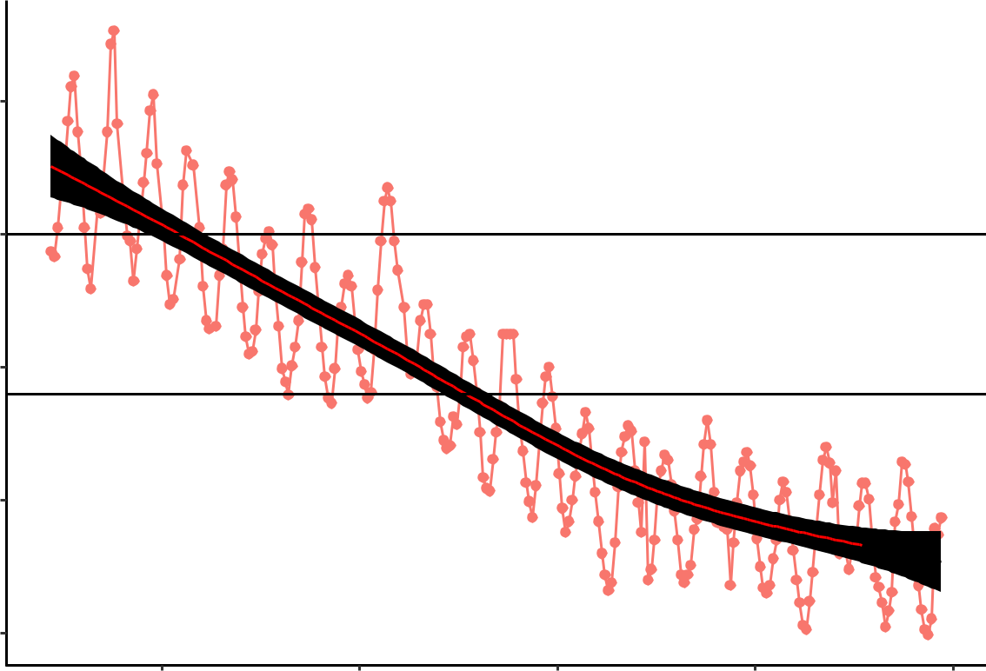

|  |  |  |  |  |  |  |
| --- | --- | --- | --- | --- | --- | --- |
|  | 5.0 |  |  |  |  |  |
| ( )mAHD | 4.5 |  |  |  | Current |  |
|  |  |  |  |  |
|  |  |  |  |  |  |
| Level | 4.0 |  |  |  | Proposed |  |
| Water |  |  |  |  |  |  |
|  | 3.5 |  |  |  |  |  |
|  | 3.0 |  |  |  |  |  |
|  | 2000 | 2005 | 2010 | 2015 | 2020 |  |
|  |  |  | Year |  |  |  |

Figure 58: Groundwater levels recorded at bore 61618500 in the vicinity of Lake Wilgarup. Red segments along trendline indicate preiods of significant decline in groundwater levels.

91

92

|  |
| --- |
| Figure 59: Only the |

Year

|  |  |  |  |  |  |
| --- | --- | --- | --- | --- | --- |
| 2020 | | 2015 | 2010 | 2005 | 2000 |
|  |  |  |  |  |  |
|  |  |  |  |  |  |

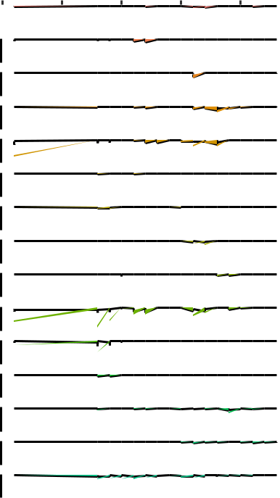

|  |
| --- |
| Cover Abundance |

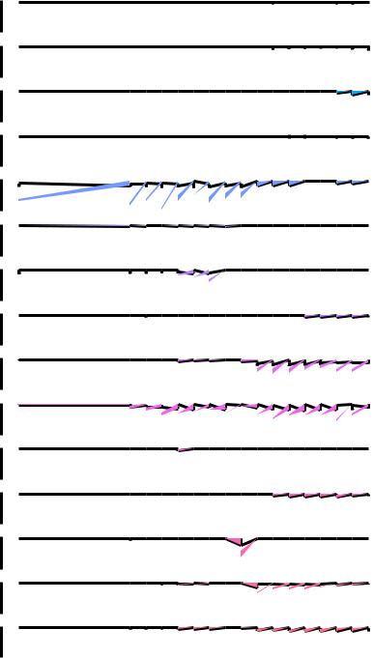

|  |
| --- |
| NA |

X_Anagallis_arvensis

X_Avena_barbata

X_Avena_fatua

X_Briza_maxima

X_Bromus_diandrus

X_Carpobrotus_edulis

X_Cirsium_vulgare

X_Conyza_albida

X_Ehrharta_calycina

X_Ehrharta_longiflora

X_Fumaria_capreolata

X_Galium_murale

X_Hypochaeris_glabra

X_Pelagonium_capitatum

X_Solanum_nigrum

X_Sonchus_asper

X_Sonchus_oleraceus

Banksia_littoralis

Baumea_articulata

Baumea_juncea

Baumea_vaginalis

Cassytha_sp

Centella_cordifolia

Eucalyptus_gomphocephala

Juncus_pallidus

Koala_feed_eucalyptus

Lepidosperma_gladiatum

Lepidosperma_longitudinale

Melaleuca_rhaphiophylla

Myoporum_capraroides

Opercularia_hispida

Scaevola_sp

Spyridium_globulosum

Xanthorrhoea_preissii

Table 17: Ecological consequences of revised thresholds in terms of compliance of stated site values and site management objectives at Lake Wilgarup.

|  |  |  |
| --- | --- | --- |
|  | Likely eﬀect of 2030 revised |  |
|  | thresholds | Future Compliance |
|  | |  |
|  | **Site values** |  |
| * One of few remaining undisturbed | | Not any more |
| wetlands within the region | |  |
| * Rich and unusual vegetation (dense | | No |
| monospecific stands of sedges) | |  |
| * Likely to support diverse fauna | |  |

**Site management objectives**

* Maintain the environmental quality of Lake Wilgarup

|  |  |  |
| --- | --- | --- |
| * Maintain the existing extent and | | No |
|  | variety of wetland vegetation |  |
|  |  |  |

93

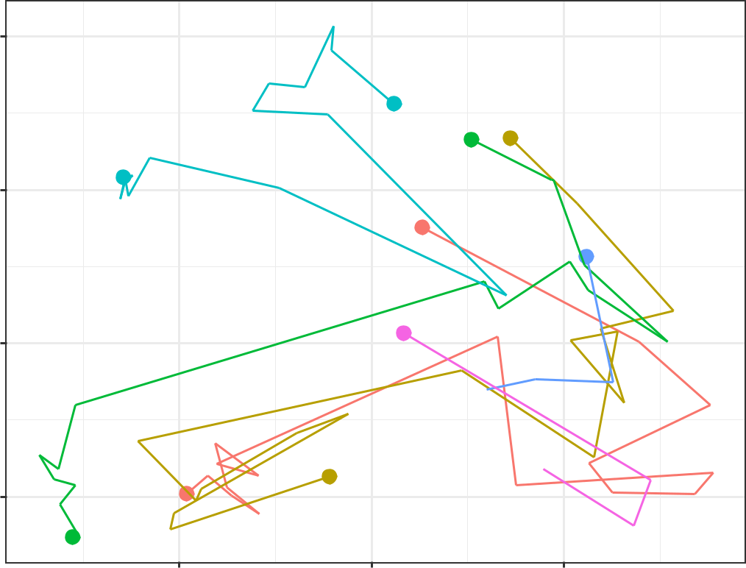

|  |  |  |  |  |  |
| --- | --- | --- | --- | --- | --- |
| 2 |  |  |  |  |  |
|  | 2019 | 2019 |  |  |  |
| 1997 | 2019 |  | Plot |  |  |
|  |  |  |  |
| 1 |  |  |  |  |
|  |  |  |  |  |
|  |  |  | a | A |  |
| LV2 | 2019 | 2019 | a | B |  |
|  |  | a | C |  |
|  |  |  |  |
|  |  |  | a | D |  |
| 0 | 2019 |  | a | X |  |
|  |  |  | a | Y |  |
| 1997 | 1997 |  |  |  |  |
| −1 |  |  |  |  |
| 1997 |  |  |  |  |  |
| −1 | 0 | 1 |  |  |  |
|  | LV1 |  |  |  |  |



Figure 60: Unconstrained ordination based on the latent variable model for each surveyed year for Lake Wilgarup. Plots are represented as diﬀerent colours and consecutive years are joined by a line with first and last survey years labeled.

94

|  |
| --- |
| Species |

X_Sonchus_oleraceus

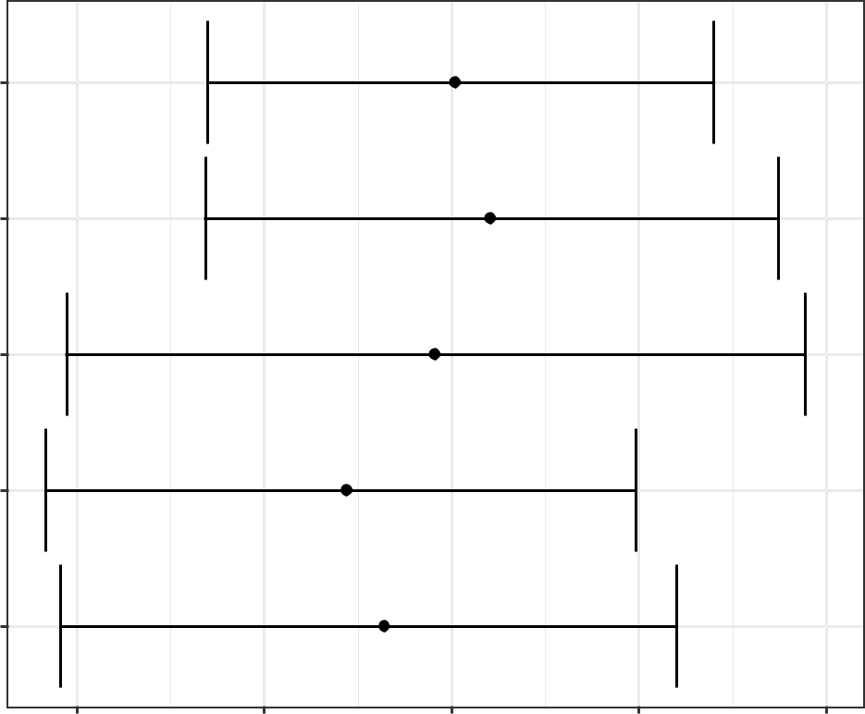

X_Solanum_nigrum

X_Fumaria_capreolata

X_Ehrharta_longiflora

X_Bromus_diandrus

−2.0 −1.5 −1.0 −0.5 0.0

Posterior Mean

Figure 61: Estimated mean regression coeﬃcients (dots) and 95% credible intervals (bars) for eﬀect of groundwater levels at Lake Wilgarup on vegetation species cover abundances based on Bayesian Regression Analysis (HUI REF 2015). Species with a negative mean posterior value are likely to increase in cover abundance as water levels decline. Only those species with coeﬃcients significanlty diﬀerent to zero are shown.

95

Table 18: Five year summaries of surface water level data at Pipidinny Swamp

|  |  |  |  |  |  |  |  |
| --- | --- | --- | --- | --- | --- | --- | --- |
| Period | Mean max seasonal | Mean min seasonal | Mean seasonal change | Month of | Month of | Mean max to |  |
| level (mAHD) | level (mAHD) | (m) | maximum | minimum | min (days) |  |
|  |  |
|  |  |  |  |  |  |  |  |
| 08/1994 - 07/1999 | 3.2 | 1.8 | 1.34 | September | May | 213 |  |
| 08/1999 - 07/2004 | 2.8 | 1.8 | 0.98 | October | March | 168 |  |
| 08/2004 - 07/2009 | 2.4 | 2.0 | 0.39 | September | November | 12 |  |
| 08/2009 - 07/2014 | 2.0 | 1.0 | 0.98 | October | July | 88 |  |
| 08/2014 - 07/2019 | 2.0 | 1.0 | 0.97 | September | January | 124 |  |
|  |  |  |  |  |  |  |  |

**Pipidinny Swamp**

Vegetation damaged by a fire in 2005. Macroinvertebrate and water quality monitoring occurred in the 2000s but ceased in 2011 as the wetland was atypical and had little water. A single vegetation survey has been conducted in September 2019 and the results presented here.

**Hydrology**

There has been at least a 2 m decline in surface water levels at Pipidinny Swamp since the mid 1990’s, although measurements at the staﬀ gauge were frequently below the minimum recordable level in the mid-late 2000’s to 2019 despite the gauge being moved in 2010 (Figure 62). Mean maximum seasonal surface waters are at least 1.2 m lower now than in the 1994-1999 seasons (Table 18). Records of minimum levels are diﬃcult to interpret due to the water levels frequently being below the staﬀ gauge. Groundwater levels at the nearby bore 61611872 suggest that water levels at the swamp are no longer in decline, however this conclusion assumes groundwater levels at the bore and surface water levels at the staﬀ gauge are related (Figure 62). It is not possible to verify this assumption as groundwater measurements have only been made while the surface water levels have been below detection limits for the staﬀ gauge.

It is likely that water levels in Yanchep National Park will increase under the proposed 2030 changes in groundwater abstraction. The proposed threshold level of 1.1 m at bore 61611872 is likely to slightly increase or stabilise surface water levels in Pipidinny Swamp.

**Vegetation character**

The transect at Pipidinny Swamp consists of a series of depressions/swamps interspersed with tracks and grassy banks. The transect was established close to the bore but is only 20 m in length due to the terrain. Subsequently, only four *Melaleuca* trees could be included. Species richness and diversity on and around the transect was low, with *Acacia saligna* the dominant overstorey species, although *Melaleuca rhaphiophylla* appeared in good health (both on and around the transect). *Baumea articulata* was present, albeit in low abundance, several meters up slope from the surface water, and was in moderate health with a couple of dead stems present. No recruitment was recorded. The location’s potential value as important habitat was indicated by the presence of a south west carpet python in amongst the *Typha*. A number of exotic species are abundant at the site, including *Bromus diandrus*, *Ehrharta longiflora* and *Typha orientalis*.

**Revised water level threshold eﬀects**

The site values of Pipidinny Swamp are unlikely to be maintained under the proposed changes to groundwater abstraction (Table 20).

96

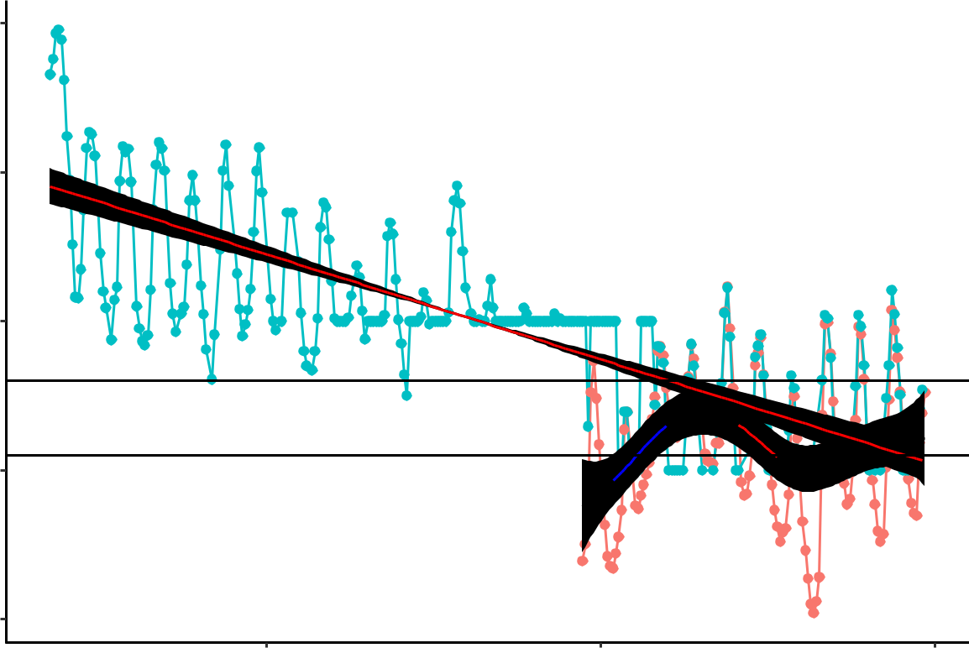

|  |  |  |  |  |  |
| --- | --- | --- | --- | --- | --- |
|  | 4 |  |  |  |  |
|  | 3 |  |  |  |  |
| ( )mAHD |  |  |  |  |  |
| Level | 2 |  |  |  |  |
|  | Current |  |  |  |
| Water |  |  |  |  |  |
|  | 1 | Proposed |  |  |  |
|  |  |  |  |  |
|  | 0 |  |  |  |  |
|  |  | 2000 | 2010 | 2020 |  |
|  |  |  | Year |  |  |

Figure 62: Ground and surface water levels recorded at bore 61611872 (red) and staﬀ gauge 6162624 (blue) that represent fluctuations in water levels at Pipidinny Swamp. Surface water levels were initially only recordable above 2 mAHD and later above 1 mAHD. Red segments of trend line represent periods of significant decline in water levels while blue segments represent periods of significant increases in water levels.

97

Table 19: Vegetation cover abundance at the two plots established at Pipidinny Swamp in September 2019.

|  |  |  |  |  |
| --- | --- | --- | --- | --- |
| Species | Plot A | Plot B | Status |  |
|  |  |  |  | |
| *Bromus diandrus* | 4 | 9 | Exotic |  |
| *Cirsium vulgare* | 2 | 0 | Exotic | |
| *Ehrharta longiflora* | 7 | 9 | Exotic | |
| *Euphorbia sp.* | 0 | 1 | Exotic | |
| *Fumaria muralis* | 2 | 3 | Exotic | |
| *Pelargonium capitatum* | 2 | 2 | Exotic | |
| *Sonchus oleraceus* | 2 | 1 | Exotic | |
| *Symphiotrichum squamatum* | 1 | 0 | Exotic | |
| *Typha orientalis* | 6 | 0 | Exotic | |
| *Acacia saligna* | 6 | 10 | Native | |
| *Baumea articulata* | 2 | 0 | Native | |
| *Melaleuca rhaphiophylla* | 4 | 0 | Native | |
| *Myoporum caprarioides* | 3 | 2 | Native | |
| *Rhagodia baccata* | 3 | 4 | Native | |
| *Spyridium globulosum* | 3 | 3 | Native | |
|  |  |  |  |  |

Table 20: Ecological consequences of revised thresholds in terms of compliance of stated site management objectives at Pipidinny Swamp.

|  |  |  |  |
| --- | --- | --- | --- |
|  |  | Likely eﬀect of 2030 revised |  |
|  |  | thresholds | Future Compliance |
|  |  |  |  |
|  | **Site management objectives** |  |  |
| * Improve groundwater levels to | | Water levels are currently more | No |
|  | increase area of permanent deep water | than 1 m lower than pre-2000 levels. |  |
|  | habitat for fauna | Proposed changes to abstraction |  |
|  |  | are unlikely to restore the swamp to |  |
|  |  | these water levels |  |
| * Improve groundwater levels to | | I have no data | Unlikely |
|  | maintain fringing vegetation to support |  |  |
|  | a range of habitat types for |  |  |
|  | macroinvertebrates |  |  |
|  |  |  |  |

98

Table 21: Five year summaries of surface water level data at Lexia 186

|  |  |  |  |  |  |  |  |
| --- | --- | --- | --- | --- | --- | --- | --- |
| Period | Mean max seasonal | Mean min seasonal | Mean seasonal change | Month of | Month of | Mean max to |  |
| level (mAHD) | level (mAHD) | (m) | maximum | minimum | min (days) |  |
|  |  |
|  |  |  |  |  |  |  |  |
| 08/1994 - 07/1999 | 3.2 | 1.8 | 1.34 | September | May | 213 |  |
| 08/1999 - 07/2004 | 2.8 | 1.8 | 0.98 | October | March | 168 |  |
| 08/2004 - 07/2009 | 2.4 | 2.0 | 0.39 | September | November | 12 |  |
| 08/2009 - 07/2014 | 2.0 | 1.0 | 0.98 | October | July | 88 |  |
| 08/2014 - 07/2019 | 2.0 | 1.0 | 0.97 | September | January | 124 |  |
|  |  |  |  |  |  |  |  |

**Lexia 186**

The Lexia 186 wetland has a high conservation value because it (R Froend, R. C. Loomes, et al., 2004). The Lexia system of wetlands is composed of three separate wetlands, Lexia 86, Lexia 94 and Lexia 186. Lexia 186 was normally a seasonally waterlogged basin (Dampland), however, prolonged decline of groundwater levels mean water levels are below the level of the basin all year. There has been dramatic shifts in fringing vegetation health and composition as the basin sediments dry and oxidise.

**Hydrology**

There has almost been a significant decline in groundwater levels at Lexia 186 from 1996 to 2015 by approximately 1 m and a significant increases in water levels since 2015 by 0.5 m (Figure 63). Nonetheless, current mean maximum and minimum water levels are 1.2 and 0.8 m below 1994-1999 levels and seasonally minimums are occurring earlier in the year (Table 21). Groundwater levels at Lexia 186 have been non-compliant since 2000. Proposed reductions in groundwater abstraction are not projected to increase water levels in the dampland, therefore a threshold 0.7m below the current threshold has been proposed for 2030. This projection will maintain groundwater at similar levels to the period between 2010-2015.

**Vegetation dynamics**

Vegetation monitoring has been occurring at Lexia 186 since 1997 with the last survey conducted in 2018 (Figure 64). Overall canopy health has remained stable with most *Melaleuca preissiana* in good or excellent condition and most *Banksia ilicifolia* with average condition (Buller et al., 2018). Exotic richness is very low at Lexia 186 and natives account for approximately 90 % of total cover abundance at the transect. Ordination reveals similar trajectories in compositional change for each plot that reflect the continual changes in cover abundances of species (Figure 65). Regression analyses did not reveal significant eﬀects of groundwater levels on any of the species present at Lexia 186 (Figure **??**). This result suggests that community composition is changing due to other factors that are independent of groundwater. This is surprising given the significant declines in groundwater at the site. (NOT SURE IF THERE IS ANY Baumea AT THE SITE AND WHETHER IT HAS DECLINED OR DISAPPEARED - PERHAPS WORTH A COMMENT) (ARE THERE ANY OTHER DRAMTIC CHANGES AT THE SITE?) WILL RE RUN ANALYSIS TO CONFIRM.

**Revised water level threshold eﬀects**

The site values of the Lexia 186 wetland are unlikely to be maintained under the proposed changes to groundwater abstraction (Table 22).

99

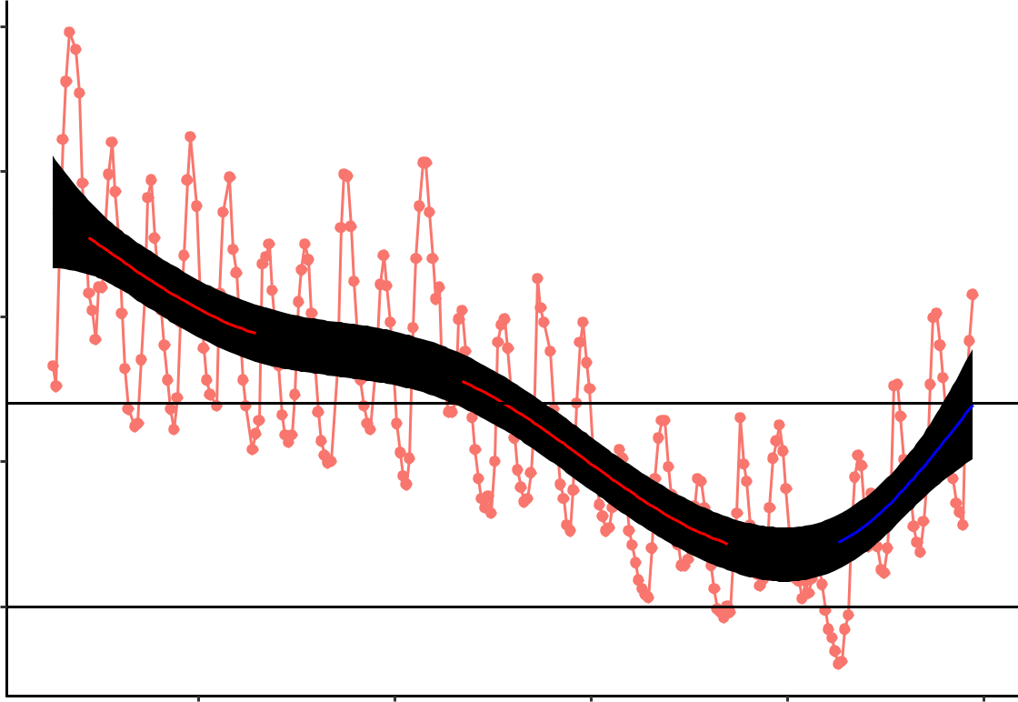

|  |  |  |  |  |  |  |
| --- | --- | --- | --- | --- | --- | --- |
|  | 48.5 |  |  |  |  |  |
|  | 48.0 |  |  |  |  |  |
| ( )mAHD | 47.5 |  |  |  |  |  |
| Level |  |  |  |  |  |  |
| Water | Current |  |  |  |  |  |
| 47.0 |  |  |  |  |  |
|  | Proposed |  |  |  |  |  |
|  | 46.5 |  |  |  |  |  |
|  | 2000 | 2005 | 2010 | 2015 | 2020 |  |
|  |  |  | Year |  |  |  |

Figure 63: Groundwater levels recorded at bore 61613214 that represent water level fluctuations at Lexia 186. Red segments represent periods of significant decline in water levels while blue segments represent periods of significant increase in water levels.

100

|  |
| --- |
| 101 |

|  |  |  |  |  |  |  |  |  |  |  |  |  |  |  |  |  |  |  |  |  |  |  |  |  |  |  |  |  |  |  |  |  |  |  |  |
| --- | --- | --- | --- | --- | --- | --- | --- | --- | --- | --- | --- | --- | --- | --- | --- | --- | --- | --- | --- | --- | --- | --- | --- | --- | --- | --- | --- | --- | --- | --- | --- | --- | --- | --- | --- |
|  | X Hypochaeris glabra | X Ursinia anthemoides | Acacia pulchella | Adenanthos obovatus | Astartea scoparia | Banksia attenuata | Banksia ilicifolia | Chamaescilla corymbosa | Dasypogon bromeliifolius | Euchilopsis linearis | Gompholobium tomentoseum | Hibbertia stellaris | Hibbertia subvaginata | Hypocalymma angustifolium | Hypolaena exsulca | Lagenophora huegelii | Lepidosperma longitudinale | Lepidosperma squarrosa | Leucopogon racemulosus | Levenhookia pusilla | Lomandra sp_ | Macrozamia riedlei | Melaleuca preissiana | Orthrosanthus laxus | Patersonia occidentalis | Pericalymma ellipticum | Pulteneaea reticulata | Schoenus sp1 | Scholtzia involucrata | Siloxerus filifolius | Stylidium brunonianum | Stylidium repens | Trachymene pilosa | Xanthorrhoea preissii |  |
|  | 2000 |  |  |  |  |  |  |  |  |  |  |  |  |  |  |  |  |  |  |  |  |  |  |  |  |  |  |  |  |  |  |  |  |  |  |
|  | 2005 |  |  |  |  |  |  |  |  |  |  |  |  |  |  |  |  |  |  |  |  |  |  |  |  |  |  |  |  |  |  |  |  | A |  |
|  | 2010 |  |  |  |  |  |  |  |  |  |  |  |  |  |  |  |  |  |  |  |  |  |  |  |  |  |  |  |  |  |  |  |  |  |
|  |  |  |  |  |  |  |  |  |  |  |  |  |  |  |  |  |  |  |  |  |  |  |  |  |  |  |  |  |  |  |  |  |  |  |
|  | 2015 |  |  |  |  |  |  |  |  |  |  |  |  |  |  |  |  |  |  |  |  |  |  |  |  |  |  |  |  |  |  |  |  |  |  |
|  | 2000 |  |  |  |  |  |  |  |  |  |  |  |  |  |  |  |  |  |  |  |  |  |  |  |  |  |  |  |  |  |  |  |  |  |  |
|  | 2005 |  |  |  |  |  |  |  |  |  |  |  |  |  |  |  |  |  |  |  |  |  |  |  |  |  |  |  |  |  |  |  |  | B |  |
|  | 2010 |  |  |  |  |  |  |  |  |  |  |  |  |  |  |  |  |  |  |  |  |  |  |  |  |  |  |  |  |  |  |  |  |  |
|  |  |  |  |  |  |  |  |  |  |  |  |  |  |  |  |  |  |  |  |  |  |  |  |  |  |  |  |  |  |  |  |  |  |  |
| Year | 2015 |  |  |  |  |  |  |  |  |  |  |  |  |  |  |  |  |  |  |  |  |  |  |  |  |  |  |  |  |  |  |  |  |  |  |
| 2000 |  |  |  |  |  |  |  |  |  |  |  |  |  |  |  |  |  |  |  |  |  |  |  |  |  |  |  |  |  |  |  |  |  |  |
|  |  |  |  |  |  |  |  |  |  |  |  |  |  |  |  |  |  |  |  |  |  |  |  |  |  |  |  |  |  |  |  |  |  |  |
|  | 2005 |  |  |  |  |  |  |  |  |  |  |  |  |  |  |  |  |  |  |  |  |  |  |  |  |  |  |  |  |  |  |  |  | C |  |
|  | 2010 |  |  |  |  |  |  |  |  |  |  |  |  |  |  |  |  |  |  |  |  |  |  |  |  |  |  |  |  |  |  |  |  |  |
|  |  |  |  |  |  |  |  |  |  |  |  |  |  |  |  |  |  |  |  |  |  |  |  |  |  |  |  |  |  |  |  |  |  |  |
|  | 2015 |  |  |  |  |  |  |  |  |  |  |  |  |  |  |  |  |  |  |  |  |  |  |  |  |  |  |  |  |  |  |  |  |  |  |
|  | 2000 |  |  |  |  |  |  |  |  |  |  |  |  |  |  |  |  |  |  |  |  |  |  |  |  |  |  |  |  |  |  |  |  |  |  |
|  | 2005 |  |  |  |  |  |  |  |  |  |  |  |  |  |  |  |  |  |  |  |  |  |  |  |  |  |  |  |  |  |  |  |  | D |  |
|  | 2010 |  |  |  |  |  |  |  |  |  |  |  |  |  |  |  |  |  |  |  |  |  |  |  |  |  |  |  |  |  |  |  |  |  |
|  |  |  |  |  |  |  |  |  |  |  |  |  |  |  |  |  |  |  |  |  |  |  |  |  |  |  |  |  |  |  |  |  |  |  |
|  | 2015 |  |  |  |  |  |  |  |  |  |  |  |  |  |  |  |  |  |  |  |  |  |  |  |  |  |  |  |  |  |  |  |  |  |  |

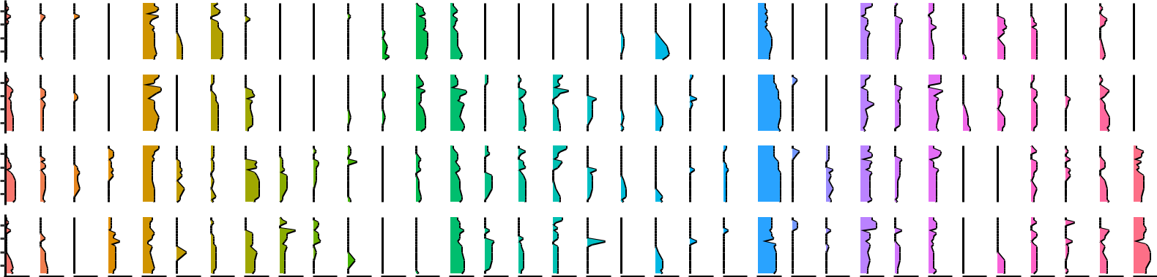

Cover Abundance

Figure 64: Cover abundances for each species across the four plots (A, B, C, D) at the Lexia 186 transect. Invasive species are denoted by ‘X’. Only the most common species are included.

Table 22: Ecological consequences of revised thresholds in terms of compliance of stated site management objectives at the Lexia 186 wetland.

Likely eﬀect of 2030 revised thresholds Future Compliance

**Site values**

Undisturbed by typical impacts No

Supports diverse vegetation

Significant fauna habitat

**Site management objectives**

Conserve ecological values No Protect vegetation assemblages in and fringing the wetland Protect invertebrate communities dependent on the wetland

102

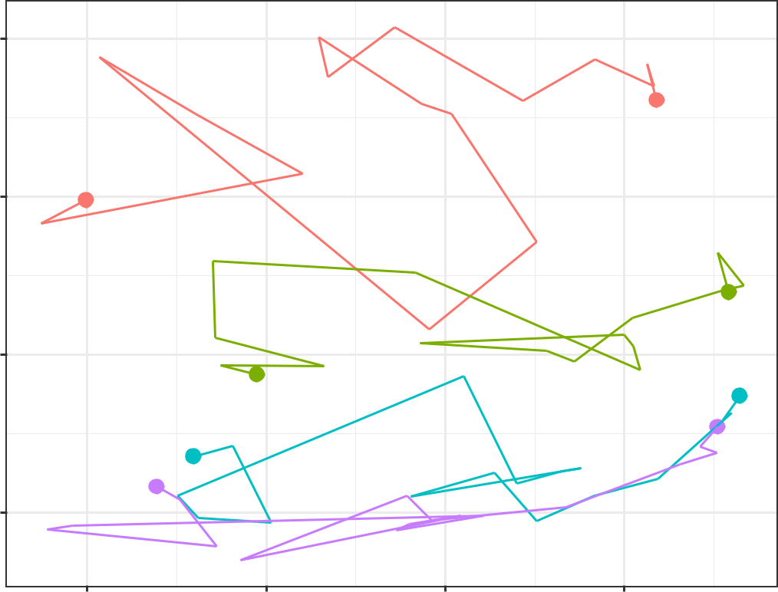

|  |  |  |  |  |  |  |
| --- | --- | --- | --- | --- | --- | --- |
| 2 |  |  |  |  |  |  |
|  |  |  |  | 2018 |  |  |
| 1 | 1997 |  |  |  |  |  |
|  |  |  | Plot |  |  |
|  |  |  |  |  |  |
| LV2 |  |  |  | a | A |  |
|  |  |  | a | B |  |
|  |  |  |  | 2018 |  |  |
|  |  |  |  | a | C |  |
| 0 |  | 1997 |  | a | D |  |
|  |  |  |  | 2018 |  |  |
|  |  |  |  | 2018 |  |  |
|  |  | 1997 |  |  |  |  |
| −1 | 1997 |  |  |  |  |  |
|  |  |  |  |  |  |
|  | −2 | −1 | 0 | 1 |  |  |
|  |  |  | LV1 |  |  |  |



Figure 65: Unconstrained ordination based on the latent variable model for each surveyed year for Lexia 186. Plots are represented as diﬀerent colours and consecutive years are joined by a line with first and last survey years labeled.

103

**Melaleuca Park 173**

Melaleuca Park 173 (EPP 173) is located within the Bassendean North Vegetation Complex and represents a regionally significant wetland (Hill et al., 1996). Normally, the site represents a permanently filled lake that is fed from a series of springs along the western margin of the basin (R Froend, R. C. Loomes, et al., 2004; Judd and Horwitz, 2019). The waters supported a rich macroinvertebrate community and an endemic population of the black-striped minnow (*Galaxiella nigrostriata*). There have been dramatic decreases in surface and groundwater levels in recent decades, to the point where the lake is almost dry during the summer months. Declining water levels are thought to have caused the local extinction of the black-striped minnow and degradation of fringing vegetation.

**Hydrology and water quality**

There has been a prolonged decline in surface water levels since 1990 that show similar trends with fluctuations in groundwater levels (bore 61613213; Figure 66). Surface water level measurements are now unreliable at staﬀ 6162628 due to water levels usually being below the minimum level of the staﬀ. Since 2011, groundwater levels have been stable. Mean maximum and minimum water levels have decreased by 0.8 m and 0.5 m, respectively, since 1994 (Table 23). The latest 5 year period (2014-2019) suggests that groundwaters are reaching annual minimums earlier in the year than in previous seasons. Groundwater levels have been non-compliant during the monitoring period. The proposed threshold level of 48.5 mAHD is 1.7 m lower than the current threshold. Managing the wetland to these levels may result in further declines in water levels.

Melaleuca Park 173 is the only monitored wetland to show organic acidity (Judd and Horwitz, 2019). The waters are dark and have high gilvin levels (94.7 FTU). The acidic water have a pH between 3.4 and 5.1. Recent monitoring suggests current pH is low (3.7). The lake usually has total nitrogen levels between 2000 and 2800 *µ*g/L.

**Vegetation dynamics**

Vegetation monitoring has been occurring at Melaleuca Park from 1997 to 2018 (Buller et al., 2019). There has been marked changes in vegetation composition along the transect during this monitoring period (Figure 67). In 2014, *Baumea articulata* was absent from the transect, however, due to a wet season which saw Plot A and B submerged in 2018, *B. articulata* was recorded in low abundance. Similar changes have been observed for *Astartea scoparia*, which prior to 2018 was recorded wither dead or in poor condition. Since 2018, many of the *A. scoparia* plants were observed with new shoots. Other important vegetation components in Plot A include *Lepidosperma longitudinale* and *Leptocarpus scariosus*, both of which are also present in Plot B, whilst the former is present throughout the transect. The long-term decline in water levels has had an adverse eﬀect on the health of the *Melaleuca preissiana* population. Generally, this important canopy forming species has been declining in health, despite slight increases in plant health for 2018. The slight increase in *M. preissiana* health may be attributed to the recent stabilisation of groundwater in levels.

Ordination reveals distinct shifts in community composition since 1997 (Figure 68). Although Plot A is distinct, in terms of vegetation cover abundances, to Plots B, C and D, all plots display an upwards trajectory along the second axis (LV2). For Plot A, this the shift in composition is likely due to the loss of *B. articulata* from the plot. Modeling compositional changes in vegetation with changes in groundwater levels suggests a number of species which are likely to increase in cover abundance with declining groundwater levels (Figure 69). These species, such as *Xanthorrhoea preissii* and *Dielsia stenostachya*, are likely to increase in cover abundance in lower areas of the basin under a scenario of continuing declining groundwater levels.

**Aquatic Invertebrates**

Aquatic macroinvertebrate family richness has been declining since the late 2000’s when water levels began declining (Figure 71). As water chemistry has changed little during this period, the decline in richness is

104

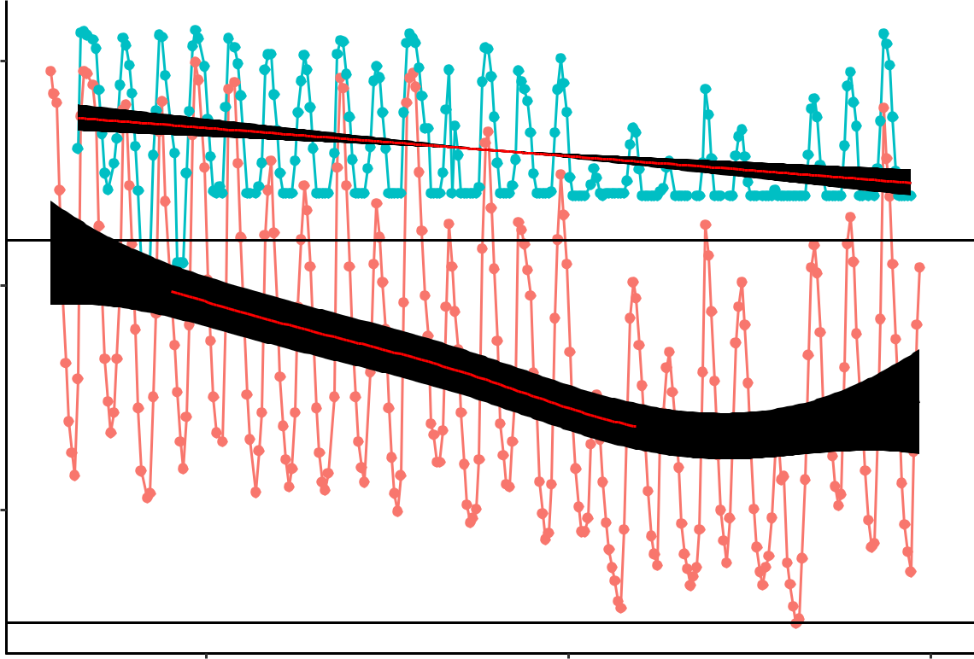

|  |  |  |  |  |
| --- | --- | --- | --- | --- |
|  | 51 |  |  |  |
| ( )mAHD |  |  | Current |  |
| 50 |  |  |  |
|  |  |  |  |
| Water Level |  |  |  |  |
|  | 49 |  |  |  |
|  |  |  | Proposed |  |
|  | 2000 | 2010 | 2020 |  |
|  |  | Year |  |  |

Figure 66: Ground and surface water levels for Melaleuca Park 173 recorded at bore 61613213 (red) and staﬀ 6162628 (blue). The minimum recordable water level for the staﬀ gaugue is 50.4 mAHD. Blue dots at 50.4 mAHD represent water levels below the minimum level measurable by the staﬀ. Red segments on fitted line represent statistically significant periods of declining water levels. Current and proposed threshold levels for bore 61613213 are represented by dotted and dashed lines, respectively.

likely due to the degradation of habitats caused by the lower surface waters and extended dry periods during summer (GMEMP 2019). Macroinvertebrate assemblage composition has shifted since the initial 2000 survey (Figure 72). Since 2011, assemblage composition has been shifting away from the 2000 community, suggesting further shifts in composition are likely due to sustained low water levels. Taxa that have disappeared from the wetland include Chydoridae, Leptoceridae, Orthocladiinae and Unioncolidae (Figure 70).

**Revised water level threshold eﬀects**

It is likely that management many of the site values of the Melaleuca Park wetland will be achievable given the projected decline in groundwater levels (Table 24).

105

Table 23: Five year summaries of groundwater level data at Melaleuca Park 173. Data is based from bore 61613213 due to many readings on surface water staﬀ 6162628 being below the minimum reading level of 50.4 mAHD.

|  |  |  |  |  |  |  |  |
| --- | --- | --- | --- | --- | --- | --- | --- |
| Period | Mean max seasonal | Mean min seasonal | Mean seasonal change | Month of | Month of | Mean max to |  |
| level (mAHD) | level (mAHD) | (m) | maximum | minimum | min (days) |  |
|  |  |
|  |  |  |  |  |  |  |  |
| 08/1994 - 07/1999 | 50.9 | 49.2 | 1.73 | September | May | 242 |  |
| 08/1999 - 07/2004 | 50.8 | 49.1 | 1.66 | September | May | 220 |  |
| 08/2004 - 07/2009 | 50.6 | 49.0 | 1.59 | September | May | 168 |  |
| 08/2009 - 07/2014 | 50.0 | 48.7 | 1.27 | October | June | 224 |  |
| 08/2014 - 07/2019 | 50.1 | 48.7 | 1.38 | September | April | 225 |  |
|  |  |  |  |  |  |  |  |

106

|  |
| --- |
| 107 |

|  |  |  |  |  |  |  |  |  |  |  |  |  |  |  |  |  |  |  |  |  |  |  |  |  |  |  |  |  |  |  |  |  |  |  |  |  |  |  |  |  |  |  |
| --- | --- | --- | --- | --- | --- | --- | --- | --- | --- | --- | --- | --- | --- | --- | --- | --- | --- | --- | --- | --- | --- | --- | --- | --- | --- | --- | --- | --- | --- | --- | --- | --- | --- | --- | --- | --- | --- | --- | --- | --- | --- | --- |
|  | X Briza maxima | X Hypochaeris glabra | X Moraea sp_ | Acacia pulchella | Amphipogon laguroides | Aotus gracillima | Astartea scoparia | Baumea articulata | Caladenia marginata | Calothamnus lateralis | Cassytha racemosa | Chamaescilla corymbosa | Corymbia calophylla | Dampiera linearis | Dasypogon bromeliifolius | Dielsia stenostachya | Drosera macrantha | Drosera pallida | Euchilopsis linearis | Gonocarpus pithyoides | Hibbertia stellaris | Hypocalymma angustifolium | Hypolaena exsulca | Lepidosperma longitudinale | Leptocarpus scariosus | Leucopogon australis | Loxocarya flexuosa | Melaleuca preissiana | Orthrosanthus laxus | Patersonia occidentalis | Pericalymma ellipticum | Platytheca galioides | Pterostylis nana | Schoenus sp1 | Sphaerolobium sp_ | Stylidium brunonianum | Taxandria linearifolia | Thelymitra macrophylla | Thysanotus multiflorus | Xanthorrhoea preissii | Xanthosia huegelii |  |
|  | 2000 |  |  |  |  |  |  |  |  |  |  |  |  |  |  |  |  |  |  |  |  |  |  |  |  |  |  |  |  |  |  |  |  |  |  |  |  |  |  |  |  |  |
|  | 2005 |  |  |  |  |  |  |  |  |  |  |  |  |  |  |  |  |  |  |  |  |  |  |  |  |  |  |  |  |  |  |  |  |  |  |  |  |  |  |  | A |  |
|  | 2010 |  |  |  |  |  |  |  |  |  |  |  |  |  |  |  |  |  |  |  |  |  |  |  |  |  |  |  |  |  |  |  |  |  |  |  |  |  |  |  |  |
|  |  |  |  |  |  |  |  |  |  |  |  |  |  |  |  |  |  |  |  |  |  |  |  |  |  |  |  |  |  |  |  |  |  |  |  |  |  |  |  |  |  |
|  | 2015 |  |  |  |  |  |  |  |  |  |  |  |  |  |  |  |  |  |  |  |  |  |  |  |  |  |  |  |  |  |  |  |  |  |  |  |  |  |  |  |  |  |
|  | 2000 |  |  |  |  |  |  |  |  |  |  |  |  |  |  |  |  |  |  |  |  |  |  |  |  |  |  |  |  |  |  |  |  |  |  |  |  |  |  |  |  |  |
|  | 2005 |  |  |  |  |  |  |  |  |  |  |  |  |  |  |  |  |  |  |  |  |  |  |  |  |  |  |  |  |  |  |  |  |  |  |  |  |  |  |  | B |  |
|  | 2010 |  |  |  |  |  |  |  |  |  |  |  |  |  |  |  |  |  |  |  |  |  |  |  |  |  |  |  |  |  |  |  |  |  |  |  |  |  |  |  |  |
|  |  |  |  |  |  |  |  |  |  |  |  |  |  |  |  |  |  |  |  |  |  |  |  |  |  |  |  |  |  |  |  |  |  |  |  |  |  |  |  |  |  |
| Year | 2015 |  |  |  |  |  |  |  |  |  |  |  |  |  |  |  |  |  |  |  |  |  |  |  |  |  |  |  |  |  |  |  |  |  |  |  |  |  |  |  |  |  |
| 2000 |  |  |  |  |  |  |  |  |  |  |  |  |  |  |  |  |  |  |  |  |  |  |  |  |  |  |  |  |  |  |  |  |  |  |  |  |  |  |  |  |  |
|  |  |  |  |  |  |  |  |  |  |  |  |  |  |  |  |  |  |  |  |  |  |  |  |  |  |  |  |  |  |  |  |  |  |  |  |  |  |  |  |  |  |
|  | 2005 |  |  |  |  |  |  |  |  |  |  |  |  |  |  |  |  |  |  |  |  |  |  |  |  |  |  |  |  |  |  |  |  |  |  |  |  |  |  |  | C |  |
|  | 2010 |  |  |  |  |  |  |  |  |  |  |  |  |  |  |  |  |  |  |  |  |  |  |  |  |  |  |  |  |  |  |  |  |  |  |  |  |  |  |  |  |
|  |  |  |  |  |  |  |  |  |  |  |  |  |  |  |  |  |  |  |  |  |  |  |  |  |  |  |  |  |  |  |  |  |  |  |  |  |  |  |  |  |  |
|  | 2015 |  |  |  |  |  |  |  |  |  |  |  |  |  |  |  |  |  |  |  |  |  |  |  |  |  |  |  |  |  |  |  |  |  |  |  |  |  |  |  |  |  |
|  | 2000 |  |  |  |  |  |  |  |  |  |  |  |  |  |  |  |  |  |  |  |  |  |  |  |  |  |  |  |  |  |  |  |  |  |  |  |  |  |  |  |  |  |
|  | 2005 |  |  |  |  |  |  |  |  |  |  |  |  |  |  |  |  |  |  |  |  |  |  |  |  |  |  |  |  |  |  |  |  |  |  |  |  |  |  |  | D |  |
|  | 2010 |  |  |  |  |  |  |  |  |  |  |  |  |  |  |  |  |  |  |  |  |  |  |  |  |  |  |  |  |  |  |  |  |  |  |  |  |  |  |  |  |
|  |  |  |  |  |  |  |  |  |  |  |  |  |  |  |  |  |  |  |  |  |  |  |  |  |  |  |  |  |  |  |  |  |  |  |  |  |  |  |  |  |  |
|  | 2015 |  |  |  |  |  |  |  |  |  |  |  |  |  |  |  |  |  |  |  |  |  |  |  |  |  |  |  |  |  |  |  |  |  |  |  |  |  |  |  |  |  |

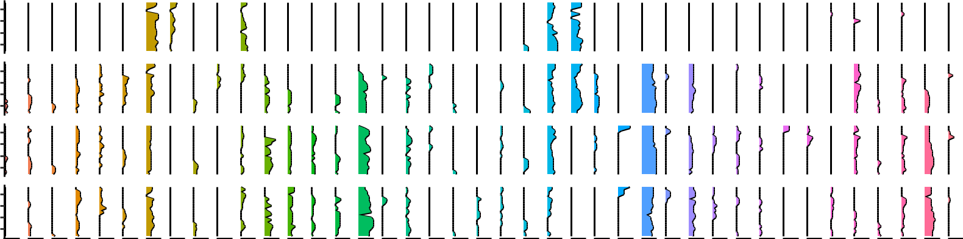

Cover Abundance

Figure 67: Cover abundances for each species across the four plots (A, B, C, D) at the Melaleuca Park 173 transect recorded for the survey period.

Invasive species are denoted by ‘X’. Only the most common species are included.

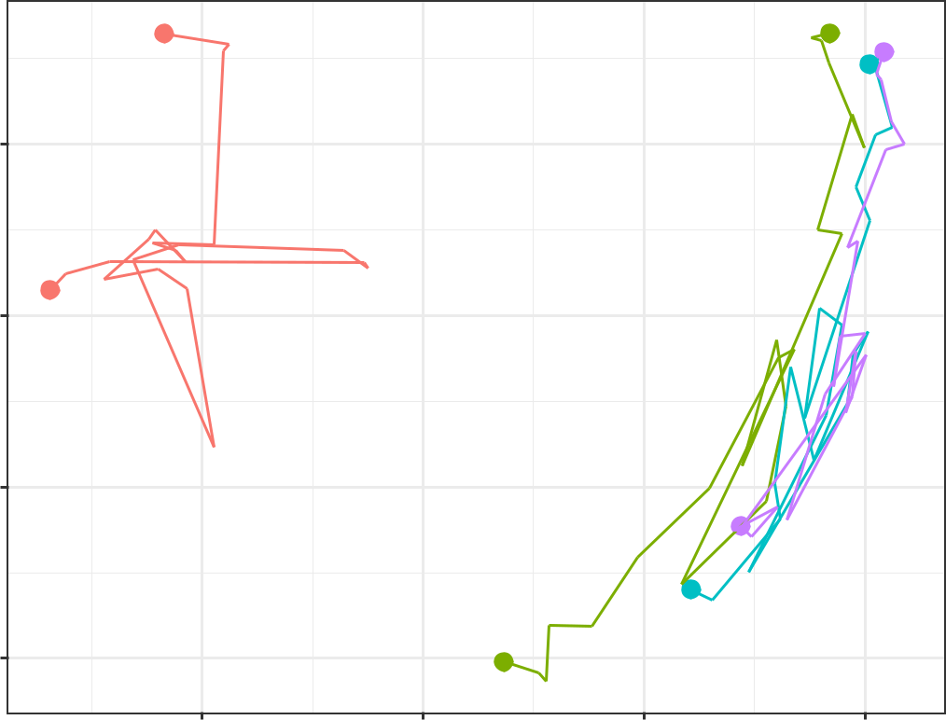

|  |  |  |  |  |  |  |  |
| --- | --- | --- | --- | --- | --- | --- | --- |
|  | 2018 |  |  | 2018 | 2018 |  |  |
|  |  |  |  |  |  |  |
|  |  |  |  | 2018 |  |  |  |
| 1 |  |  |  |  |  |  |  |
|  |  |  |  |  | Plot |  |  |
| 0 | 1997 |  |  |  | a | A |  |
| LV2 |  |  |  |  | a | B |  |
|  |  |  |  |  |  |
|  |  |  |  |  | a | C |  |
|  |  |  |  |  | a | D |  |
| −1 |  |  |  |  |  |  |  |
|  |  |  |  | 1997 |  |  |  |
|  |  |  |  | 1997 |  |  |  |
| −2 |  |  | 1997 |  |  |  |  |
|  |  |  |  |  |  |  |
|  | −2 | −1 | 0 | 1 |  |  |  |
|  |  |  | LV1 |  |  |  |  |



Figure 68: Unconstrained ordination based on the latent variable model for each surveyed year for Melaleuca Park 173. Plots are represented as diﬀerent colours and consecutive years are joined by a line with first and last survey years labeled.

108

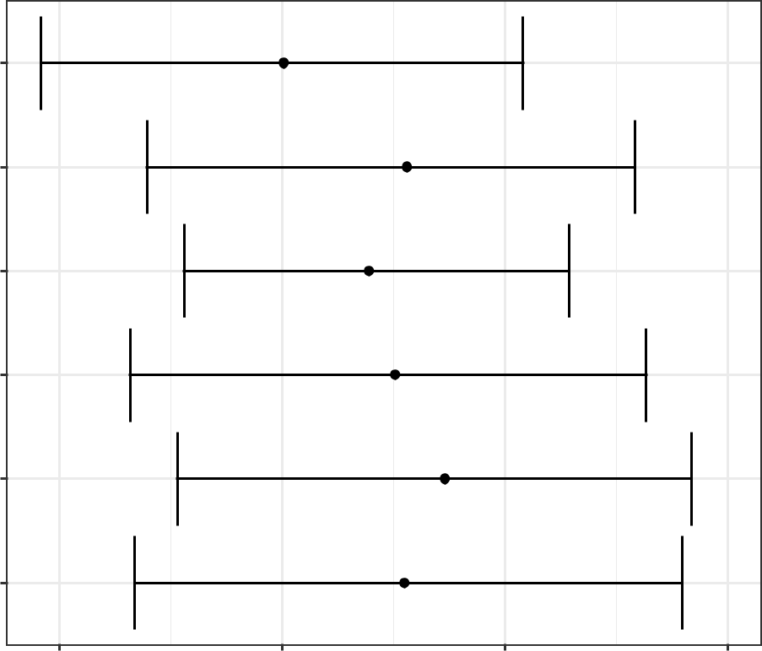

Xanthorrhoea_preissii

Patersonia_occidentalis

Dielsia_stenostachya

|  |
| --- |
| Species |

Dasypogon_bromeliifolius

Corymbia_calophylla

Chamaescilla_corymbosa

−3 −2 −1 0

Posterior Mean

Figure 69: Estimated mean regression coeﬃcients (dots) and 95% credible intervals (bars) for eﬀect of groundwater levels at Melaleuca Park 173 on vegetation species cover abundances based on Bayesian Regression Analysis (HUI REF 2015). Species with a negative mean posterior value are likely to increase in cover abundance as water levels decline. Only those species with coeﬃcients significanlty diﬀerent to zero are shown.

109

|  |  |  |  |  |  |  |  |  |  |  |  |  |  |  |  |  |  |  |  |  |  |  |  |  |  |  |
| --- | --- | --- | --- | --- | --- | --- | --- | --- | --- | --- | --- | --- | --- | --- | --- | --- | --- | --- | --- | --- | --- | --- | --- | --- | --- | --- |
| Limnesiidae | Unioncolidae | Parastacidae | Aeshnidae | Lestidae | Ecnomidae | Leptoceridae | Corixidae | Mesoveliidae | Notonectidae | Veliidae | Chaoborinae | Chironominae | Culicidae | Orthocladiinae | Tanypodinae | Curculionidae | Dytiscidae | Hydrophilidae | Limnichidae | Scirtidae | Calanoida | Cyclopoida | Cyprididae | Chydoridae | Daphniidae | Macrothricidae |



2000



2005

|  |
| --- |
| 110 |

|  |
| --- |
| Year |

2010

2015

Abundance

Figure 70: Cover abundances for each aquatic macroinvertebrate familiy at Lake Melaleuca Park 173.

Table 24: Ecological consequences of revised thresholds in terms of compliance of stated site management objectives at the Melaleuca Park 172 wetland.

|  |  |  |
| --- | --- | --- |
|  | Likely eﬀect of 2030 revised |  |
|  | thresholds | Future Compliance |
|  | |  |
|  | **Site values** |  |
| * Unique hydrology | |  |
| * High vertebrate and macro | |  |
| invertebrate species richness | |  |
| * Contains most northern population of | |  |
| black stripe minnow (*Galaxiella* | |  |
| *nigrostriata*) | |  |
| **Site management objectives** | |  |
| * Maintain wildlife and landscape | |  |
| values of the wetlands | |  |
| * Maintain the existing areas of | |  |
| wetland and stream vegetation they | |  |
| support | |  |
| * To protect invertebrate communities | | No |
| dependent on the wetland and stream | |  |
| * To protect the fish species, *Galaxiella* | | No |
| *nigrostriata* | |  |
|  |  |  |

111

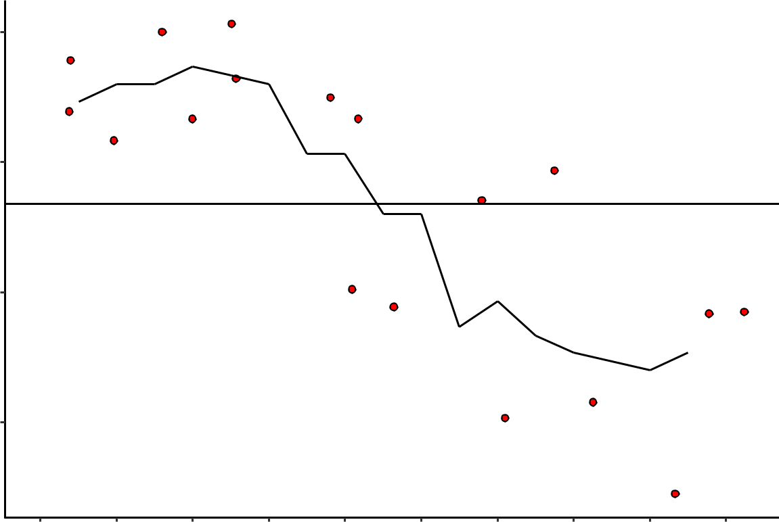

|  |  |  |  |  |  |  |  |  |  |  |  |
| --- | --- | --- | --- | --- | --- | --- | --- | --- | --- | --- | --- |
|  | 25 |  |  |  |  |  |  |  |  |  |  |
|  | 20 |  |  |  |  |  |  |  |  |  |  |
| richness |  |  |  |  |  |  |  |  |  |  |  |
| Family | 15 |  |  |  |  |  |  |  |  |  |  |
|  |  |  |  |  |  |  |  |  |  |  |
|  | 10 |  |  |  |  |  |  |  |  |  |  |
|  | 2000 | 2002 | 2004 | 2006 | 2008 | 2010 | 2012 | 2014 | 2016 | 2018 |  |
|  |  |  |  |  |  | Year |  |  |  |  |  |

Figure 71: Richness of aquatic invertebrate families for each year at Lake Melaleuca Park 173. Line is a moving 3-year averavge.

112

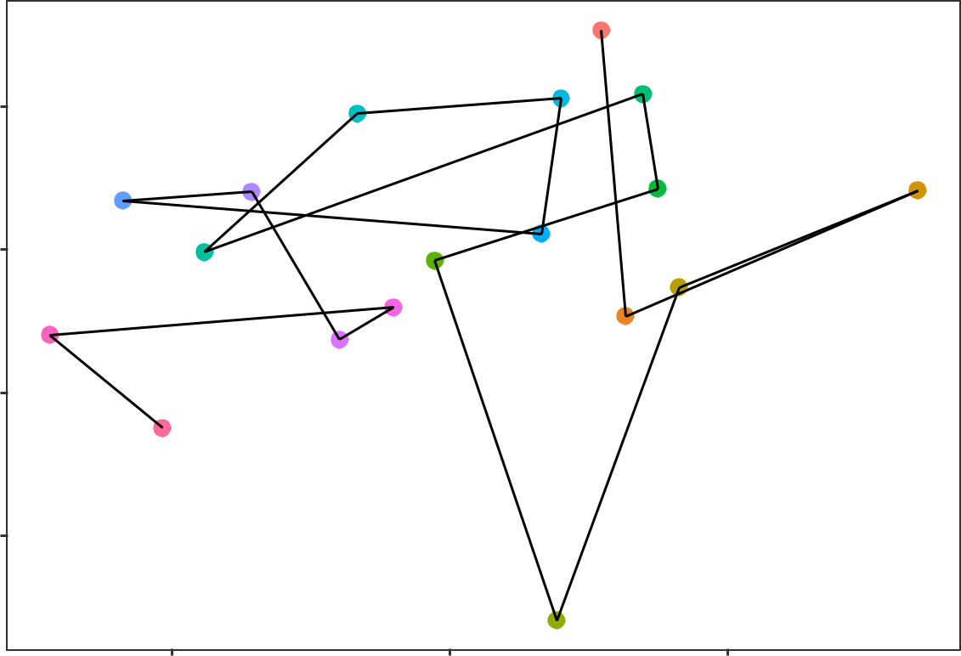

|  |  |  |
| --- | --- | --- |
|  |  | 2000 |
| 0.1 |  |  |
| 0.0 |  |  |
| LV2 |  |  |
| −0.1 |  |  |
| 2018 |  |  |
| −0.2 |  |  |
| −0.4 | 0.0 | 0.4 |
|  | LV1 |  |

Figure 72: Unconstrained ordination based on invertebrate data for each surveyed year for Lake Melaleuca Park 173. Consecutive years are joined by a line with first and last survey years labeled.

113

**Melaleuca Park 78**

Melaleuca Park 78 (also referred to as EPP 78 or Dampland 78) is located north-west of the Lexia wetlands in the southern area of Melaleuca Park. The site is approximately 6.7 ha in area and represents a regionally significant wetland (Hill et al., 1996). Melaleuca Park 78 is classified as a Dampland habitat, meaning the basin has seasonally waterlogged soils that are not often inundated with surface waters (Semeniuk and Semeniuk, 1996). The site is an important habitat for a unique assemblage of phreatophytic vegetation which provides important habitat for native populations of fauna.

**Hydrology**

Water levels at the site have been declining since the beginning of monitoring in 1999 up until 2014, although absolute minimum levels were recorded in 2016. Bore 61613231 indicates that groundwaters in the dampland may have declined by about 1.3 m since 1999, although there has been a recent increase in groundwater levels since 2016 due to increased rainfall (Figure 73). Current 5 year mean maximum and minimum groundwater levels in the bore are about 1 m lower than when monitoring began in 1999, with peak levels occurring in October/November and minimums occurring between April-May (Table 25).

Groundwater levels have mostly been non-compliant since 2012 after a significant decline from 2009 levels. The eﬀects of reduced abstraction are unlikely to arrest the decline in groundwater levels at this wetland. The proposed threshold is 0.4 m lower than the current threshold. Further declines in groundwater levels are expected by 2030 under a drying climate scenario.

**Vegetation dynamics**

The vegetation transect has been monitored at Melaleuca Park 78 since 1997 and was last surveyed in 2018 (Buller et al. (2019); Figure 74). The site is largely dominated by native species that include a dense understorey of *Beaufortia elegans*, *Pultenea reticulata* and *Kunzea glabrescens*. The overstorey is largely composed of *Melaleuca preissiana* throughout the transect and *Banksia attenuata*, *Banksia ilicifolia* and *Banksia menziesii* in the higher parts of the basin. In 2006, the transect was heavily aﬀected by a fire but thevegetation has since made some recovery. *Baumea articulata* disappeared from the transect during this period. A number of tree deaths were reported following the fire but there is evidence of recovery, particularly for low-lying stands of *M. preissiana*. Trajectories of compositional change provide further evidence for post-fire recovery as recent plot assemblages are becoming more similar to those recorded before the fire (Figure 75).

Bayesian regression modelling suggests a number of species associated with low groundwater levels (Figure 76). In particular, some natives, including *B. attenuata*, *Hibbertia subvaginata* and *M. preissiana*, are likely to increase in cover abundance under a scenario of further decreasing groundwaters. The cover abundance of exotics, including *Aira caryophyllea*, *Briza maxima*, *Ehrharta calycina*, *Hypochaeris glabra*, *Poa annua*, *Sonchus oleraceus* and *Ursinia anthemoides*, are also likely to increase in cover abundance withd declininggroundwaters. Some of the species are groundwater dependent, such as the *Banksia* species, suggesting that despite being in decline, groundwater will remain important in determining the vegetation composition of the wetland It is also likely that the richness of exotic species will increase with groundwater decline as the site becomes invaded by exotics not currently recorded at the site.

**Revised water level threshold eﬀects**

Further declines in groundwater levels will make it unlikely that site values will be maintained at Melaleuca Park 78 (Table 26).

114

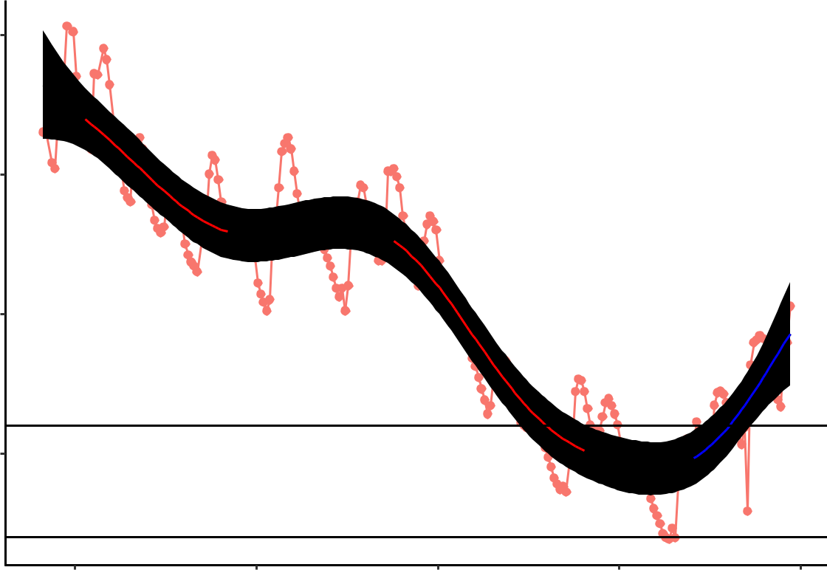

|  |  |  |  |  |  |  |  |
| --- | --- | --- | --- | --- | --- | --- | --- |
|  | 66.5 |  |  |  |  |  |  |
| ( )mAHD | 66.0 |  |  |  |  |  |  |
|  |  |  |  |  |  |  |
| Level | 65.5 |  |  |  |  |  |  |
| Water |  |  |  |  |  |  |  |
|  | 65.0 | Current |  |  |  |  |  |
|  |  |  |  |  |  |  |
|  |  | Proposed |  |  |  |  |  |
|  |  | 2000 | 2005 | 2010 | 2015 | 2020 |  |
|  |  |  |  | Year |  |  |  |

Figure 73: Groundwater levels recorded at bore 61613231 in the vicinity of the Melaleuca Park 78 wetland. Red segments on fitted line represent statistically significant periods of decline and blue represent statistically significant periods of increasing water levels.

115

Table 25: Five year summaries of groundwater level data at Maleleuca Park 78 recorded at bore 61613231.

|  |  |  |  |  |  |  |  |
| --- | --- | --- | --- | --- | --- | --- | --- |
| Period | Mean max seasonal | Mean min seasonal | Mean seasonal change | Month of | Month of | Mean max to |  |
| level (mAHD) | level (mAHD) | (m) | maximum | minimum | min (days) |  |
|  |  |
|  |  |  |  |  |  |  |  |
| 08/1999 - 07/2004 | 66.2 | 65.8 | 0.40 | October | May | 235 |  |
| 08/2004 - 07/2009 | 66.0 | 65.6 | 0.36 | November | April | 228 |  |
| 08/2009 - 07/2014 | 65.4 | 65.1 | 0.31 | October | July | 213 |  |
| 08/2014 - 07/2019 | 65.2 | 64.9 | 0.29 | November | May | 170 |  |
|  |  |  |  |  |  |  |  |

116

|  |
| --- |
| 117 |

|  |  |  |  |  |  |  |  |  |  |  |  |  |  |  |  |  |  |  |  |  |  |  |  |  |
| --- | --- | --- | --- | --- | --- | --- | --- | --- | --- | --- | --- | --- | --- | --- | --- | --- | --- | --- | --- | --- | --- | --- | --- | --- |
|  | X Aira caryophyllea | X Hypochaeris glabra | X Ursinia anthemoides | Adenanthos cygnorum | Aotus gracillima | Astartea scoparia | Austrostipa compressa | Banksia attenuata | Banksia ilicifolia | Banksia menziesii | Beaufortia elegans | Dasypogon bromeliifolius | Hibbertia sp_ | Hibbertia subvaginata | Isolepis cernua | Kunzea glabrescens | Melaleuca preissiana | Podotheca gnaphalioides | Pteridium esculentum | Pultenaea reticulata | Regelia inops | Thysanotus manglesianus | Trachymene pilosa |  |
|  | 2000 |  |  |  |  |  |  |  |  |  |  |  |  |  |  |  |  |  |  |  |  |  |  |  |
|  | 2005 |  |  |  |  |  |  |  |  |  |  |  |  |  |  |  |  |  |  |  |  |  | A |  |
|  | 2010 |  |  |  |  |  |  |  |  |  |  |  |  |  |  |  |  |  |  |  |  |  |  |
|  | 2015 |  |  |  |  |  |  |  |  |  |  |  |  |  |  |  |  |  |  |  |  |  |  |  |
|  | 2000 |  |  |  |  |  |  |  |  |  |  |  |  |  |  |  |  |  |  |  |  |  |  |  |
|  | 2005 |  |  |  |  |  |  |  |  |  |  |  |  |  |  |  |  |  |  |  |  |  | B |  |
|  | 2010 |  |  |  |  |  |  |  |  |  |  |  |  |  |  |  |  |  |  |  |  |  |  |
| Year | 2015 |  |  |  |  |  |  |  |  |  |  |  |  |  |  |  |  |  |  |  |  |  |  |  |
| 2000 |  |  |  |  |  |  |  |  |  |  |  |  |  |  |  |  |  |  |  |  |  |  |  |
|  | 2005 |  |  |  |  |  |  |  |  |  |  |  |  |  |  |  |  |  |  |  |  |  | C |  |
|  | 2010 |  |  |  |  |  |  |  |  |  |  |  |  |  |  |  |  |  |  |  |  |  |  |
|  | 2015 |  |  |  |  |  |  |  |  |  |  |  |  |  |  |  |  |  |  |  |  |  |  |  |



2000



2005

2010 D

2015

Cover Abundance

Figure 74: Cover abundances for each species across the four plots (A, B, C, D) at the Melaleuca Park 78 transect. Invasive species are denoted by ‘X’.

Only the most common species are included.

Table 26: Ecological consequences of revised thresholds in terms of compliance of stated site management objectives at the Melaleuca Park 78 wetland.

Likely eﬀect of 2030 revised thresholds Future Complia

**Site values**

Supports wetland vegetation

**Site management objectives**

Maintain wildlife and landscape values of the wetlands

Maintain the existing areas of wetlands and wetland vegetation

118

|  |  |  |  |  |
| --- | --- | --- | --- | --- |
| 1 |  |  |  |  |
| 1999 |  |  |  |  |
|  | 2018 |  |  |  |
|  | 2018 |  |  |  |
|  | 2018 |  |  |  |
| 0 |  | 2018 |  |  |
| 1999 | Plot |  |  |
|  |  |  |
|  |  |  |  |
| LV2 | 1999 | a | A |  |
| 1999 | a | B |  |
|  |  |  |  |
|  |  | a | C |  |
|  |  | a | D |  |
| −1 |  |  |  |  |
| −1 | 0 | 1 |  |  |
|  | LV1 |  |  |  |

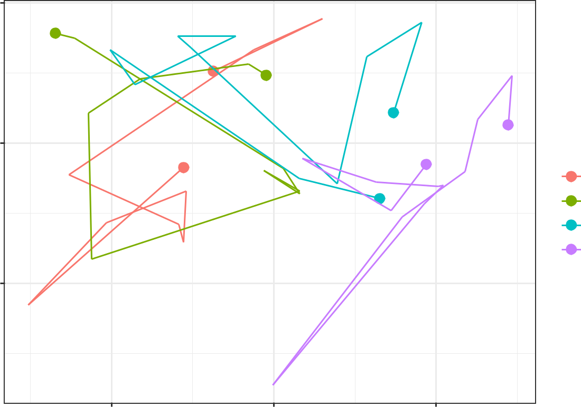

Figure 75: Unconstrained ordination based on the latent variable model for each surveyed year for Melaleuca Park 78. Plots are represented as diﬀerent colours and consecutive years are joined by a line with first and last survey years labeled.

119

|  |
| --- |
| Species |

X_Ursinia_anthemoides

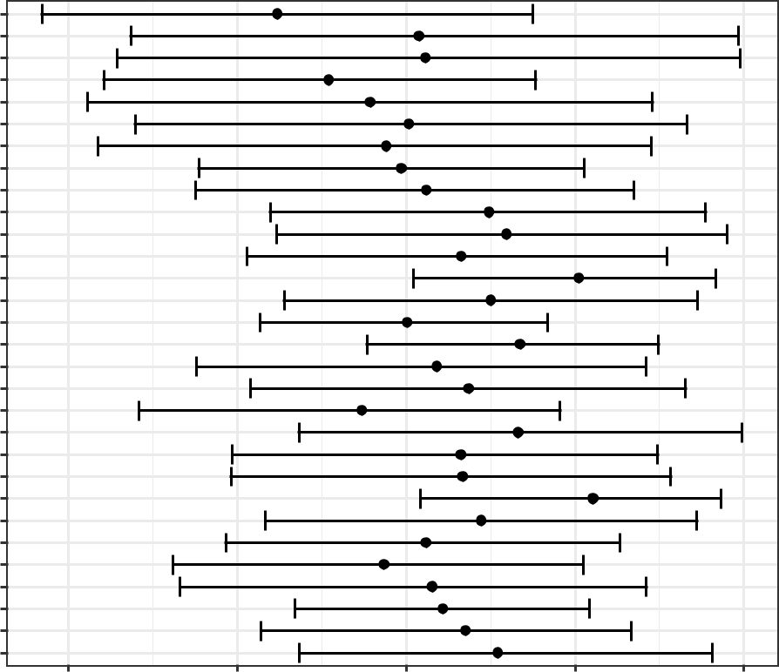

X_Sonchus_oleraceus

X_Poa_annua

X_Hypochaeris_glabra

X_Ehrharta_calycina

X_Briza_maxima

X_Aira_caryophyllea

Trachymene_pilosa

Thysanotus_manglesianus

Stylidium_repens

Restionaceae_sp_

Regelia_inops

Pultenaea_reticulata

Podotheca_gnaphalioides

Melaleuca_preissiana

Kunzea_glabrescens

Isolepis_cernua

Hypolaena_exsulca

Hibbertia_subvaginata

Dryandra_sp_

Dasypogon_bromeliifolius

Caladenia_flava

Beaufortia_elegans

Banksia_menziesii

Banksia_ilicifolia

Banksia_attenuata

Austrostipa_compressa

Astartea_scoparia

Aotus_gracillima

Adenanthos_cygnorum

−2.0 −1.5 −1.0 −0.5 0.0

Posterior Mean

Figure 76: Estimated mean regression coeﬃcients (dots) and 95% credible intervals (bars) for eﬀect of groundwater levels at Melaleuca Park 78 on vegetation species cover abundances based on Bayesian Regression Analysis (HUI REF 2015). Species with a negative mean posterior value are likely to increase in cover abundance as water levels decline. Only those species with coeﬃcients significanlty diﬀerent to zero are shown.

120

Table 27: Five year summaries of surface water level data at MM59B

|  |  |  |  |  |  |  |  |
| --- | --- | --- | --- | --- | --- | --- | --- |
| Period | Mean max seasonal | Mean min seasonal | Mean seasonal change | Month of | Month of | Mean max to |  |
| level (mAHD) | level (mAHD) | (m) | maximum | minimum | min (days) |  |
|  |  |
|  |  |  |  |  |  |  |  |
| 08/1994 - 07/1999 | 37.2 | 36.2 | 1.08 | October | June | 229 |  |
| 08/1999 - 07/2004 | 37.2 | 36.1 | 1.11 | October | June | 244 |  |
| 08/2004 - 07/2009 | 36.6 | 35.8 | 0.86 | September | June | 244 |  |
| 08/2009 - 07/2014 | 36.2 | 35.5 | 0.72 | October | June | 249 |  |
| 08/2014 - 07/2019 | 36.3 | 35.6 | 0.69 | October | June | 249 |  |
|  |  |  |  |  |  |  |  |

**MM59B - Whiteman Park East**

**Hydrology**

Groundwater levels at Whiteman Park East have been declining since 1980, although this decline seems to have stabilised since 2010 (Figure 77). Current 5-year mean maximum and minimum water levels are 0.9 and 0.6 m lower than 1994-1999 levels, respectively (Table 27). Minimum water levels occur in June, while maximums are usually reached in October.

**Vegetation**

The site contains a fairly sparse understorey and open mixed woodland canopy consisting of *Banksia* spp,

*Allocasuarina fraseriana*, *Nuytsia floribunda* and *Eucalyptus todtiana*. *Banksia* species found at the siteinclude *B. attenuata*, *B. ilicifolia* and *B. menziesii*. Vegetation is slightly degraded with signs of rabbits evident. Species richness and diversity are notably less than some of the other Pinjar sites and more exotic species, such as *Ursinia anthemoides*, are present at high cover abundances. Predominant native understorey species include *Scholtzia involucrata*, *Calytrix* spp. and *Patersonia occidentalis*. *Banksia* spp. health was mostly good, although some *B. attenuata* appeared to be approaching senescence, and a number of dead *Banksia* are also present. Recruitment was present but low.

Table: Ecological consequences of revised thresholds in terms of compliance of stated site values and site management objectives for MM59B. | | Likely eﬀect of 2030 revised thresholds | Future Compliance | | :———— | :———– | :——: | | **Site values** ||| | * Selected to represent water levels over area of undisturbed phreatophytic vegetation | | | | * Banksia woodland <8m depth to groundwater | | | | **Site management** **objectives** ||| | * To protect terrestrial vegetation | ||

121

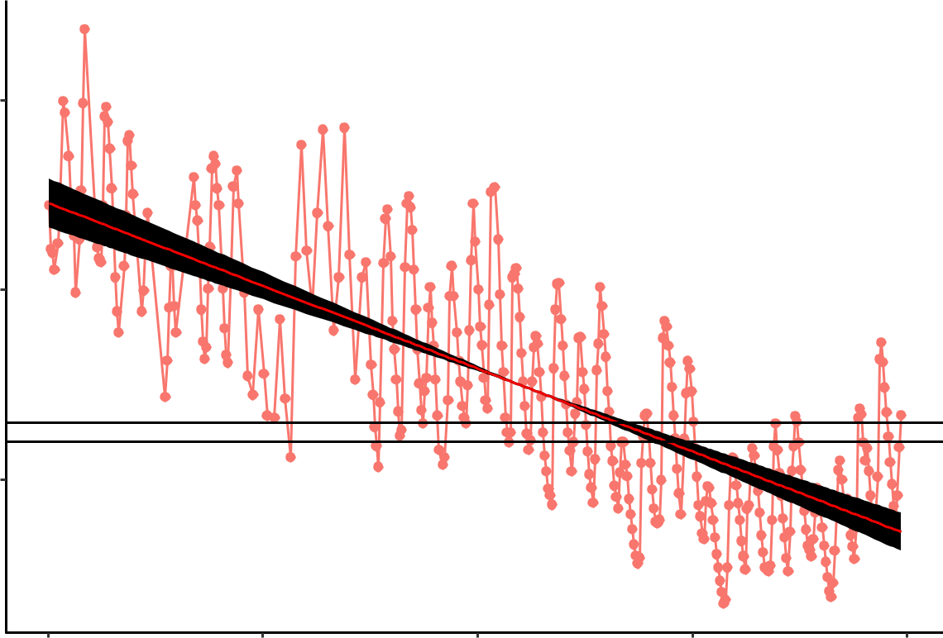

|  |  |  |  |  |  |  |  |
| --- | --- | --- | --- | --- | --- | --- | --- |
|  | 38 |  |  |  |  |  |  |
| ( )mAHD | 37 |  |  |  |  |  |  |
| Level |  |  |  |  |  |  |
|  |  |  |  |  |  |  |
| Water |  | Current |  |  |  |  |  |
|  |  |  |  |  |  |  |
|  | 36 | Proposed |  |  |  |  |  |
|  |  | 1980 | 1990 | 2000 | 2010 | 2020 |  |
|  |  |  |  | Year |  |  |  |

Figure 77: Groundwater levels recorded at bore 61610661 in the vicinity of MM59B. Red segments represent periods of significant decline in groundwater level while blue segments represent periods of significant increase in groundwater level.

122

Table 28: Five year summaries of groundwater level data at PM9. The 2014-2019 period is based on data up to 2016 only.

|  |  |  |  |  |  |  |  |
| --- | --- | --- | --- | --- | --- | --- | --- |
| Period | Mean max seasonal | Mean min seasonal | Mean seasonal change | Month of | Month of | Mean max to |  |
| level (mAHD) | level (mAHD) | (m) | maximum | minimum | min (days) |  |
|  |  |
|  |  |  |  |  |  |  |  |
| 08/1994 - 07/1999 | 58.4 | 57.7 | 0.73 | November | June | 252 |  |
| 08/1999 - 07/2004 | 57.5 | 56.8 | 0.68 | September | July | 201 |  |
| 08/2004 - 07/2009 | 56.5 | 56.0 | 0.49 | October | July | 257 |  |
| 08/2009 - 07/2014 | 55.2 | 54.7 | 0.44 | November | September | 207 |  |
| 08/2014 - 07/2019 | 54.4 | 52.8 | 1.55 | December | May | 242 |  |
|  |  |  |  |  |  |  |  |

**PM9 - Pinjar North**

Copied from quote - “Water levels at PM9 have been monitored since 1976 and have fallen approx. 7 meters over this time. It is assumed that vegetation at this site is now no longer able to access groundwater. The nearest vegetation monitoring transect is ‘P50’, located near the Water Corporation’s P50 production bore east of Lake Pinjar, approximately 2.2 km away to the south-west. The P50 transect has been subjected to diﬀerent influences over the years, including (previous) pumping of the P50 production bore and widespread deaths of vegetation following a succession of high temperatures in the early 1990s, and several fires. There has been an increase in the frequency and cover of species that prefer ‘broad’ site conditions, and an increase in the relative proportion of cover from introduced species. There is a consistent decline on the transect in species preferring excessive wetness.”

WHERE IS VEGETARTION TRANSECT AT P50?

**Hydrology**

Groundwater at PM9 have almost continually been in decline since 1980 from approximately 59 mAHD to 2016 levels around 53 mAHD (Figure 78). The most significant rate of decline has been occurring since 1995 to 2016. Maximum and minimal seasonal water levels are 4 and 5 m lower now than in the 1994-1999 period, respectively (Table 28). Since 2016, no measurements at bore 61610804 have been made due to the operation of a nearby rifle range. It is unknown if groundwater levels have continued to decline since 2016 because no measurements have been recorded due to safety concerns regarding access to the bore. If the observed decline has continued, groundwater levels at the site may currently be below 52 mAHD, representing more than a 7 m decline since 1980.

123

|  |  |  |  |  |
| --- | --- | --- | --- | --- |
| 60 |  |  |  |  |
| 58 |  |  |  |  |
| ( )mAHD |  |  | Current |  |
| 56 |  |  |  |
| Water Level |  |  |  |  |
| 54 |  |  |  |  |
| 52 |  |  |  |  |
| 1980 | 1990 | 2000 | 2010 |  |
|  |  | Year |  |  |

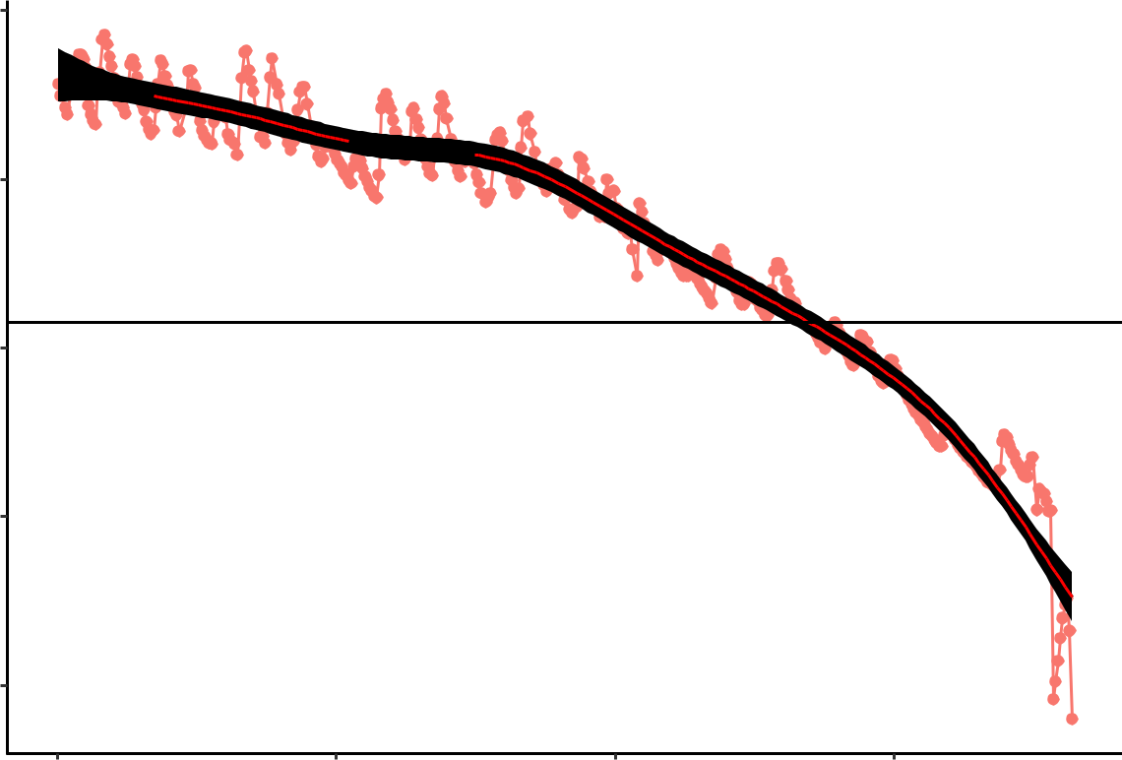

Figure 78: Groundwater levels recorded at bore 61610804 in the vicinity of PM9. Red segments along trendline indicate preiods of significant decline in groundwater levels.

124

Table 29: Five year summaries of surface water level data at WM1

|  |  |  |  |  |  |  |  |
| --- | --- | --- | --- | --- | --- | --- | --- |
| Period | Mean max seasonal | Mean min seasonal | Mean seasonal change | Month of | Month of | Mean max to |  |
| level (mAHD) | level (mAHD) | (m) | maximum | minimum | min (days) |  |
|  |  |
|  |  |  |  |  |  |  |  |
| 08/1994 - 07/1999 | 57.1 | 56.2 | 0.95 | November | April | 217 |  |
| 08/1999 - 07/2004 | 56.5 | 55.6 | 0.86 | October | June | 246 |  |
| 08/2004 - 07/2009 | 55.9 | 55.1 | 0.81 | October | July | 200 |  |
| 08/2009 - 07/2014 | 54.9 | 54.3 | 0.54 | October | August | 204 |  |
| 08/2014 - 07/2019 | 55.1 | 54.5 | 0.57 | October | August | 110 |  |
|  |  |  |  |  |  |  |  |

**WM1 - Pinjar**

WM1 is located east of Lake Pinjar in the Chitty Road Bushland within the Bassendean north vegetation complex. Water levels at WM1 have been non-compliant since 2001.

**Hydrology**

Groundwater levels at WM1 have declined up to 4.0 m since 1980, although recent rainfall has increased levels from 54.4 to 55.5 mAHD since 2015 (Figure 79). Current mean maximum and minimum water levels are 2.0 and 1.7 m lower than 1994-1999 levels (Table 29). Maximum water levels generally occur in October and minimum water levels are now occurring later in the year than previously.

**Vegetation character**

The area has been aﬀected by fire in the past (sometime between early Jan 2015 and late February 2015) and some of the older *Banksias* on the transect have old fire scars. Vegetation structure and community composition of the site is typical *Banksia* woodland, consisting of overstorey species *B. attenuata*, *B. menziesii* and *B. ilicifolia* and a typically diverse dry land understorey of *Acacia pulchella*, *Adenanthos cygnorum*, *Jacksonia* spp and *Xanthorrhoea preissii*. Although not recorded in the transect, *Melaleuca preissiana* hasbeen noted nearby. In general, *Banksia* health appears good despite several individuals having significant insect damage and yellow leaves. Previous reports have document the decline of vegetation at this site due to declining groundwater levels (Department of Water, 2008; Water and Rivers Commission, 2004). The trends included a general thinning of the understory, *B. attenuata* deaths, declining condition of *B. ilicifolia* and *B.* *menziessi*. *Eucalyptus todtiana* and *Corymbia calophylla* have also been reported to be declining in health in2008 (Department of Water, 2008).

Table 30: Ecological consequences of revised thresholds in terms of compliance of stated site values and site management objectives for WM1.

Likely eﬀect of 2030 revised

thresholds Future Compliance

**Site values**

* Selected to represent water levels over area of undisturbed phreatophytic vegetation
* *Banksia* woodland <8m depth togroundwater

**Site management objectives**

* To protect terrestrial vegetation
* Maintain the existing extent and variety of wetland vegetation

125

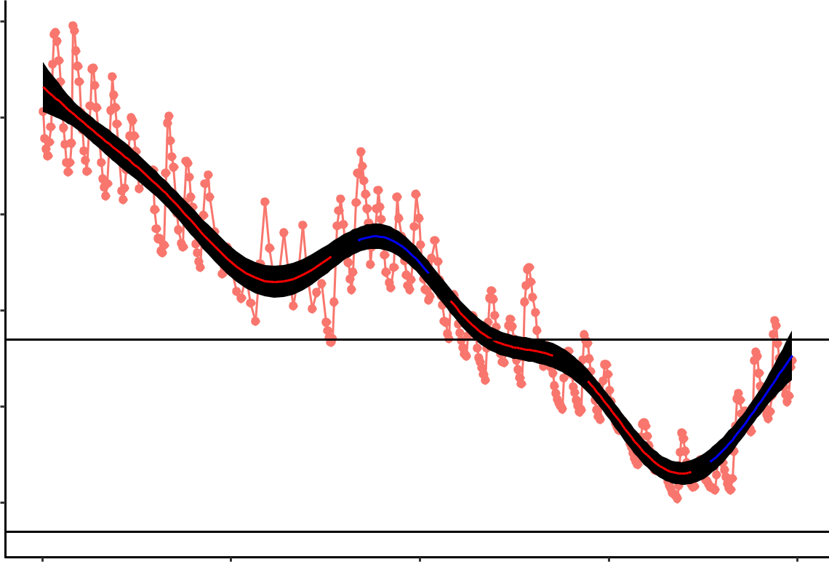

|  |  |  |  |  |  |  |
| --- | --- | --- | --- | --- | --- | --- |
|  | 59 |  |  |  |  |  |
|  | 58 |  |  |  |  |  |
| ( )mAHD | 57 |  |  |  |  |  |
|  |  |  |  |  |  |
| Level | 56 |  |  |  | Current |  |
|  |  |  |  |  |
| Water |  |  |  |  |  |
|  |  |  |  |  |  |
|  | 55 |  |  |  |  |  |
|  | 54 |  |  |  | Proposed |  |
|  | 1980 | 1990 | 2000 | 2010 | 2020 |  |
|  |  |  | Year |  |  |  |

Figure 79: Groundwater levels recorded at bore 61610833 in the vicinity of WM1. Red segments along trendline indicate preiods of significant decline in groundwater levels and blue segments represent significant increases in groundwater level.

126

Table 31: Five year summaries of surface water level data at WM2

|  |  |  |  |  |  |  |  |
| --- | --- | --- | --- | --- | --- | --- | --- |
| Period | Mean max seasonal | Mean min seasonal | Mean seasonal change | Month of | Month of | Mean max to |  |
| level (mAHD) | level (mAHD) | (m) | maximum | minimum | min (days) |  |
|  |  |
|  |  |  |  |  |  |  |  |
| 08/1994 - 07/1999 | 68.5 | 67.6 | 0.94 | November | April | 216 |  |
| 08/1999 - 07/2004 | 68.1 | 67.4 | 0.68 | October | June | 246 |  |
| 08/2004 - 07/2009 | 67.7 | 67.1 | 0.62 | October | July | 205 |  |
| 08/2009 - 07/2014 | 66.8 | 66.4 | 0.46 | October | August | 210 |  |
| 08/2014 - 07/2019 | 67.0 | 66.5 | 0.52 | October | May | 79 |  |
|  |  |  |  |  |  |  |  |

**WM2 - Melaleuca Park North**

Located in Melaleuca Park in the Bassendean north vegetation complex, the area represents an area of undisturbed phreatophytic vegetation, including *Banksia* woodlands (REPORT 82392).

**Hydrology**

There has been periods of significant decline in groundwater levels from 68.8 mAHD in 1980 to 66.4 mAHD in 2014 (Figure 80). Since 2015, there has been an increase in groundwater to slightly above 67 mAHD. Mean maximum and minimum seasonal water levels are now 1.5 and 0.9 m lower than the period 1994-1999. Maximum levels have consistently been reached in October, on average (Table 31).

**Vegetation character**

The vegetation around monitoring bore WM2 has similar vegetation composition as WM1. The vegetation also appears to have been aﬀected by fire in the summer of 2014/2015. The understorey is highly diverse, with *Acacia pulchella*, *Adenanthos cygnorum* and *Xanthorrhoea preissii* common. Canopy cover is quite open, with several mature *Banksias* present. Most *Banksias* were resprouts and/or young trees between 1 and 3 m tall. Several mature trees bore significant epicormic growth. New *Banksia* recruitment (mainly very small seedlings) for *Banksia attenuata* and *Banksia menziessi* has been observed, perhaps in response to recent increases in groundwater levels.

Table 32: Ecological consequences of revised thresholds in terms of compliance of stated site values and site management objectives for WM2.

Likely eﬀect of 2030 revised

thresholds Future Compliance

**Site values**

* Selected to represent water levels over area of undisturbed phreatophytic vegetation
* *Banksia* woodland <8m depth togroundwater

**Site management objectives**

* To protect terrestrial vegetation
* Maintain the existing extent and variety of wetland vegetation

127

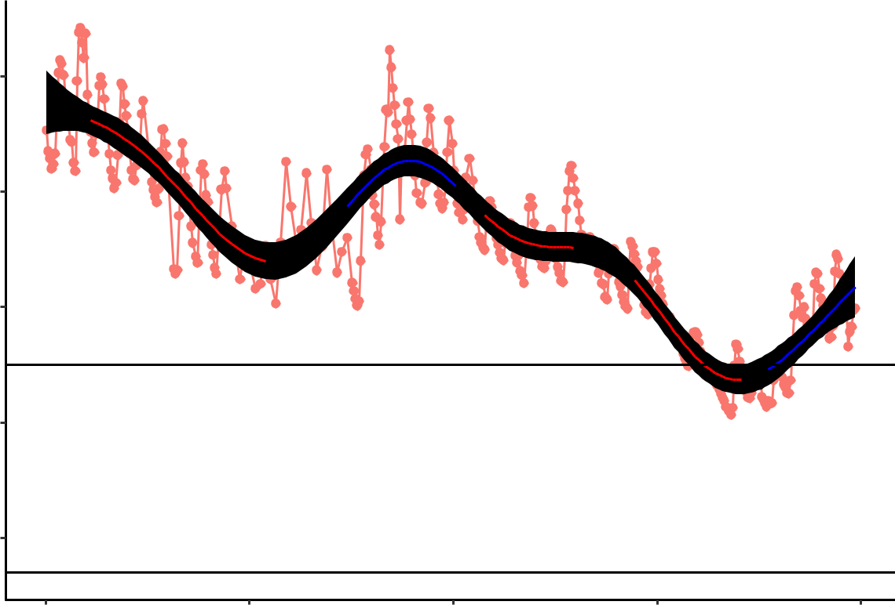

|  |  |  |  |  |  |  |
| --- | --- | --- | --- | --- | --- | --- |
|  | 69 |  |  |  |  |  |
| ( )mAHD | 68 |  |  |  |  |  |
|  |  |  |  |  |  |
| Level | 67 |  |  |  |  |  |
|  |  |  |  |  |  |
| Water |  |  |  |  | Current |  |
|  |  |  |  |  |  |
|  | 66 |  |  |  |  |  |
|  | 65 |  |  |  |  |  |
|  |  |  |  |  | Proposed |  |
|  | 1980 | 1990 | 2000 | 2010 | 2020 |  |
|  |  |  | Year |  |  |  |

Figure 80: Groundwater levels recorded at bore 61610908 in the vicinity of WM2. Red segments along trendline indicate preiods of significant decline in groundwater levels and blue segments represent significant increases in groundwater level.

128

Table 33: Five year summaries of surface water level data at WM8

|  |  |  |  |  |  |  |  |
| --- | --- | --- | --- | --- | --- | --- | --- |
| Period | Mean max seasonal | Mean min seasonal | Mean seasonal change | Month of | Month of | Mean max to |  |
| level (mAHD) | level (mAHD) | (m) | maximum | minimum | min (days) |  |
|  |  |
|  |  |  |  |  |  |  |  |
| 08/1994 - 07/1999 | 66.3 | 65.7 | 0.65 | October | July | 230 |  |
| 08/1999 - 07/2004 | 66.0 | 65.5 | 0.53 | December | June | 180 |  |
| 08/2004 - 07/2009 | 65.6 | 65.2 | 0.40 | November | July | 256 |  |
| 08/2009 - 07/2014 | 65.0 | 64.7 | 0.36 | November | August | 200 |  |
| 08/2014 - 07/2019 | 65.0 | 64.7 | 0.33 | December | July | 30 |  |
|  |  |  |  |  |  |  |  |

**WM8 - Melaleuca Park**

The WM8 monitoring bore is located in Melaleuca Park within the Bassendean north vegetation complex and represents native vegetation that may be aﬀected by abstraction from the Lexia groundwater scheme. There has been no reported change in vegetation at the site, although no monitoring or transects have been established here.

**Hydrology**

Groundwater levels began to decline in 2000 at WM8 from approximately 66.0 mAHD to 64.6 mAHD in 2015 (Figure 81). Since 2015, there has been an increase in groundwater levels to approximately 65.5 mAHD. Mean maximum and minimum seasonal water levels have declined by 1.3 and 1.0 m, respectively (Table 33). Maximum levels are generally reached in December while minimum levels are reached in July.

**Vegetation character**

The vegetation community at WM8 is typical of *Banksia* woodland. There is a sparse understorey composed predominately of *Lyginia barbata*, *Scholtzia involucrata* and *Eremaea pauciflora*. The canopy is open and consists predominately of *Banksia attenuata* and *B. menziesii*. Tree health at the site was good although a number of dead mature *Banksias* were present. There is evidence of recent *Banksia attenuata* recruitment, mainly in the form of small seedlings. *Jacksonia floribunda* in notably poorer health than at the other Pinjar sites (WM1 and WM2).

Table 34: Ecological consequences of revised thresholds in terms of compliance of stated site values and site management objectives for WM8.

Likely eﬀect of 2030 revised

thresholds Future Compliance

**Site values**

* Selected to represent water levels over area of undisturbed phreatophytic vegetation
* *Banksia* woodland <8m depth togroundwater

**Site management objectives**

* To protect terrestrial vegetation
* Maintain the existing extent and variety of wetland vegetation

129

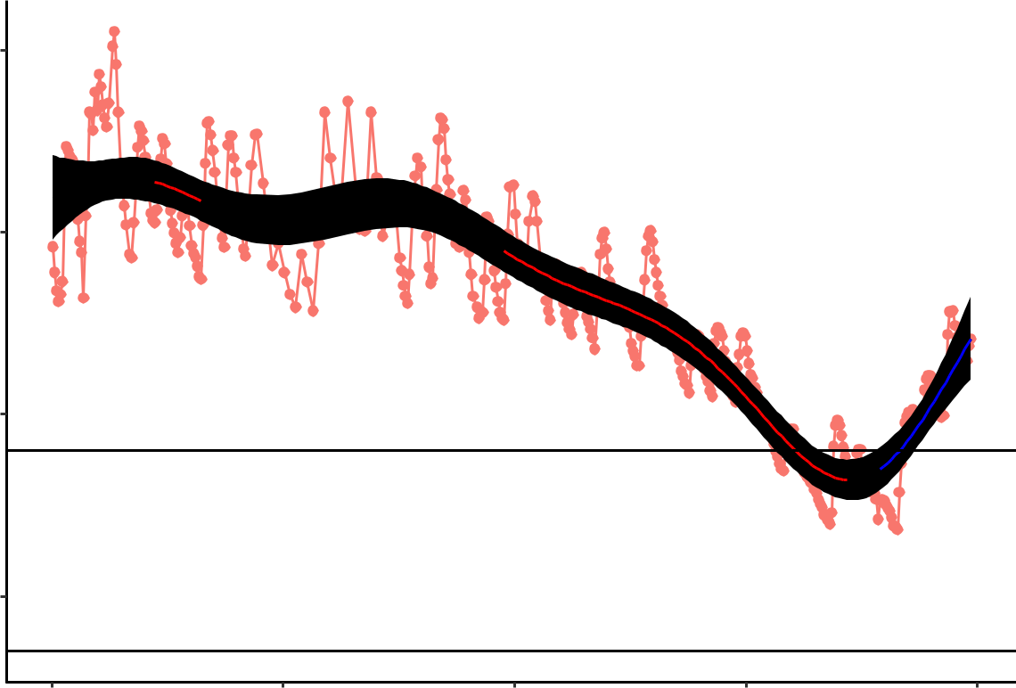

|  |  |  |  |  |  |  |
| --- | --- | --- | --- | --- | --- | --- |
|  | 67 |  |  |  |  |  |
| ( )mAHD | 66 |  |  |  |  |  |
|  |  |  |  |  |  |
| Level |  |  |  |  |  |  |
| Water | 65 |  |  |  |  |  |
|  |  |  |  | Current |  |
|  |  |  |  |  |  |
|  | 64 |  |  |  |  |  |
|  |  |  |  |  | Proposed |  |
|  | 1980 | 1990 | 2000 | 2010 | 2020 |  |
|  |  |  | Year |  |  |  |

Figure 81: Groundwater levels recorded at bore 61610983 in the vicinity of WM8. Red segments along trendline indicate preiods of significant decline in groundwater levels and blue segments represent significant increases in groundwater level.

130

Table 35: Five year summaries of surface water level data at Lake Gwelup

|  |  |  |  |  |  |  |  |
| --- | --- | --- | --- | --- | --- | --- | --- |
| Period | Mean max seasonal | Mean min seasonal | Mean seasonal change | Month of | Month of | Mean max to |  |
| level (mAHD) | level (mAHD) | (m) | maximum | minimum | min (days) |  |
|  |  |
|  |  |  |  |  |  |  |  |
| 08/1994 - 07/1999 | 7.5 | 5.7 | 1.85 | September | April | 239 |  |
| 08/1999 - 07/2004 | 6.7 | 5.1 | 1.52 | October | April | 172 |  |
| 08/2004 - 07/2009 | 6.3 | 5.0 | 1.32 | September | December | 14 |  |
| 08/2009 - 07/2014 | 6.1 | 5.0 | 1.17 | October | January | 138 |  |
| 08/2014 - 07/2019 | 7.3 | 5.6 | 1.66 | October | April | 222 |  |
|  |  |  |  |  |  |  |  |

**Lake Gwelup**

Lake Gwelup is a shallow groundwater system located in the highly urbanised area of Gwelup/Karrinyup. The lake is permanently inundated and provides important habitat to a variety of fauna and fringing vegetation. The wetland is not currently a Ministerial criteria site.

**Hydrology**

Lake water levels were first monitored in 1960, but regular monitoring has occurred between 1967 and 1988, and from 1999 until the present. Lake levels in the 1970s and 1980s were 1m to 2m higher than in the 2000s (Figure 82). They have risen again since 2013 following a reduction in nearby public water supply abstraction, and levels are currently similar to levels in the 1980s and 1990’s (Table 35). The nearby bore 61610032 has been monitored since 1972. Water levels at the bore have declined by around 4 meters since the start of monitoring. Levels have been reasonably stable since the early 2000s and have trended slightly upwards since 2011.

**Vegetation dynamics**

Vegetation monitoring at Lake Gwelup began in 2013 and was last conducted in 2017. The start of the transect was inundated by approximately 0.7 m of surface water during the 2017 survey. The wetland is dominated by exotic species such as *Cynodon dactylon* and *Ehrharta calycina* despite exotic cover abundance declining in the later surveys (Figure 83). The overstorey is dominated by the natives *Eucalyptus rudis* and *Maleleuca rhaphiophyla* which are in good health (Buller et al., 2018). There was a dramatic shift in community composition between 2014 and 2017 due to inundation of the plots (Figure 84). Bayesian regression analysis reveals that a number of exotic species will continue to decrease in cover abundances with the higher water levels (Figure 85).

**Revised water level threshold eﬀects**

131

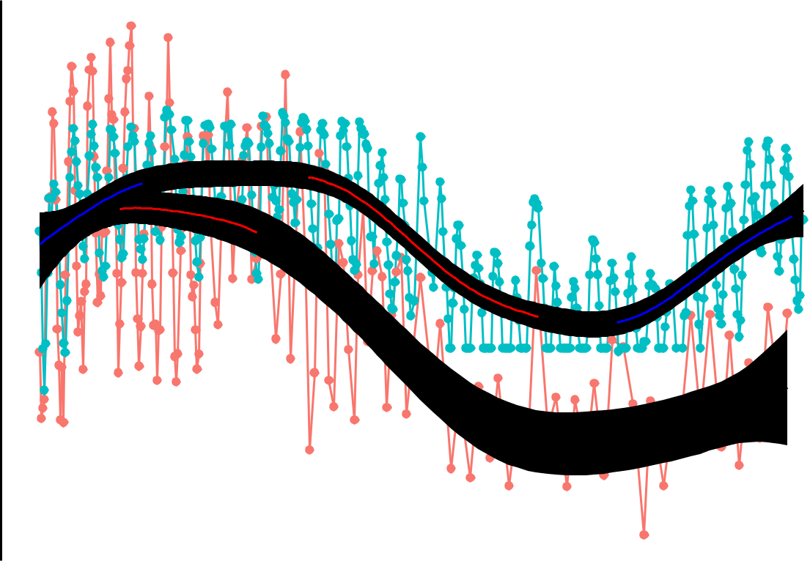

|  |  |  |  |  |  |  |
| --- | --- | --- | --- | --- | --- | --- |
|  | 8 |  |  |  |  |  |
| ( )mAHD | 6 |  |  |  |  |  |
| Water Level |  |  |  |  |  |
|  |  |  |  |  |  |
|  | 4 |  |  |  |  |  |
|  | 1980 | 1990 | 2000 | 2010 | 2020 |  |
|  |  |  | Year |  |  |  |

Figure 82: Ground and surface water levels for Lake Gwelup recorded at bore 61610032 (red) and staﬀ 6162504 (blue). The minimum recordable water level for the staﬀ gaugue is 5.0 mAHD. Blue dots at 5.0 mAHD represent water levels below the minimum level measurable by the staﬀ. Red segments on fitted line represent statistically significant periods of decline and blue represent statistically significant periods of increasing water levels.

132

|  |
| --- |
| 133 |

|  |  |  |  |  |  |  |  |  |  |  |  |  |  |  |  |
| --- | --- | --- | --- | --- | --- | --- | --- | --- | --- | --- | --- | --- | --- | --- | --- |
|  | 2013 | X Avena barbata | X Bromus diandrus | X Cynodon dactylon | X Ehrharta calycina | X Ehrharta longiflora | X Euphorbia peplus | X Fumaria capreolata | X Lactuca serriola | X Pelargonium capitatum | X Vicia sativa | Centella asiatica | Eucalyptus rudis | Melaleuca rhaphiophylla |  |
|  |  |  |  |  |  |  |  |  |  |  |  |  |  |  |
|  |  |  |  |  |  |  |  |  |  |  |  |  |  |  |
|  |  |  |  |  |  |  |  |  |  |  |  |  |  |
|  | 2014 |  |  |  |  |  |  |  |  |  |  |  |  |  |  |
|  | 2015 |  |  |  |  |  |  |  |  |  |  |  |  | A |  |
|  | 2016 |  |  |  |  |  |  |  |  |  |  |  |  |  |  |
|  | 2017 |  |  |  |  |  |  |  |  |  |  |  |  |  |  |
|  |  |  |  |  |  |  |  |  |  |  |  |  |  |
|  |  |  |  |  |  |  |  |  |  |  |  |  |  |  |
|  | 2013 |  |  |  |  |  |  |  |  |  |  |  |  |  |  |
|  |  |  |  |  |  |  |  |  |  |  |  |  |  |  |
| Year | 2014 |  |  |  |  |  |  |  |  |  |  |  |  |  |  |
| 2015 |  |  |  |  |  |  |  |  |  |  |  |  | B |  |
|  |  |  |  |  |  |  |  |  |  |  |  |  |  |
|  | 2016 |  |  |  |  |  |  |  |  |  |  |  |  |  |  |
|  | 2017 |  |  |  |  |  |  |  |  |  |  |  |  |  |  |
|  |  |  |  |  |  |  |  |  |  |  |  |  |  |  |
|  | 2013 |  |  |  |  |  |  |  |  |  |  |  |  |  |  |
|  | 2014 |  |  |  |  |  |  |  |  |  |  |  |  |  |  |
|  | 2015 |  |  |  |  |  |  |  |  |  |  |  |  | C |  |

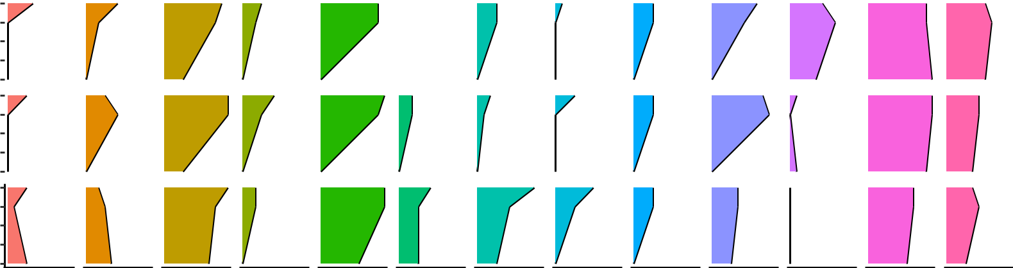

2016

2017

Cover Abundance

Figure 83: Cover abundances for each species across the four plots (A, B, C, D) at the Lake Gwelup transect. Invasive species are denoted by ‘X’. Only the most common species are included.

Table 36: Ecological consequences of revised thresholds in terms of compliance of stated site management objectives at Lake Gwelup.

|  |  |  |
| --- | --- | --- |
|  | Likely eﬀect of 2030 revised |  |
|  | thresholds | Future Compliance |
|  |  |  |
|  | **Site management objectives** |  |
| * To maintain permanent water for | | Yes |
|  | fauna habitat and for visual amenity, |  |
|  | to maintain fringing vegetation. |  |
|  |  |  |

134

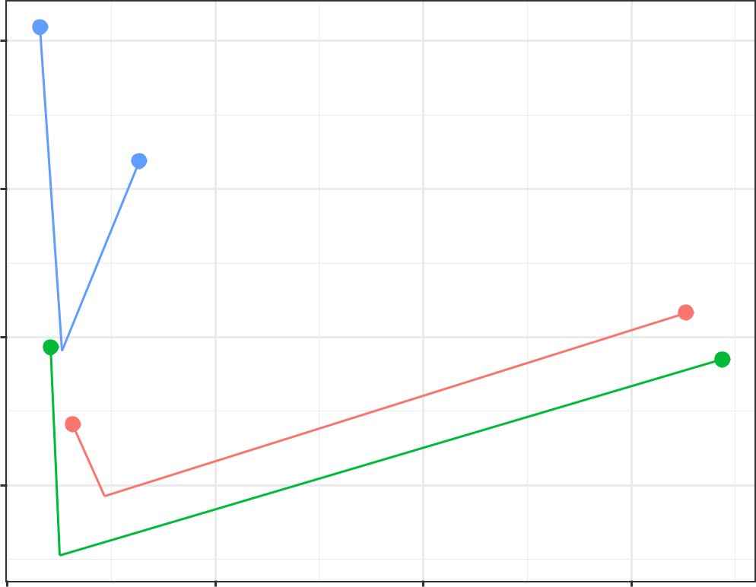

|  |  |  |  |  |  |  |
| --- | --- | --- | --- | --- | --- | --- |
|  | 2013 |  |  |  |  |  |
| 0.2 |  |  |  |  |  |  |
| 0.1 | 2017 |  |  |  |  |  |
|  |  |  |  |  |  |
|  |  |  |  | Plot |  |  |
| LV2 |  |  | 2017 | a | A |  |
|  |  | a | B |  |
|  | 2013 |  |  |  |
| 0.0 |  | 2017 | a | C |  |
|  |  |  |
|  | 2013 |  |  |  |  |  |
| −0.1 |  |  |  |  |  |  |
| −1 | 0 | 1 | 2 |  |  |  |
|  |  | LV1 |  |  |  |  |



Figure 84: Unconstrained ordination based on the latent variable model for each surveyed year for Lake Gwelup. Plots are represented as diﬀerent colours and consecutive years are joined by a line with first and last survey years labeled.

135

|  |
| --- |
| Species |

X_Vicia_sativa

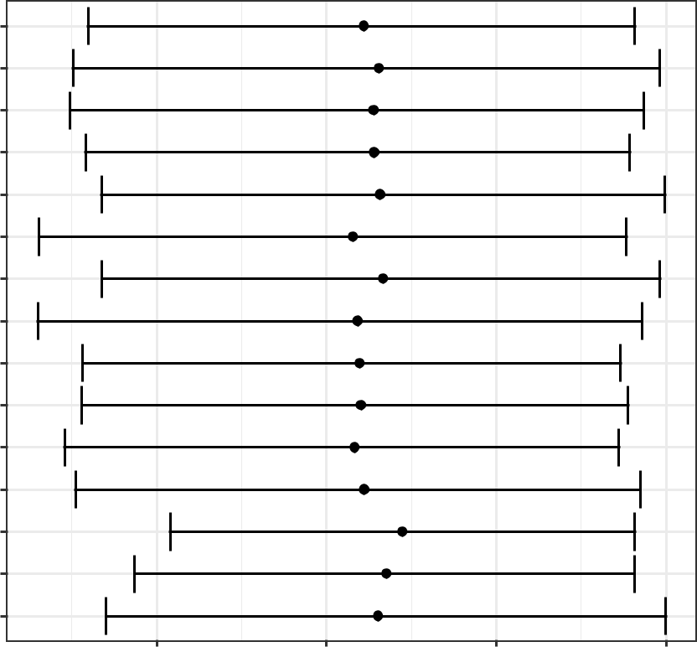

X_Symphyotrichum_squamatum

X_Sonchus_asper

X_Pelargonium_capitatum

X_Lotus_angustissimus

X_Lactuca_serriola

X_Hypochaeris_glabra

X_Hordeum_leporinum

X_Fumaria_capreolata

X_Euphorbia_peplus

X_Ehrharta_longiflora

X_Ehrharta_calycina

X_Cynodon_dactylon

X_Bromus_diandrus

X_Avena_barbata

−3 −2 −1 0

Posterior Mean

Figure 85: Estimated mean regression coeﬃcients (dots) and 95% credible intervals (bars) for eﬀect of groundwater levels at Lake Gwelup on vegetation species cover abundances based on Bayesian Regression Analysis (HUI REF 2015). Species with a negative mean posterior value are likely to increase in cover abundance as water levels decline. Only those species with coeﬃcients significanlty diﬀerent to zero are shown.

136

Table 37: Five year summaries of surface water level data at Quin Brook

|  |  |  |  |  |  |  |  |
| --- | --- | --- | --- | --- | --- | --- | --- |
| Period | Mean max seasonal | Mean min seasonal | Mean seasonal change | Month of | Month of | Mean max to |  |
| level (mAHD) | level (mAHD) | (m) | maximum | minimum | min (days) |  |
|  |  |
|  |  |  |  |  |  |  |  |
| 08/1994 - 07/1999 | 59.0 | 58.8 | 0.26 | January | July | 125 |  |
| 08/1999 - 07/2004 | 58.2 | 58.1 | 0.16 | January | April | 93 |  |
| 08/2004 - 07/2009 | 57.1 | 56.9 | 0.25 | October | April | 203 |  |
| 08/2009 - 07/2014 | 55.6 | 55.4 | 0.14 | November | April | 196 |  |
| 08/2014 - 07/2019 | 54.1 | 54.0 | 0.11 | October | October | 47 |  |
|  |  |  |  |  |  |  |  |

**Quin Brook**

Quin Brook is a base flow system where surface flow, riparian vegetation and habitat maintenance all depend on groundwater (R Froend, R Loomes, et al., 2004). The series of interconnected ponds that occur along Quin Brook are of high conservation value because of the pristine nature of the fringing vegetation and the aquatic associated fauna likely to inhabit the surface waters and riparian zones.

**Hydrology**

The hydrology of Quin Brook is not well understood. Stretches of the brook are dry most of the year and may have previously been supported by groundwater (Johnson, 2000). Near the confluence with Gingin Brook, flow is maintained throughout the year by groundwater with winter discharge an important source of fill for Lake Yeal (Department of Water, 2011). Groundwater levels at bore 61710060 have been in constant decline since the early 1980’s from approximately 59.5 mAHD to current levels at 53.8 m AHD (Figure 86). Mean maximum and minimum groundwater levels are now nearly 5.0 m below 1994-1999 levels with seasonal patterns almost indistinguishable (Table **??**).

**Vegetation dynamics**

Vegetation at Quin Brook is dominated by some key wetland species, including *Melaleuca rhaphiophyla*, *Eucalyptus rudis*, *Banksia littoralis* and *Melaleuca preissiana*. Vegetation monitoring, which began in 2009,indicates that the *Melaleuca* species have declined significantly in cover abundance to the point where it is no longer present in the higher levels of the transect (Figure 87). Cover abundance of *E. rudis* has remained relatively stable despite the health of individual trees declining (Buller et al., 2019). Other abundant species at the site include *Astartea scoparia*, *Hypocalymna angustifolium* and *Kunzea glabrescens*. All plots along the vegetation monitoring transect have shifted in composition since 2009, mainly due to the decline in *M. rhaphiophyla* and *M. preissiana* (Figure 88). Many species are likely to increase in cover abundanceswith groundwater level decline, including an exotic grass, the exotic *Sonchus asper* and *Lotus angustissimus* (Figure 89). Some natives associated with lower groundwater levels include *Senecio* sp., *Pteridium esculentum*

and *Hypolaena exsulca*.

137

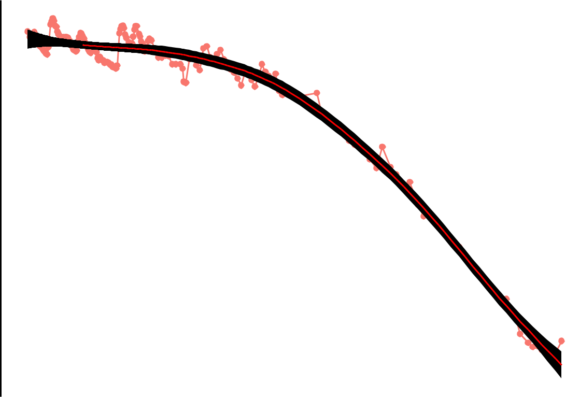

|  |  |  |  |  |  |  |
| --- | --- | --- | --- | --- | --- | --- |
|  | 59 |  |  |  |  |  |
| ( )mAHD | 57 |  |  |  |  |  |
| Water Level |  |  |  |  |  |
|  |  |  |  |  |  |
|  | 55 |  |  |  |  |  |
|  | 53 |  |  |  |  |  |
|  | 1980 | 1990 | 2000 | 2010 | 2020 |  |
|  |  |  | Year |  |  |  |

Figure 86: Groundwater levels recorded at bore 61710060 in the vicinity of Quin Brook. Red segments along trendline indicate preiods of significant decline in groundwater levels.

138

|  |
| --- |
| 139 |

|  |  |  |  |  |  |  |  |  |  |  |  |  |  |  |  |  |  |  |  |  |  |  |  |  |  |  |  |  |  |  |  |  |  |  |  |  |  |  |  |  |
| --- | --- | --- | --- | --- | --- | --- | --- | --- | --- | --- | --- | --- | --- | --- | --- | --- | --- | --- | --- | --- | --- | --- | --- | --- | --- | --- | --- | --- | --- | --- | --- | --- | --- | --- | --- | --- | --- | --- | --- | --- |
|  | X Aira sp_ | X Carpobrotus edulis | X Conyza parva | X Conyza sp2 | X Cortaderia selloana | X Exotic sp1 | X Hypochaeris glabra | X Lotus angustissimus | X Solanum nigrum | X Sonchus asper | X Sonchus oleraceus | Symphyotrichum squamatum | X Unknown grass2 | Astartea scoparia | Austrostipa sp_ | Banksia menziesii | Beaufortia elegans | Callistachys lanceolata | Cassytha racemosa | Eucalyptus rudis | Euchilopsis linearis | Eutaxia virgata | Hypocalymma angustifolium | Hypolaena exsulca | Isolepis cernua | Juncus pallidus | Kunzea glabrescens | Lepidosperma longitudinale | Loxocarya sp_ | Melaleuca preissiana | Melaleuca rhaphiophylla | Microtis media | Nutsyia floribunda | Podotheca gnaphalioides | Pteridium esculentum | Pterostylis sp2 | Pultenaea reticulata | Senecio sp_ | Trachymene pilosa |  |
|  |  |  |  |  |  |  |  |  |  |  |  | X |  |  |  |  |  |  |  |  |  |  |  |  |  |  |  |  |  |  |  |  |  |  |  |  |  |  |  |  |
|  | 2010 |  |  |  |  |  |  |  |  |  |  |  |  |  |  |  |  |  |  |  |  |  |  |  |  |  |  |  |  |  |  |  |  |  |  |  |  |  |  |  |
|  | 2012 |  |  |  |  |  |  |  |  |  |  |  |  |  |  |  |  |  |  |  |  |  |  |  |  |  |  |  |  |  |  |  |  |  |  |  |  |  | A |  |
|  | 2014 |  |  |  |  |  |  |  |  |  |  |  |  |  |  |  |  |  |  |  |  |  |  |  |  |  |  |  |  |  |  |  |  |  |  |  |  |  |  |
|  | 2016 |  |  |  |  |  |  |  |  |  |  |  |  |  |  |  |  |  |  |  |  |  |  |  |  |  |  |  |  |  |  |  |  |  |  |  |  |  |  |  |
|  | 2018 |  |  |  |  |  |  |  |  |  |  |  |  |  |  |  |  |  |  |  |  |  |  |  |  |  |  |  |  |  |  |  |  |  |  |  |  |  |  |  |
|  | 2010 |  |  |  |  |  |  |  |  |  |  |  |  |  |  |  |  |  |  |  |  |  |  |  |  |  |  |  |  |  |  |  |  |  |  |  |  |  |  |  |
|  | 2012 |  |  |  |  |  |  |  |  |  |  |  |  |  |  |  |  |  |  |  |  |  |  |  |  |  |  |  |  |  |  |  |  |  |  |  |  |  | B |  |
|  | 2014 |  |  |  |  |  |  |  |  |  |  |  |  |  |  |  |  |  |  |  |  |  |  |  |  |  |  |  |  |  |  |  |  |  |  |  |  |  |  |
| Year | 2016 |  |  |  |  |  |  |  |  |  |  |  |  |  |  |  |  |  |  |  |  |  |  |  |  |  |  |  |  |  |  |  |  |  |  |  |  |  |  |  |
| 2010 |  |  |  |  |  |  |  |  |  |  |  |  |  |  |  |  |  |  |  |  |  |  |  |  |  |  |  |  |  |  |  |  |  |  |  |  |  |  |  |
|  | 2018 |  |  |  |  |  |  |  |  |  |  |  |  |  |  |  |  |  |  |  |  |  |  |  |  |  |  |  |  |  |  |  |  |  |  |  |  |  |  |  |
|  | 2012 |  |  |  |  |  |  |  |  |  |  |  |  |  |  |  |  |  |  |  |  |  |  |  |  |  |  |  |  |  |  |  |  |  |  |  |  |  | C |  |
|  | 2014 |  |  |  |  |  |  |  |  |  |  |  |  |  |  |  |  |  |  |  |  |  |  |  |  |  |  |  |  |  |  |  |  |  |  |  |  |  |  |
|  | 2016 |  |  |  |  |  |  |  |  |  |  |  |  |  |  |  |  |  |  |  |  |  |  |  |  |  |  |  |  |  |  |  |  |  |  |  |  |  |  |  |
|  | 2018 |  |  |  |  |  |  |  |  |  |  |  |  |  |  |  |  |  |  |  |  |  |  |  |  |  |  |  |  |  |  |  |  |  |  |  |  |  |  |  |
|  | 2010 |  |  |  |  |  |  |  |  |  |  |  |  |  |  |  |  |  |  |  |  |  |  |  |  |  |  |  |  |  |  |  |  |  |  |  |  |  |  |  |
|  | 2012 |  |  |  |  |  |  |  |  |  |  |  |  |  |  |  |  |  |  |  |  |  |  |  |  |  |  |  |  |  |  |  |  |  |  |  |  |  | D |  |
|  | 2014 |  |  |  |  |  |  |  |  |  |  |  |  |  |  |  |  |  |  |  |  |  |  |  |  |  |  |  |  |  |  |  |  |  |  |  |  |  |  |
|  | 2016 |  |  |  |  |  |  |  |  |  |  |  |  |  |  |  |  |  |  |  |  |  |  |  |  |  |  |  |  |  |  |  |  |  |  |  |  |  |  |  |
|  | 2018 |  |  |  |  |  |  |  |  |  |  |  |  |  |  |  |  |  |  |  |  |  |  |  |  |  |  |  |  |  |  |  |  |  |  |  |  |  |  |  |

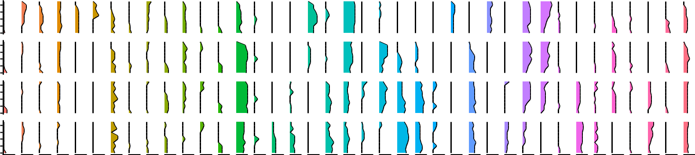

Cover Abundance

Figure 87: Cover abundances for each species across the five plots (A, B, C, D and E) at the Quin Brook transect. Invasive species are denoted by ‘X’.

Only the most common species are included.

Table 38: Five year summaries of groundwater level data at Gingin Brook recorded at bore 61710078.

|  |  |  |  |  |  |  |  |
| --- | --- | --- | --- | --- | --- | --- | --- |
| Period | Mean max seasonal | Mean min seasonal | Mean seasonal change | Month of | Month of | Mean max to |  |
| level (mAHD) | level (mAHD) | (m) | maximum | minimum | min (days) |  |
|  |  |
|  |  |  |  |  |  |  |  |
| 08/1994 - 07/1999 | 39.6 | 39.2 | 0.45 | October | July | 219 |  |
| 08/1999 - 07/2004 | 39.2 | 38.6 | 0.52 | December | May | 198 |  |
| 08/2004 - 07/2009 | 38.5 | 38.1 | 0.43 | October | June | 213 |  |
| 08/2009 - 07/2014 | 37.9 | 37.5 | 0.40 | October | May | 221 |  |
| 08/2014 - 07/2019 | 37.8 | 37.4 | 0.43 | November | May | 141 |  |
|  |  |  |  |  |  |  |  |

**Gingin Brook**

Gingin Brook is a new proposed in the Gingin water allocation plan (draft expected 2023). There is currently no baseline vegetation data for the site.

**Hydrology**

Groundwaters at this site have significantly declined during the period between 1989 and 2015 by approximately 2.5 m (Figure 90). Mean seasonal maximum and minimum groundwater levels have also decreased by 1.8 since 1994, with current monthly minimums generally occurring earlier in the year than in between 1994 and 1999 (Table 38).

140

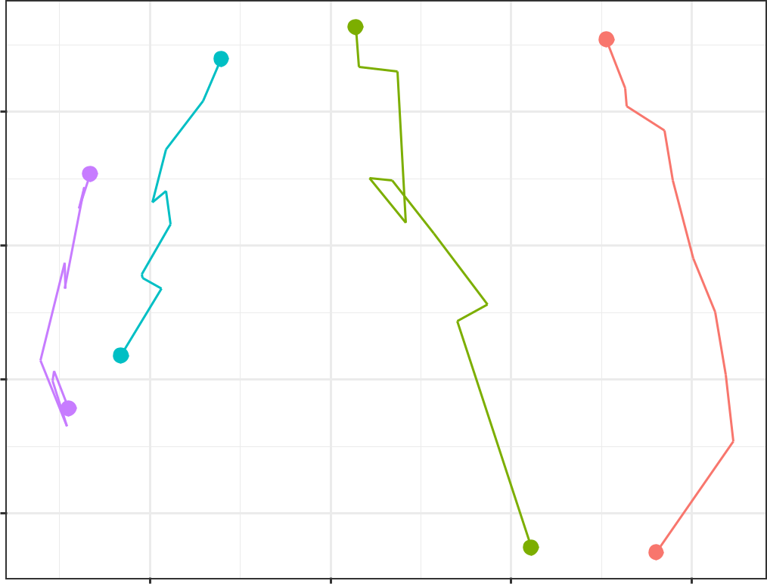

|  |  |  |  |  |  |
| --- | --- | --- | --- | --- | --- |
|  | 2018 |  | 2018 |  |  |
|  | 2018 |  |  |  |
|  |  |  |  |  |
| 1 |  |  |  |  |  |
| 2018 |  |  | Plot |  |  |
|  |  |  |  |  |
| 0 |  |  | a | A |  |
| LV2 |  |  |  |
|  |  | a | B |  |
|  |  |  |  |
| 2009 |  |  | a | C |  |
|  |  | a | D |  |
| −1 |  |  |  |
|  |  |  |  |  |
| 2009 |  |  |  |  |  |
| −2 |  |  | 2009 |  |  |
|  |  |  |  |  |
|  |  |  | 2009 |  |  |
| −1 | 0 | 1 | 2 |  |  |
|  |  | LV1 |  |  |  |



Figure 88: Unconstrained ordination based on the latent variable model for each surveyed year for Quin Brook. Plots are represented as diﬀerent colours and consecutive years are joined by a line with first and last survey years labeled.

141

|  |
| --- |
| Species |

X_Unknown_grass2

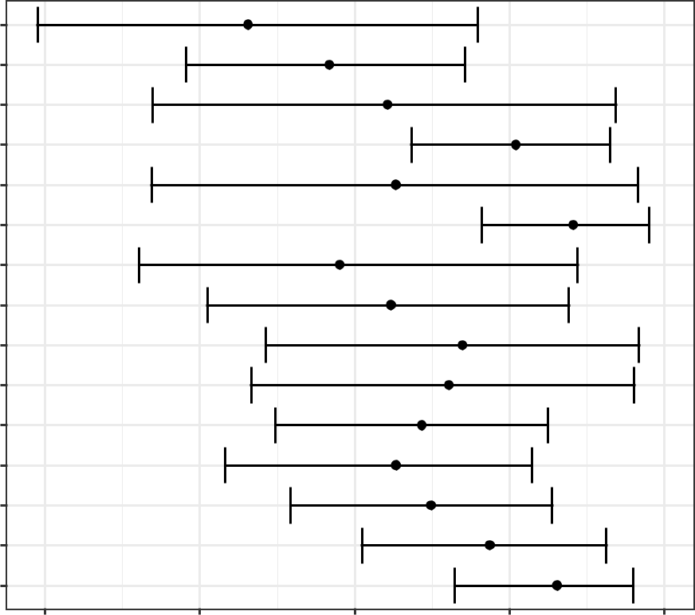

X_Sonchus_asper

X_Lotus_angustissimus

X_Hypochaeris_glabra

X_Aira_sp_

Trachymene_pilosa

Senecio_sp_

Pteridium_esculentum

Nutsyia_floribunda

Microtis_media

Kunzea_glabrescens

Hypolaena_exsulca

Hypocalymma_angustifolium

Cassytha_racemosa

Astartea_scoparia

−2.0 −1.5 −1.0 −0.5 0.0

Posterior Mean

Figure 89: Estimated mean regression coeﬃcients (dots) and 95% credible intervals (bars) for eﬀect of groundwater levels at Quin Brook on vegetation species cover abundances based on Bayesian Regression Analysis (HUI REF 2015). Species with a negative mean posterior value are likely to increase in cover abundance as water levels decline while species with positive values are predicted to increase in cover abundance with water increasing water levels. Only those species with coeﬃcients significanlty diﬀerent to zero are shown.

142

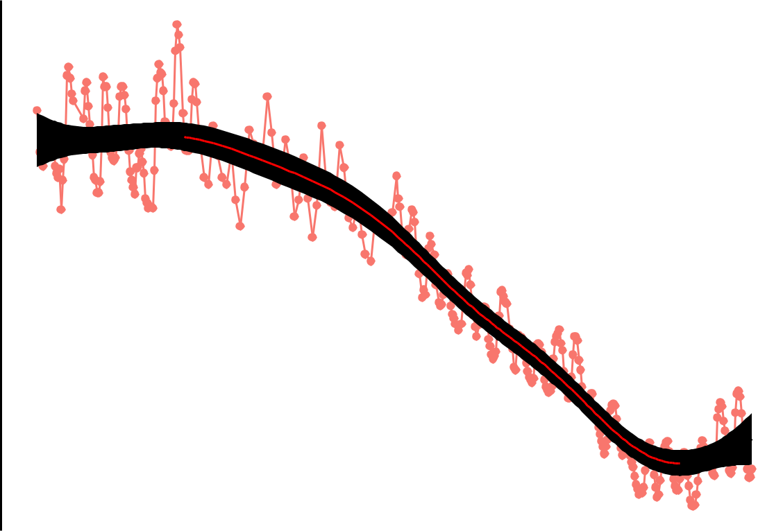

|  |  |  |  |  |  |  |
| --- | --- | --- | --- | --- | --- | --- |
|  | 40 |  |  |  |  |  |
| ( )mAHD | 39 |  |  |  |  |  |
| Water Level |  |  |  |  |  |
|  |  |  |  |  |  |
|  | 38 |  |  |  |  |  |
|  | 1980 | 1990 | 2000 | 2010 | 2020 |  |
|  |  |  | Year |  |  |  |

Figure 90: Groundwater levels recorded at bore 61710078 that represent fluctuations in groundwaters at Gingin Brook. Red segments on fitted line represent statistically significant periods of declining groundwater levels.

143

**Summary**

**Overview**

**Vegetation**

**Aquatic Invertebrates**

**Management objectives**

**Conclusions**

(COMMENT ON MELALEUCA QUINQUENERVIA? MARIGINIUP)

**References**

Bamford, M.J., Bamford, A.R., 2003. Vertebrate Fauna: Valuesand Groundwater Dependence in the Gnangara Study Area. Water; Rivers Commission, Perth, Western Australia.

Buller, G., Kavazos, C.R.J., Froend, R., 2019. Wetland Vegetation Monitoring 2018 Survey of Gnangara Wetlands. Edith Cowan Univeristy, Joondalup.

Buller, G., Kavazos, C.R.J., Froend, R., 2018. Wetland Vegetation Monitoring 2017 Survey of Gnangara Wetlands. Edith Cowan University, Joondalup.

Department of Water, 2011. Groundwater-surface water interaction along Gingin Brook Western Australia (No. January). Government of Western Australia.

Department of Water, 2008. Review of ministerial conditions on the groundwater resources of the Gnangara Mound (No. January). Department of Water, Perth, Western Australia.

England, M.H., Ummenhofer, C.C., Santoso, A., 2006. Interannual rainfall extremes over southwest Western Australia linked to Indian Ocean climate variability. Journal of Climate 19, 1948–1969. [https://doi.org/10.](https://doi.org/10.1175/JCLI3700.1) [1175/JCLI3700.1](https://doi.org/10.1175/JCLI3700.1)

Froend, R., Loomes, R.C., Horwitz, P., Rogan, R., Lavery, P., How, J., Storey, A.W., Bamford, M., Metcalf, B., 2004. Study of Ecological Water Requirements on the Gnangara and Jandakot Mounds under Section 46 of the EP Act. Task 1: Identification and Re-valuation of Ecological Values. Centre for Ecosystem Management, Edith Cowan University, Joondalup, Western Australia.

Froend, R., Loomes, R., Horwitz, P., Bertuch, M., Storey, A., Bamford, M., 2004. Study of Ecological Water Requirements on the Gnangara and Jandakot Mounds under Section 46 of the EP Act. Task 2: Determination of Ecological Water Requirements (No. September). Centre for Ecosystem Management, Edith Cowan University, Perth, Western Australia.

Groom, P.K., Froend, R.H., Mattiske, E.M., 2000. Impact of groundwater abstraction on a Banksia woodland , Swan Coastal Plain, Western Australia. Ecological Management & Restoration 1, 117–124.

Heddle, E.M., Loneragan, D.W., Havel, J.J., 1980. Vegetation complexes of the Darling System, Western Australia. Atlas of natural resources, Darling System, Western Australia. Department of Conservation an Environment, Perth.

Hill, A.L., Semeniuk, C.A., Semeniuk, V., Marco, A.D., 1996. Wetland Mapping, Classification and Evaluation, Main Report, in: Wetlands of the Swan Coastal Plain. Perth, Western Australia.

144

Horwitz, P., Bradshaw, D., Hopper, S., Davies, P., Froend, R., Bradshaw, F., 2008. Hydrological change escalates risk of ecosystem stress in Australia’s threatened biodiversity hotspot. Journal of the Royal Society of Western Australia 91, 1–11.

Horwitz, P., Rogan, R., Halse, S., Davis, J., Sommer, B., 2009. Wetland invertebrate richness and endemism on the Swan Coastal Plain, Western Australia. Marine and Freshwater Research 60, 1006–1020. [https:](https://doi.org/10.1071/MF08204) [//doi.org/10.1071/MF08204](https://doi.org/10.1071/MF08204)

Hui, F.K., 2016. boral – Bayesian Ordination and Regression Analysis of Multivariate Abundance Data in r. Methods in Ecology and Evolution 7, 744–750. <https://doi.org/10.1111/2041-210X.12514>

Hui, F.K.C., 2018. boral: Bayesian Ordination and Regression AnaLysis.

Johnson, S.L., 2000. Hydrogeological assessment of the perennial brooks on the Dandaragan Plateau. Water; Rivers Commission, Perth, Western Australia.

Judd, S., Horwitz, P., 2019. Annual Report for the Gnangara Mound Environmental Monitoring Programme

* Macroinvertebrate and Water Quality Wetland Monitoring for Spring 2018. Edith Cowan University, Joondalup, Perth.

McArthur, W.M., Bettenay, E., 1960. The development and distribution of the soils of the Swan coastal plain, Western Australia., Second. ed. Commonwealth Scientific; Industrial Research Organisation, Australia, Melbourne.

Muler, A.L., Canham, C.A., Etten, E.J.B.V., Stock, W.D., Froend, R.H., 2018. Forest Ecology and Management Using a functional ecology approach to assist plant selection for restoration of Mediterranean woodlands. Forest Ecology and Management 424, 1–10. <https://doi.org/10.1016/j.foreco.2018.04.032>

Pinheiro, J., Bates, D., DebRoy, S., Sarkar, D., R Core Team, 2019. nlme: Linear and Nonlinear Mixed Eﬀects Models.

Quintero Vasquez, M., Lund, M.A., 2018. Yellagonga Regional Park wetlands water quality monitoring 2017/18 report. Center for Ecosystem Management, Edith Cowan Univerisity, Perth, Australia.

Rogan, R., Loomes, R., Froend, R., 2006. Wetland vegetation monitoring 2005 - survey of Gnangara Wetlands.

Centre for Ecosystem Managment, Edith Cowan University, Joondalup, Western Australia.

Salama, R.B., Bekele, E., Hatton, T., Pollock, D., Lee-Steere, N., 1991. Sustainable yield of groundwater of the Gnangara Mound, Perth, Western Australia 1–21.

Semeniuk, C.A., Semeniuk, V., 1996. The geomorphic classification of wetlands, in: Hill, A.L., Semeniuk, C.A., Semeniuk, V., Marco, A.D. (Eds.), Wetlands of the Swan Coastal Plain. Perth, Western Australia, pp. 30–49.

Sommer, B., Horwitz, P., Hewitt, P., 2008. Assessment of Wetland Invertebrate and Fish Biodiversity for the Gnangara Sustainability Strategy (GSS) (No. November). Centre for Ecosystem Management, Edith Cowan University, Joondalup, Western Australia.

Water and Rivers Commission, 2004. Environmental management of groundwater abstraction from the Gnangara Mound 2000-2003 - Triennial report to the Environmental Protection Authority. (No. March). Water; Rivers Commission, Perth, Western Australia.

Water Authority of Western Australia, 1995. Review of proposed changes to environmental conditions

* Gnangara Mound groundwater resources (Section 46) / Water Authority of Western Australia. Water Authority of Western Australia, Leederville, W.A.

Wood, S., 2019. mgcv: Mixed GAM Computation Vehicle with Automatic Smoothness Estimation.

Wood, S.N., 2011. Fast stable restricted maximum likelihood and marginal likelihood estimation of semipara-metric generalized linear models. Journal of the Royal Statistical Society. Series B: Statistical Methodology 73, 3–36. <https://doi.org/10.1111/j.1467-9868.2010.00749.x>

Yesertener, C., 2007. Assessment of the declining groundwater levels in the Gnangara Mound, Report HG1.

ed. Perth, Western Australia.

145

Zencich, S.J., Froend, R.H., Turner, J.V., Gailitis, V., 2002. Influence of groundwater depth on the seasonal sources of water accessed by Banksia tree species on a shallow, sandy coastal aquifer. Oecologia 131, 8–19. <https://doi.org/10.1007/s00442-001-0855-7>

146